ALINA S. BERG

FAITH AND AGENCY ON THE CAMINO:
WALKING BETWEEN SHARED ‘SUBSTANCE’ AND CULTURAL (DIS)APPEARANCE
Abstract
Debates in the anthropology of pilgrimage are often centred around the pilgrim/tourist binary, while religious commodities are said to collapse the distinction between substance and appearance. The present study is based on fieldwork conducted on two sub-routes of the Camino de Santiago: the Camino francés in northern Spain, and the Via podiensis in southern France. In highlighting the role of movement, the way can be considered the goal. Drawing on literature on infrastructure, I contrast European cultural hegemony with ‘the spirit of the Camino’, which I conceptualize as pilgrim-agency. Commoditization, framed around locality, dominates in small municipalities that depend on external support, whereas ‘particular’ owners of gîtes and albergues conduct a form of gift-exchange rooted in the ‘spirit of the Camino’. The Camino can thus be classified as a distinct place enacted by the pilgrim through contrasting processes of selective attention to and fetishization of the path. Finally, I refer to Actor Network Theory to combine the actors and processes previously analysed into a cohesive framework. As an actor-network, the Camino comes to stand on its own, losing its ‘European’ notion; yet it extends over its particularity. This ANT framework can be applied to the concept of agency (entailing attribution), but it also transcends the New Age notion of ‘I’ and, when applied to pilgrim’s beliefs, comes to unite contrasting motifs. Such an approach highlights the fact that anthropological research need not be stuck on fixed binaries.

‘Faith is not the clinging to a shrine but an endless pilgrimage of the heart.’
― Abraham Joshua Heschel
Introduction: Buen Camino!
The popularity of the Camino francés, the major route of the European networks leading to Santiago de Compostela in north-east Spain, has reached new dimensions, with over 300,000 pilgrims walking the Camino in 2017. Roughly every five to ten kilometres, next to one of the bars or restaurants fringing the Camino that are usually called ‘El Caminante’, ‘km xyz’, or ‘Ultreia’, Erdinger Weißbräu wishes you Buen Camino! (see Figure 1). In between these comfortable shelters, large advertising boards ensure that the pilgrim knows there will be a place to stay in the next town, together with a jacuzzi and a massage therapist, all included in the price.
On the last kilometres of this ‘strange road to Santiago’, as Paulo Coelho refers to it (2009), the pilgrim is just beginning to be entranced by the peaceful, soothing scents of the eucalyptus forest when his synchronicity is suddenly disrupted by the international runway of Santiago Airport. Along with the ever-growing crowd of tourist-pilgrims (turigrinos) on this last stretch, he is forced to spend the next few kilometres skirting the infrastructure that enables the masses to flow in in the first place, before entering the suburbs of the city, where the relics of St James are kept in the cathedral.
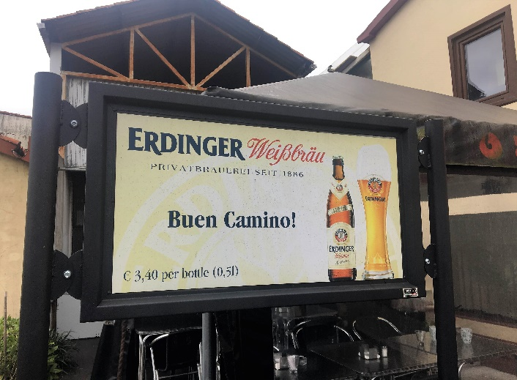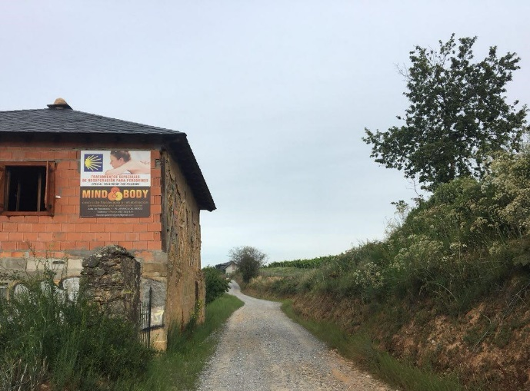
Figure 1. Advertisements in Galicia, Spain, 2018 (taken by author).

The ‘Camino’, as it exists today, consists of a large network of surrounding infrastructure and actors, many of them exhibiting an almost absurd degree of commodification. Jones (2010) states that religious commodities violate the separation of two distinct spheres – virtue and appearance vs. vanity and substance. Tourism, as a form of the commodification of an ‘authentic’ place-product, is often concerned with a similar binary, namely that between the local and the global. The study of pilgrimage unites tourism and religious commodification, while in itself inhabiting movement and thus complicating the theorization of a fixed notion of place.
New Age pilgrimage is most commonly framed around an analysis of the pilgrim’s perspective consisting of his personal motives and beliefs placed in an extensive (circular) debate around the pilgrim/tourist binary. Captivating as this analytical discourse is, I spent countless hours contemplating how to unite statements like ‘It helps you empty yourself’ and ‘I want to find my identity/God’ into an all-encompassing framework, even when I had already decided to step away from the debate. Instead, I moved towards an emic approach in framing the concept of ‘Camino-substance’ as a complex system of faith that does not fit into a particular religious tradition or category, but stands on its own as a set of values and priorities. Two pilgrims I encountered describe it as followed: ‘The Camino makes you feel human again. It makes you care about others, help others, being helped by others. It doesn’t matter what the religion, age, the colour of the skin, the language is. On the Camino we are all the same. Your feet are gonna hurt just like everybody else’s.’
I will introduce this ‘spirit’ as a form of pilgrim-agency, a substance so to say, in the context of the larger hegemonic structures of European cultural bodies. Agency, in turn, will be conceptualized as an alternative form of faith linked to attribution as a process within the larger network of the Camino agent. Through the course of this dissertation, I will argue that the ‘Camino’ as an infrastructure that is both physical and conceptual has taken one a life on its own, having come to represent a distinct network-agent. In the course of my argumentation, I will move from a material to a conceptual level to apply what Latour and Latour (2005) have called the ‘material-semiotic’ method. In examining the Camino in terms of its processual character along with the agents that surround it –that is, as a ‘constantly shifting networks of relationships’ on these two levels – I will end by arguing that, since ‘the way is the goal’, substance outweighs appearance.
This is traceable throughout three layers of abstraction and from different perspectives. In the first section, I will define the substance–appearance binary through the frame of power and agency. In the second chapter, I will add locality as an agent in order to analyse the process of commoditization as a way of contributing to ‘appearance’. The Camino, I will argue, represents a separate notion of ‘particularity’, which I will illustrate in the subsequent passage. Further, I will ask how the Camino structure can be loosened from its hegemonic context as a form of conceptual agency. Finally, looking at the Camino as an actor-network sets up the necessary framework to analyse beliefs and motives within a shifting network of relationships.
Methodology: every step of the way
The general aim of this study is to provide an all-encompassing, innovative theoretical framework for the existing literature on the Camino in order to situate it within the broader debate on religious commodification. Geertz (1988: 10) has famously phrased the main challenge that ethnography poses to the anthropologist as ‘how to be a pilgrim and a cartographer at the same time’. Through the participant observation of walking alongside so many pilgrims, as well an etic analysis of infrastructure, I quite literally attempt to do exactly that. Further, his quote also underlines the figurative use of the term ‘pilgrim’ in everyday discourse, as well as its disenchantment and secularization.
The data I use are based on participant observation on the Camino in southern France and northern Spain, along with semi-structured interviews of pilgrims and other parties involved, conducted in June-July 2018. Participant observation in this case involved hiking the trail along with the pilgrims – that is, twenty to thirty kilometres or five-eight hours every day for five weeks, the average length of most routes within the Camino framework. My sensitivity to the topic was increased through my own experience as a pilgrim walking on one of the newly established routes from my hometown on the French-German border to Le-Puy-en-Velay, France (approximately seven hundred kilometres) in 2014 (see Figure 2). This was the starting point of the path I took as part of the fieldwork presented here.
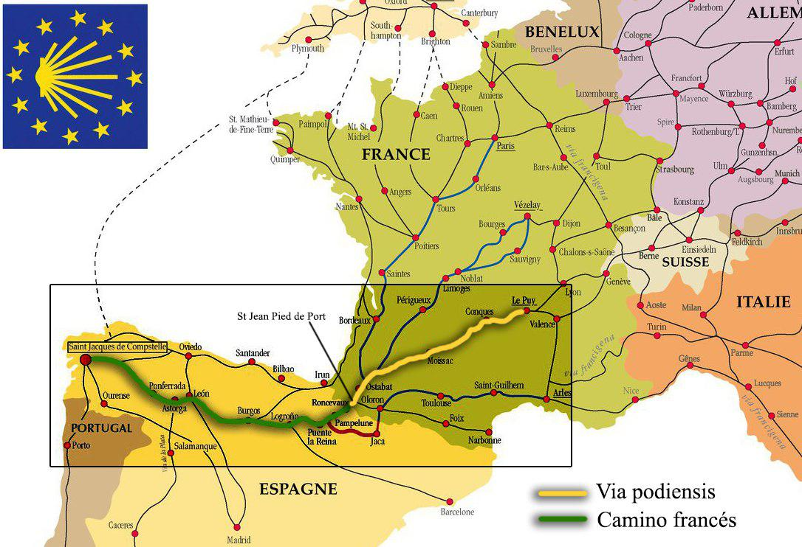
Figure 2. European network of Caminos
Despite my previous involvement in pilgrimage, I considered this to be a fundamental (set of) step(s) in acquiring reliable and profound insight into my informants’ lived experiences. First, the pilgrimage is a physically and mentally challenging journey grounded in individual sensual involvement. Movement plays a major part in the analytical framework of pilgrimage (Coleman and Eade 2004), entailing notions of embodiment and phenomenology that words can capture only partially (Csordas 1994; Morgan 2010). Secondly, the social life of pilgrims on the Camino has been characterized as revolving around the authenticity of shared experience (Frey 1998; Peelen and Jansen 2007); walking with them thus allowed a deeper interpersonal connection with pilgrims. Semi-structured interviews (including open questions) were chosen on the basis of previous recommendations in pilgrimage context; they leave room for the interviewees to reflect and phrase experiences in their own terms (Bernard 2006; Knox et al. 2014; Margry 2008b). Although I chose to rely more heavily on participant observation in the present study, the interviews contributed vitally to the understanding of the larger phenomenon and helped develop interpersonal trust and joint contemplation, which significantly enriched my own theoretical considerations.
My argument is grounded in two contrasting case studies (see Figure 3). The first is the Camino francés (the path that people commonly refer to as the Camino), which stretches all the way through northern Spain from the French side of the Basque country to Santiago de Compostela in Galicia. It is by far the most popular route, with over 60% of pilgrims to Compostela taking this path, and it attracts a fairly international participation. The Via Podiensis (the Way of Le Puy), by contrast, which leads from the high plateau of the Massif Central to the Basque town of St-Jean-Pied-de-Port, is far less frequented and mainly chosen by Europeans from surrounding countries.
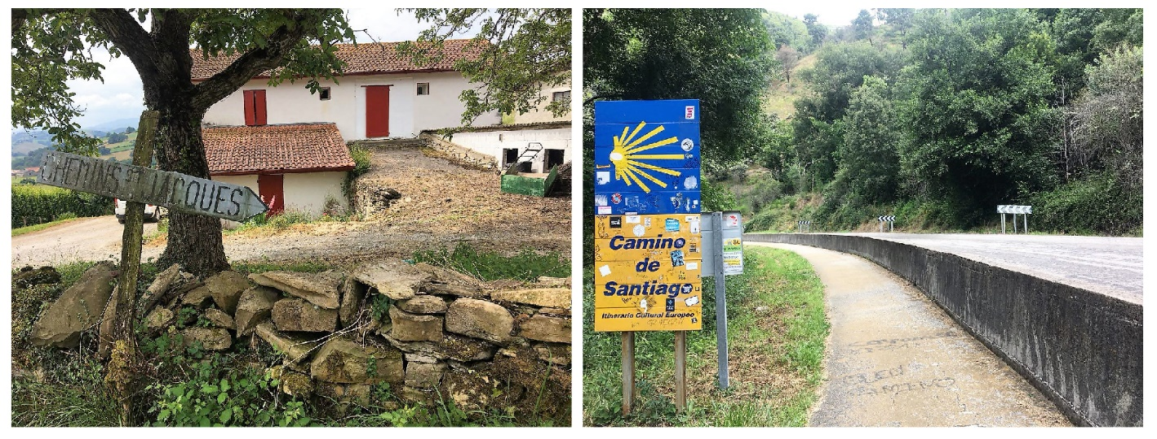
Figure 3. Via podiensis, France (left) and Camino francés, Spain (right), 2018 (taken by author).
The combination of these two pilgrimages allows for a broadening of the often limited ethnographic horizon to the wider European context, an angle that studies focusing solely on Spain have not been able to capture. Enlarging the framework also entails abstracting the concept of the pilgrimage as such to examine the surrounding material and semiotic structures. As I was collecting my data, I realized that this dual take on pilgrimage was where the particular strength of my own fieldwork lay and thus decided to extend my initial focus to the Camino’s larger social structure, thus presenting a new lens through which to view well-traversed anthropological territory.

The ‘Way’ is the Goal: the Camino as an infrastructure
Pilgrimage, of course, is not a religious commodity in the classical sense. More accurately, it can be seen as a dynamic ‘place’-product. Highlighting the role of movement in constituting meaning has been suggested as a new analytical framework within pilgrimage research (Coleman and Eade 2004; Peelen and Jansen 2007). Coleman and Eade (2004) identify four different implications of movement in pilgrimage research: 1) movement as performative action plays a key role in creating collective identity through a ‘kinetic mapping of space’; 2) movement as embodied action is linked to the pilgrim’s bodily experience; 3) movement as part of a semantic field places the pilgrimage within its local culture with reference to notions of landscape, space and place; and 4) movement as metaphor refers to how discourse is linked to both pilgrimage as a broad abstract category and its more refined aspects. I have chosen to adopt a rather unconventional take on pilgrimage as infrastructure, as this provides insights into virtually all of these aspects.
What characterizes pilgrimage on the Camino is the emphasis on the path as such and the walking it involves as a multipotent act, rather than the actual physical goal of Santiago (Feldman 2017; Morinis 1992; Margry 2008a). The Camino is the ‘space where religion [in the broad implication of the term] is “made” or “done” through the movement of the body’ (Peelen and Jansen 2007). As Frey (1998) outlines in her ethnography of the Camino francés, notions of authenticity revolve around the means and distance of travel, a phenomenon that has possibly increased in the context of commercialization as a way of sharpening the increasingly blurred lines between pilgrim and tourist.
The exemplary case of the revived version of the Camino as a transit- rather than a goal-focused pilgrimage has triggered the emergence of similar trails all over Europe (Margry 2008a; Ramírez 2011), thus expanding its ‘place’. With movement coming to the foreground in the context of pilgrimage, the emphasis is mostly on the pilgrim as an actor – yet commoditization is linked to physical surroundings and the material context. At the same time, New Age spirituality and pilgrimage have been examined within the boundaries of the ‘self’-subject. With reference to Actor Network Theory (ANT), I will take an encompassing approach that unites the different actors, both human and non-human, under one theoretical roof, looking at the different analytical meta-levels they represent. I will accentuate the processual embodied subject, enacting particularity as place. As such, movement – a prescribed European doctrine – helps construct the ‘imagined community’ of the Camino that sets it apart from the power discourse.
The mobility framework highlights the path over the goal, and so the Camino can essentially be regarded as an infrastructure. It enables the pilgrim to get to his or her physical goal, the worldly destination that is ideally Santiago but that has shifted practically in many cases (e.g. to Finisterre or St Jean Pied de Port). Simultaneously, it marks the figurative way to an ‘abstract’ mental goal – to God, to self-realization, to change or transition. It is thus the enactment of a more symbolic form of infrastructure that nevertheless has an actual physical representation, a network of local infrastructure surrounding it. This abstract frame naturally implies that pilgrimage is performed and embodied, and it allows one to see movement as a semantic field with reference to surrounding structures and actors. In addition, it adds to the study of infrastructure in that it demonstrates alternative ways of conceptualization: we can see infrastructure as an imagined enacted construct, while underlining a ‘bottom-up’ (agency) approach where top-down (power) approaches have been more usual. Within such a frame, we are able to re-examine the religious commodity debate from a power perspective that comprises material and non-material actors alike.

Camino politics – culturally speaking
The revival of the ancient pilgrimage route to Santiago can be traced back to the late 1960s (starting with the Camino francés), from where on the distinct path, demarcated with symbols of the scallop shell, as it is today, was gradually defined and established (Cazaux 2011; Egan 2007). The Camino is now part of a larger elaborate network of ‘sub-Caminos’ that stretches throughout Europe (Figure 2). It was only after the classification of the so-called ‘Ways of St James’ as the first European Cultural Route in 1987 that other trails and tracks, both within and outside the Camino framework, were defined and delineated within Europe (ibid.). In the following, a European guide to the ways of St James was released as a referential textbook with the vision to promote these roads to Santiago, privileged spaces directly placed within the construct of ‘European culture’. A few years later, in 1993, the Camino francés was declared a UNESCO world heritage and thus elevated from a European to a broader international political context, further increasing its popularity.
Regarding the Via Podiensis, only distinct sections of the GR65, along with specific buildings and architectural ensembles, have been classified by UNESCO as cultural heritage sites. Historically speaking, the choice of the actual paths and trails is somewhat arbitrary: although they pass the major religious sites and towns that are known for their historical significance in relation to the pilgrimage, the ‘middle parts’ would vary from pilgrim to pilgrim. Before way-markings appeared as a means to standardize traveller’s routes in the twentieth century, people did not follow a distinct path but took whatever way they were presented with. Today’s material composition of the Camino can thus be seen as a political project, the pilgrim’s experience and attention being susceptible to manipulation through the physical form of the path.
The consequence of such ‘pluralizing’ Caminos in Europe, along with the emphasis on the road, is that, although all parts are framed under the same umbrella term (‘Camino’), Santiago is no longer the ultimate physical goal. In comparison, the Japanese pilgrimage to Shikoku, as described by Reader (2006), is not limited to a single path, nor to a single starting point or destination. Pilgrims do not have to follow a particular order within this network of 88 sites and temples, as the linked circuit can be divided into segments that are then completed throughout the lifespan. Thus, the cohesion lies in the road between the sites. Looking at the larger European network of Caminos, we can see the parallels between these two pilgrimages.
On the Via Podiensis, one is always asked about one’s final destination. For more than 70% of the people I engaged with, the Via podiensis was ‘their’ Camino, with St Jean as the final goal of their journey. Many native French-speakers choose this alternative Camino, as they prefer to be within a familiar and less frequented environment. At the beginning of my journey, I was surprised to find that pilgrims feel no need to explain why they chose this Camino over the one that actually leads to Santiago. It just seemed like a natural ‘extension’ to them. A woman from Québec was inspired to take the Camino by her father, who had always wanted to walk the Camino francés. Despite his particular influence, she had chosen this route. This is just one of many examples of people coming from abroad specifically for this Camino, with no explicit intention to go on to Santiago. Though some people do consider continuing eventually, many do not set out initially with that intention.
It is quite frequent for people to divide the Camino into yearly sub-parts of between a hundred and two hundred kilometres each. Two French women I met close to Navarrenx had been walking the Via podiensis in such a manner for three consecutive years. When we arrived in St Jean, I asked whether they would continue with the Camino francés next year; they said they were considering starting a new Camino in France instead. It seems that ‘the way’ has become the goal – and the pilgrim, consequentially, moves on the road to Santiago, rather than going to Santiago.
The Camino, as it exists today, has abstracted itself from Santiago as a place and turned into an extensive space of infrastructural networks. Although the European sub-Caminos could be seen as ‘discontinuous, multi-sited objects of study’ (Marcus 1995: 97), I will argue that they unfold their meaning as a unity. Pilgrimage can provide a means for retracing ‘culture’ through interactive physical emergence within the historical and religious landscape of the country, with Shikoku in Japan being the primary example (Reader 2006). Basu (2004) provides a metaphorical account of root-tourism to Scotland as pilgrimage. However, ‘definitions of Europe are frequently both arbitrary and politically charged. […] Like the nation-state (against which it is often identified), “Europe” can be seen as much as a creation of literature and myth as it is of power’ (Goddard 1994: 25-6). As noted by Reader (2007) in one of his articles, though the Turners' (2011 [1987]) work on pilgrimage was ground-breaking within the discipline, their focus on anti-structure and ‘communitas’ as guiding principles (the pilgrim being transposed to a liminal stage and ‘voting with his feet’) resulted in the neglect of top-down dynamics—that is, the influence that higher (religious) authorities exert on the context of pilgrimage. Although a precise analysis of all stakeholders would go beyond the limitations of this study, the construction of a larger European network of Caminos is deeply intertwined with the political context and as such highly relevant to the present analysis.
Larkin (2013) describes how infrastructural projects can be analysed to reveal political patterns of rationality as commonly overseen ways of giving rise to the ‘apparatus of governmentality’ described by Foucault. By placing the larger system in the centre of the assessment and adapting a ‘holistic’ interactive approach, a larger inherent rationale can be revealed, a new form of infrastructure that goes beyond mere logistics by combining top-down policy-making with a ‘poetics of aesthetics’ (Hughes 1993; Larkin 2013). In the context of the Camino, technopolitics constitutes what Margry (2008a) frames as ‘the religion of heritage’ – political aspirations to create a pan-European identity and thus hold the political construct of the European Union together in times of ambivalence and heterogeneity. Collective history and cultural heritage are emphasized through the lens of Christianity, drawn along the contrasting lines of Islam. In its poetic mode, the Camino is detached from its simple ‘technological’ function (to take the pilgrim to his physical or abstract goal) and instrumentalized to re-create a politically fabricated Christian past and ambiguously ‘spiritual’ present – the latter, quite ironically, is tailored to modern conditions.
In response to the pluralizing, often conflicting spiritual situations that prevail in Western modernity, such heritage is ‘employed as an ostensibly secular portmanteau category, which can in a more neutral form simultaneously remould religion and give it a more open shape’ (Margry 2008a: 16). The Camino is presented as a combined account that ‘Makes You Feel Good!’ (as the Cultural Routes of the European Council brochure euphorically proclaims) on various levels. Frey (1998) documents the content of a pamphlet issued by the major Spanish pilgrim association in cooperation with the Council of Europe and the Spanish Ministry of Culture:
To go on pilgrimage to Santiago in the traditional mode is more than a tourist or sport trip made on foot over an artistic route in contact with nature. It's all of this, but also much more. It is to find yourself in the religious and historical routes of Europe, to renovate a way of interior transformation, to walk at the rhythm of other centuries, it is to [...]wander. (ibid.: 128)

Not only is European history canonised, it constructs a mythical ‘European’ landscape and identity that encompasses notions of gender, race, and sexuality (Notermans 2016; Roseman and Fife 2008). Such fictional space is reinterpreted and twisted on the level of concrete actors: ‘the institutional story cannot complete its ending in the wake of a peripatetic acephalous community that resists its role in the definition of spaces larger than the Camino. Europe can wait, because for pilgrims, the Camino cannot’ (Egan 2007: 52).In line with the Turnerian framework of liminality, the Camino is perceived by many as a way to escape civil society and the rigid structures it imposes. The ‘spirit of the Camino’ stands for an ideal egalitarian and altruistic community. It thus has some of the characteristics of an anarchist society in the sense of Scott (2009) in The art of not being governed. Larkin (2013: 333) writes:
Roads […] encode the dreams of individuals and societies and are the vehicles whereby those fantasies are transmitted and made emotionally real. […] They form us as subjects not just on a technopolitical level but also through this mobilization of affect and the senses of desire, pride, and frustration, feelings which can be deeply political.
Such underlying concepts can be revealed in ‘engag[ing] infrastructural relations as moments of enchantment’ (Harvey and Knox 2012: 525). The Camino as a pilgrimage infrastructure affords, both literally and figuratively, a particular ‘way’ of being social, an alternative route in life; it is saturated with hopes and aspirations for a spiritual and personal journey – ‘wandering’, as phrased in the pamphlet. This alludes to what Sopranzetti (2017) frames as ‘freedom with a small f’ – a subjective experience of agency within capitalist hegemony. Taxi-drivers in Bangkok are drawn into a precarious lifestyle that they perceive as emancipatory self-employment. This discourse of freedom (‘Itsaraphāp) is instituted by the post-Fordist Thai state to fit the new economic model. Here, the importance of distinguishing between Freedom (with a capital F) as a theoretical absolute notion and a contextual understanding of freedom is emphasized. The present case study faces a similar dilemma. The Camino denotes notions that are both positive (freedom to express, to wander) and negative (freedom from mundane constraints, from structure), as described by Berlin (1969). That is, agency and power exist within the same discursive framework.
Thus, the Camino set-up is not necessarily political to begin with. As it is embedded in the European heritage discourse, it becomes increasingly difficult to discern the two ‘imagined communities’ of present concern – the liminal pilgrim-universe versus the site of ‘European’ heritage. Where do we draw the lines between European ‘cultural’ hegemony and pilgrim agency? Furthermore, if European heritage is a fictional product that must be carefully carved out, then is there more to the poetic mode? Within the EU discourse, the substance/appearance binary unfolds a new meaning. ‘Appearance’ lies in constructing a cultural heritage product, whereas ‘substance’ refers to the spirit of the Camino, revolving around a particular kind of authentic altruism. Looking solely at the distinction on an abstract level, they seem to be following the same direction. By including the notion of locality as a mediator, I hope to be adding a new dimension to the discussion: commoditization.

Camino substance – particularly local
Ortner (1995) argues that resistance, encased in its infinite layers of power structures, is full of ambiguities and can often not be framed as one cohesive strand; even in top-down relations of power, the ‘higher instance’ often has something to offer. There is yet another stakeholder that should be included: local authorities that seek out institutional recognition as they benefit from their financial and cultural backing. That is, they benefit in a direct manner through funds and endowments, though at the same time tourism is indirectly promoted and often contributes to the cultural preservation of villages struck by the rural exodus (Padin and Pardellas de Blas 2015; Ramírez 2011). The contrast between the two case studies dealt with here is particularly powerful in underlining such dynamics. The Via podiensis and the Camino francés seem to represent distinct points in time with regard to the extent of their commoditization.
Commoditization is defined as the process throughout which economic goods are homogenized from the consumer’s perspective in relation to distinct attributes they possess (Appadurai 1988). To apply this to our case studies – since walking the Camino is an activity that is essentially ‘free’ in itself – what can be commodified (as in turned into a commodity) and then commoditised is the infrastructure surrounding it – one can pay for certain privileges (security being one of them). International stakeholders and local authorities often jointly organize overpriced tourist hiking package trips, with accommodation and food pre-booked, and luggage transported. At root, of course, this contradicts the idea of a pilgrim leading a simple existence, departing into the unknown.
In order to understand fully the significance of a pilgrimage, the discourses and practices of various actors have to be considered (Eade and Sallnow 2013 [1991]). In shifting the debate to the owners of pilgrim accommodation (gîtes and albergues) offered along both parts of the Camino, I will relate the tension between substance and appearance to a locality/‘particularity’ binary. Both the Basque region in France and the Galician region in Spain represent distinct cultural areas fearing their ‘disappearance’ within a nation state. They are, above all, localities, and as such they are seeking to preserve their existing status.
Gift-exchange (as opposed to commodity-exchange), is commonly described as inalienable from the giver: a power (in line with the Maori notion of hau) ‘resides in the object given that causes its recipient to pay it back’ (Mauss, 2002 [1990]: 3). This binary has been refined and questioned by various scholars. Daniels (2009) has pointed out that in Japan’s hierarchical capitalist society, gifts are essentially commodities. In the context of the Camino, which is ingrained with a spirit of sociality, a monetary transaction is a gift-exchange at heart; it entails a social form of reciprocity along with the usual exchange of money for services. Here, a useful binary can be drawn: as I will argue, the interest of local owners lies in commodity transactions, whereas ‘particular’ owners imbued with the Camino-spirit are essentially conducting gift-exchange (see Figures 4, 5). Thus, in contrast with common notions of locality in similar contexts, the former seek out the ‘appearance’ of the Camino over its ‘substance’ in context of global–local (power) dynamics.
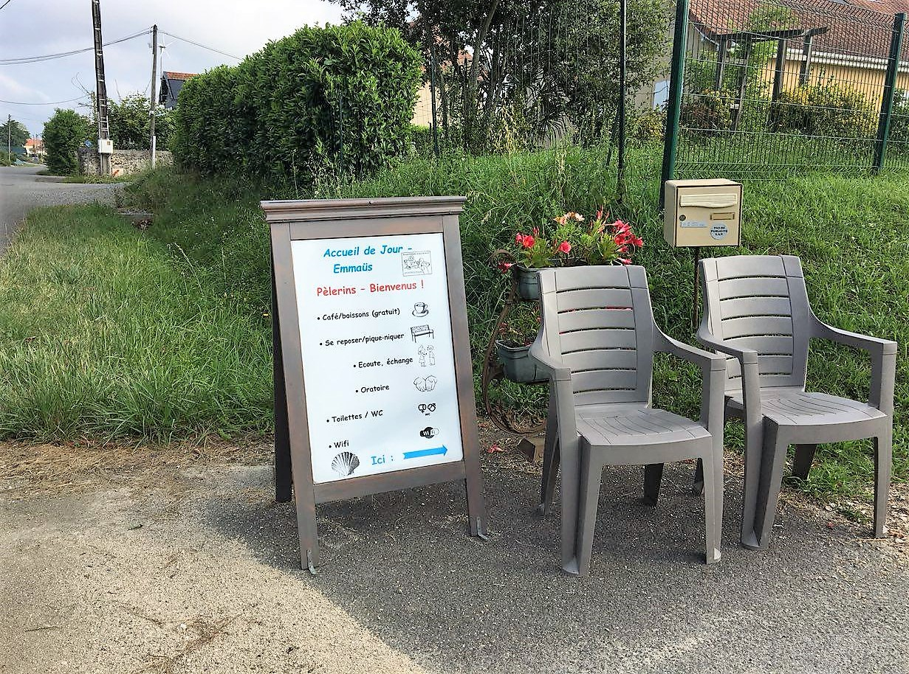
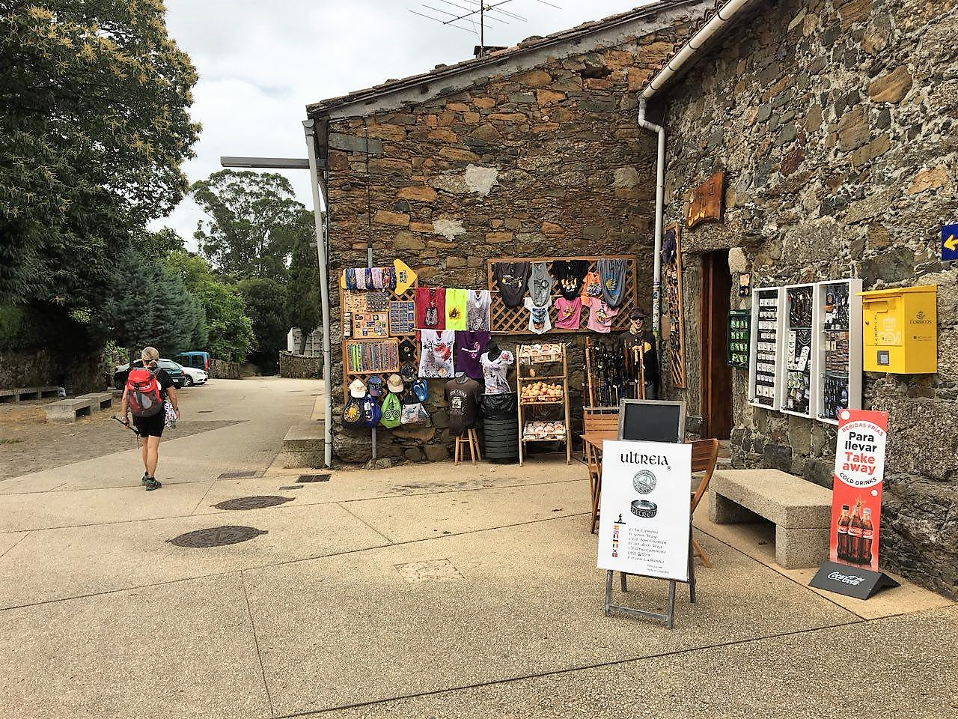
Figures 4, 5. Gift-exchange (above) in France and commodity-exchange (below) in Spain, 2018 (taken by author).
Aroue, the first stop in the Basque country after the three French routes have come together, does not ‘officially’ form part of the path leading to St-Jean-Pied-de-Port in the sense that the scallop shell way-markings do not directly lead the pilgrim through the village, which he thus has to take a slight detour from the path to reach. Nevertheless, in the context of the growing popularity of the hiking trails, the gîte communal that opened there several years ago has now been featured in the guidebooks of most travellers, where it is suggested as an étape– (‘stage’), a daily goal that most pilgrims follow quite rigorously. In many ways, the gîte fills a previous gap in the infrastructure of pilgrim accommodation and food supply, though with benefits for the village as well. Hence, upon our arrival, the owner strongly emphasised a description of an alternative route that would prevent pilgrims from walking back to the original spot on the path, but instead guide them through the entire village, eventually leading back to the demarcated Camino and shortening the hiking trail by a couple of kilometres. Although taking detours is commonly frowned upon, he managed to convince our entire group to take his advice.
The path, though ‘arbitrary’ to begin with, is relatively fixed, though modifications may be made in the long run (Cazaux 2011). If such an alternative path is taken up by most hikers, the description in the guidebooks, and eventually the official way-markings, will be altered. Being officially established as a stop on the Camino creates a lot of potential for the small local businesses (restaurants, shops) that are on the verge of dying out – which, in turn, helps preserve the local Basque culture, which is often contrasted with the larger French state. EU funds and the ‘official’ tourist hiking packages offered by the Cultural Routes of the European Council program would contribute in a similar manner. Locality can thus be emphasised temporarily through ‘global’ or international recognition and funds, while ‘skipping’ the status of a nation state. In many such places, exchange is terminated with the receipt of a counterpart value, thus making it a commodity transaction (Kopytoff 1986). This type of accommodation is most common in Galicia (the last part of the Camino francés), where ‘proper’ hostels and hotels, barely distinguishable from any such hospitality services around the globe and in a ‘secular’ context, employ staff to perform ‘alienated labour’ (as in, detached from the ‘production’ of the pilgrimage – its collective spirit). One of my Spanish informants said that ‘In many of these small villages they try to – not rob you – but yes, they know there are only certain places you can have food or have a drink. But that’s not fair – you get to a big city, and you get fairer prices.’
It is important to note, however, that to most gîte-owners in France their work does not bring any profit. In contrast with Spain, there are very few donativos. Maintaining infrastructure for pilgrims on this part of the Camino is thus dependent on independent, devoted individuals. The money they make barely pays the bills: it is merely a ‘partial transaction which should be considered in the context of the entire transaction’ (Kopytoff 1986: 69). The personal labour they put into maintenance and other services – a gift inalienable from the donor – is paid off by indulging in the collective effervescence of the pilgrims (the ‘spirit of the Camino’); reciprocity is implied through the anticipation of such sociality. In fact, the majority of owners are (ex)pilgrims themselves. They form different associations that strengthen their bonds, supporting each other through recommendations and pamphlets (e.g. ‘les haltes vers Compostelle’). In France, as a consequence, many nowners are not locals but ‘particulars’ moving to the ‘fringe’ of Camino from different regions or countries. They buy up gîtes that their previous proprietors have ‘given up on’ – a common phenomenon. An owner in St-Jean-Pied-de-Port recounted regularly having seen them come and go throughout the past decades: ‘They quit because they realise they can’t make any money. You have to be passionate about it. Most people who stay have done the Camino themselves – and this is their way of staying on it.’
This is remarkable because, as both the ending point of the Via podiensis (along with the other two French routes) and the starting point of the Camino francés, one would expect the accommodation industry to flourish in St-Jean. It seems that, to a large extent, the spirit of the Camino determines the price, so that accommodation transactions fall into the category of gift-exchange. That is, most pilgrims seek out the most basic, inexpensive gîtes, while their devoted owners try to keep the price as low as possible for the pilgrims, providing extra services in the form of hospitality and advice. As a result, gîte prices cannot be raised significantly by owners seeking a profit. As the road progresses, this notion changes. Especially on the last hundred kilometres, which one must complete on foot in order to get one’s official certificate, the Compostela, advertisements for expensive hotel rooms with extra services start popping up. This is because, as so-called turigrinos (tourist pilgrims) start emerging, the demand increases, and cheaper options get booked out. As fewer people follow ‘the spirit of the Camino’ and become more willing to pay for comfort, commodity transactions take over. Locality, contrasted with a globality of ‘nothingness’ and linked to notions of authenticity, is a common factor recognized in tourism and commoditization (Cohen 1979; Massey 2010), yet in this case it is particularity that resonates with the ‘substance’ of the Camino.
Kopytoff (1986) sees culture, by contributing to singularization, as the counter-process to commoditization. In many ways, this is what the Camino in its particularity does, even though it is in sharp contrast with the surrounding ‘culture’. Albergues and gîtes are not merely places to sleep, they are meant to make the pilgrim feel at home, providing a space for self-expression and indulging in the collective ‘spirit of the Camino’. Yet, it is precisely this idea, almost like a longing for authenticity in modern times, that attracts many pilgrim-tourists to begin with: ‘non-saleability imparts to a thing a special aura of apartness from the mundane and the common’ (Ibid.: x). The aura of gift-exchange with which the Camino is imparted entails idealized notions that many people specifically seek out.
Camino localities sharpen their regional cultures yet commoditize what I have defined as Camino-substance. In collaborating in the EU discourse for their local benefits, they violate the separation between the ‘altruistic’ substance of the Camino and its appearance as a way of emphasising ‘culture’ (implying both the larger international framework and their own locality). ‘Culture’, in this understanding, does not singularize, but ‘particularity’ does, eventually commoditizing again. Yet, where do we locate this ‘particularity’?
Camino-place: walking a fine line
The Turners (2011 [1987]) note that ‘pilgrim trails cut across the boundaries of provinces, realms, and even empires’. Looking at the Camino’s physical constitution, we can see its symbolic character as an infrastructure. It does not constitute a distinct path in its own right but is composed of ‘profane’ or mundane (infra)structures – parts of roads and hiking paths in forests that have simply been ‘chosen’ to be used (see Figure 6). Thus, the way-markings of the pilgrim’s scallop shell turn it into an infrastructure of its own. It is on this basis that the imagined community is constructed. This theoretical framework, in line with Turner’s concept of communitas, has been widely employed (Egan 2007; Frey 1998; Peelen and Jansen 2007). I have therefore chosen to focus on the material aspects that contribute to this notion, rather than the social ones. These approaches underline movement’s performative character as a mapping of space and identity within it (see Coleman and Eade 2004).

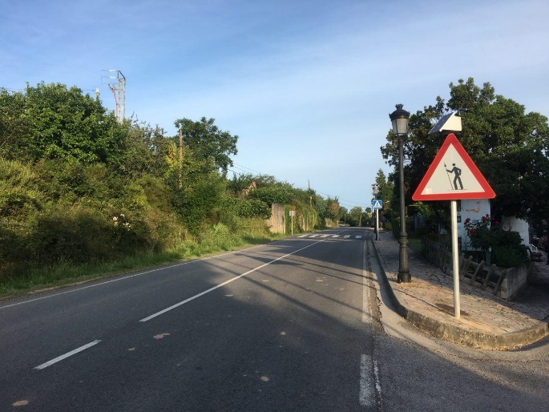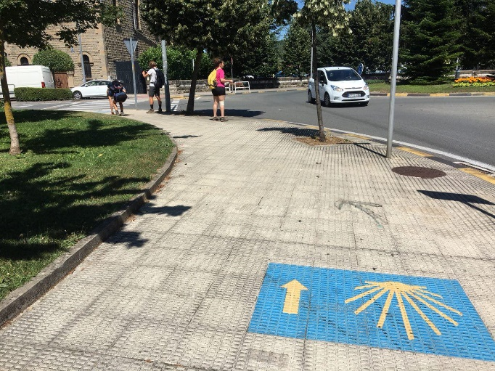
Figure 6. The ‘demarcated’ path, Spain (taken by author).
In examining the Camino’s relationship to outside structures on a physical level, I will highlight the contribution of movement as part of a semantic field. Feld and Basso (1999) state that place is the site of intense fusion, as it transcends mind and body, physical and semiotic. Anthropology has been concerned with how place (almost as a physical equivalent to Bourdieu’s habitus) is all-embracing, how it encompasses biography. Emplacement, being in such a multipotent place, has become a key concept in such analyses. But it is instead displacement that governs modern society, a sensation that pilgrimage ‘artificially’ evokes; and yet pilgrims report feeling they are not just ‘in the right place’ but part of a collective community attached to a specific site – that is, an infrastructure in motion that is constantly enacted. I will thus explore how a sense of place prevails and proves itself relevant without an actual fixed site as a point of reference but an ‘imagined’ space of community. Drawing on ANT, ‘both places and mobilities are to be analysed as relational effects’ (Duim et al. 2012: 10).
A sense of place is ‘extracted’ from a contrast between locality and ‘particularity’ – that is, pilgrims selectively attend to the ‘Camino’ as a fixed, separate entity, rather than seeing it as what it is in ‘worldly’ terms – a combination of pre-existing local structures. It is, literally and figuratively, a parallel path in life. On the one-day hike before St-Jean-Pied-de-Port on the Via podiensis, I stopped at a farm selling beverages and self-made products. The small self-service counter was accompanied by a sign with instructions in French and Basque. During the last few days the Camino had been teeming with such bilingual signs, both official and private. As I was sipping the last bit of my coffee, another pilgrim came by. ‘Finally… days of hiking without a proper place to stop!’, he exclaimed while entering. From the short conversation we had I could tell that he was French. As I left to continue my hike, I overheard him ask the farmer, who had just come back, if ‘that weird language’ on the sign was German – instructions were marked, as so many times before, in French and Basque. This example is not meant to refer to the lack of knowledge or cultural concern on the part of this man, nor to place any emphasis on the tensions between Basqueland and France, but, in my understanding, simply reflects the liminal character of the Camino. As a fellow pilgrim put it this way: ‘You live on the Camino and you are in Spain, but you don’t get to know Spain.’
Another factor that contributes to the Camino’s particularity in terms of space is a fetish-like attachment to the material structure of the Camino, the way-markings set out by official authorities. Hart (1986) states that there are ‘two sides of the coin:’ money is simultaneously a matter of top-down state and bottom-up markets. Fetishism, then, is a ‘shifting balance’ (Walker 2017). The physical properties of money can be evaluated, emphasising its materiality over the backing of the state’s authority as a form of creative agency. Historically speaking, there have never been distinct routes to Santiago, and pilgrims made their individual ways, passing through major religious centres. But to most pilgrims, the idea of losing the path represents a major fear that is associated with strong emotional reactions. An American woman told me that, on her first day after Le Puy, she had found herself completely lost in the middle of a field, sobbing like she had not done in years – ‘blocked’ and incapable of acting on her own. From a worldly (local) point of view, her situation was not forlorn – after all, she was just in the French countryside, with several villages close by. These days, it is quite easy to find your own way around with Google maps, and one can sometimes find a logistically more suitable option by taking a detour – yet pilgrims are highly attached to the ‘original’ path.
This is strongly linked to notions of authenticity, but it also draws on the concept of ‘staying on the right path’: the ‘physical dimension […] cannot be separated from the metaphorical dimension associated with the pilgrimage to Santiago’ (Cazaux 2011: 362). Keeping to the major route and managing the challenges it poses has a symbolically strong meaning attached to it, not least because of the narratives centred around it. Coelho (2009 [1987]) describes the ‘strange road to Santiago’ as a mythical journey revolving around spiritual ‘portals’ linked to specific locations on the Camino. Kerkeling (2009), a best-selling German author, writes: ‘[…] every time I deviate in the slightest from the path, the butterflies disappear. No sooner am I back on the pilgrims’ trail than I see swarms of colourful butterflies” (ibid.: 83). A rumour was spread amongst pilgrims close to Burgos that someone had put up fake yellow flashes to lead pilgrims on to the wrong path. And indeed, we later came to know that many people had got lost; here was a girl in our group who had deviated from the original path for almost twenty kilometres without noticing. Fetishizing the material structure of the Camino is not a directed action to ‘supplant or circumvent the state [“Europe”, in this case]’ (Walker 2017: 288), but a loose form of agency.
Following the path concurrently implies that pilgrims are highly susceptible to structuring; they show what I frame as a kind of selective attention (Broadbent 1958; Eysenck and Keane, 2015) to Camino-related content ‘walking through’ a cognitive and sensual ‘tunnel’ that filters out yellow arrows and scallop shells from an ocean of local signs and mundane impressions. This is not necessarily negatively connotated – they are simply moving within their liminal space. Such selective attention may not be intentional but part of an unconscious filtering of information. As cognitive psychology has shown, this is a ‘routine’ process in all individuals that helps them deal with the overwhelming amount of information we are confronted with (ibid.). However, selective attention can just as well be intentionally informed, as the following example illustrates.
On 14th July, the day of the fête nationale in France, I stayed in a gîte in St-Jean-Pied-de-Port. As the celebrations had already started, there was not a single empty bed in the room: the lights were switched off, the room in dead silence expect for the faint noises of the fireworks in the distance. This was the starting point for most pilgrims – the much-feared rite of passage through the Pyrénées to Roncesvalles lying just before them. Thus, they were completely ingrained in the Camino, the demands it poses, the challenges it implies. To many, this is an internal journey reflected in an outside structure, spiritual and mental before anything else, and so they willingly disengage from the local environment or limit their involvement to a minimum.
The concern here is an emphasis on ‘Camino-authenticity’ over local authenticity. Thus, one finds emplacement in displacement by carving out the Camino in contrast with its surroundings. Where change and movement are the only constants, the pilgrim finds steadiness in a rigid pursuit of a given infrastructure/path. It is here that the Camino as infrastructure unfolds a different meaning: it is a guideline providing the pilgrim with stability and security. Fashionable dress can be seen as both a way of following the (symbolically) righteous path in relation to the ‘substance’ of Islam through the expression of beauty as an essentially Godly feature and a way of breaking with the code of modesty the religious tradition prescribes (Jones 2010). Similarly, the rigid pursuit of the physical trail by the pilgrim may be interpreted as a way of expressing Camino-substance in being completely engaged with its ‘particular’ structures and spirit, while the fact that the whole set-up is constructed for the walker to enact ‘Europeanness’ proposes appearance. In ruling out outside influences (whether consciously or not), the boundaries are sharpened: the Camino is negatively defined as a distinct place.

Actor network: one step further
There is a second dimension of the ‘poetics of aesthetics’, one that is ‘not a representation but an embodied experience governed by the ways infrastructures produce the ambient conditions of everyday life’ (Larkin 2013: 336-7) – that is, the sensual and cognitive engagement that a particular infrastructure brings about through its material composition, or what has been called its ‘affordances’ (Gibson, 2014 [1979]). Sensations such as speed, temperature and pain become relevant physical dimensions. Since the infrastructure I am describing is not an actual ‘thing’ in itself but a composition of external networks that culminates in a place carved out along the lines of its symbolic external borders, its ‘poetics of aesthetics’ are drawn from the movement of the pilgrims as embodied action. It exists through constant enactment. Selective attention, as a process filtering Camino markings and messages, is achieved in alignment with the visual configuration/arrangement of the Camino-structure as it is perceived by the agent in displacement. It moves through the sensual ‘apparatus’, the body as the existential ground of space and ‘fluid’ place.
Latour and Latour (2005) advocate the dissolution of the substance/process binary when describing the ‘social’. I would like to apply this framework to the notion of place. It is not merely a fixed physical entity but essentially relational, a solid place only with reference to other structures. At the same time, such solidity is established through movement, as it forms the integrity of the Camino as perceived place – it is a ‘mutable mobile’ (e.g. Law and Singleton 2005: ). Following ‘radical ontology’, movement, in shaping sensual engagement and constituting emplacement in displacement for the pilgrim-actor, comes to possess a certain agency on its own. ANT suggests that agency lies between the human subject and the non-human object, or more precisely, in the constantly shifting heterogeneous associations between them. What this framework adds to the present power debate is the idea that power and agency, just like ‘place’, are not just relational and fluid (Abu-Lughod, 1990), but are constantly re-enacted in a multifaceted network encompassing different perspectives, represented here as layers of analysis.
As noted by Morgan (2010), Latour’s framework does not consider phenomenology. As a consequence, Latour highlights the importance of the embodied subject (Mohan and Warnier 2017). On the level of the pilgrimage, agency is characterized as an interaction of pilgrim and way, a constant embodiment through the process of movement and sensual engagement. As a non-physical process, it is materialized in the walker, co-jointly forming such referential place. But, as we have seen in the examples discussed above, place in turn interacts with the walker, affecting his cognition, his decision processes. Frey (1998: 112) writes:
The body and the sensations it opens the pilgrim up to become a new unexplored territory. An American professor commented as he finished the journey, ‘Now my body seemed to walk itself, the road walking my body.’ Rather than walk on the road and dominate it (as one does in a car), one's body often responds to the road and its demands.
One of my informants, who worked with pilgrims on a daily basis, stated:
On the English Camino, there is one stage where you have to walk through a tunnel of trees, and several people just started crying in there, without a reason, and at the end of the tunnel, they suddenly stopped. Some of them tried to walk back into the tunnel, but something stopped them from going.
The way supposedly acts upon them. On the conceptual level of the pilgrim, giving up agency and control creates a symbolic and literal space for expression, for example offering a discursive frame for emotions (Peelen and Jansen 2007). Pilgrimage has often been framed around the lines of therapy and healing (Schnell and Pali 2013; Smith and Kelly 2006). Boddy (1988: 14) describes how spirit healing rituals can help infertile women in ‘shifting [their] illness to another plane of discourse’ and thus transcend their culturally overdetermined selves within a socially appropriated frame.
As mentioned previously, through the spiritual ritual of walking, pilgrims are seeking to step out of their original fast-paced lifestyle of Bauman’s (2000) ‘liquid modernity’, temporarily dissolving social status, expectations and roles. The EU discourse, in promoting and elevating the Camino to a plane where such pilgrimage is not only culturally accepted but well-esteemed, plays a large part in creating the necessary room and appropriation for it. Here, power and agency are ‘two sides of the same coin’, existing as two arrows of action pointing in a similar direction, but on different levels. The official, carefully constructed ‘appearance’ of the Camino contributes to commercialization (on a large scale), yet, zooming in on the Camino itself, the multipotent ‘spiritual’ discourse set up around it attracts ‘genuine’ pilgrims who participate in the ‘pure’ substance of the Camino. Yet this is only revealed by looking at the ‘shifting networks of relationships’ and relying upon perspective.
In unfolding such agency on its own, it becomes detached from its physical notion of place altogether. As an abstract entity, it is not just loosened from specific Camino-structures within the larger network and detached from local surroundings, it is also disconnected from its ‘Europeanness’. The growing popularity of the Camino has inspired South Koreans to set up their own ‘Camino’ on Cheju Island, and many other hiking trails have seen a revival in a similar timeframe (e.g. the Pacific Crest Trail, the Appalachian Trail). A woman from Tanzania I met in the Pyrenees told me she had been returning to the Camino every year because she had not yet been able to find a similar trail, resting on the same spiritual essence and with such an elaborate infrastructure built up around it. In fact, knowing I was writing about pilgrimage, she asked me if I knew of any other hiking trails that were ‘in the spirit of the Camino’. I got into a similar conversation with an Italian hospitalera enquiring about the other Camino trails around Europe and how ‘developed’ the accommodation network was. Ultimately, she concluded that she would probably try the Shikoku trail in Japan next.
Gabriel, a taxi driver from Santiago I met just after he had completed the first part of the Camino francés, represents a quite peculiar case. He is part of the infrastructure himself, lives its commoditization and commercialization on a daily basis as a chauffeur for pilgrims, has seen the city of Santiago transformed over the course of his life, and yet is attracted to its spirit: ‘The Camino is to give and to receive’. A Danish co-pilgrim told me she was walking the Camino francés in order to get inspiration for how to lead a certain kind of lifestyle, one that was detached from possession and place, living in an altruistic community. The ‘spirit’, though particularly enacted on the Camino, is not limited to it. What draws out the contrast with locality can be transcended beyond the borders of Europe, and what dominates the trail as a ‘micro’-notion vanishes in the bigger picture. The ‘appearance’ of the European framework has thus lost its relevance under such considerations. Another interesting aspect here is that it is the Camino’s infrastructure that attracts people in the first place, with accommodation being the aspect, as I have argued, that is being commoditized the most with the growing demand. Pilgrims are looking for a certain level of security, but as soon as it gets too elaborate, authenticity intervenes; thus, these two must be carefully balanced.
Conclusion: conceptual agency and the infrastructure of belief
The actor-network frame can be neatly fitted into the notion of tropes and performances. Concerning the conceptual metaphor ‘The Way is the Goal’, I have argued on various meta-levels. Not only does it refer to the physical notion of Santiago and represents the focus on Camino-substance in contrast with external structures, it is, above all, reflected in the emphasis on movement as processual actor. There is yet another material-semiotic relationship here: the pilgrim enacts the Camino as part of its actor network on a physical level: while the metaphor conceptually ‘make[s] a movement’ in semantic space, it ‘takes [its] subjects and move[s] them along a dimension or a set of dimensions’ (Fernandez 1986: 12). The Camino is defined through semantic and physical motion. Metaphor too, as personified by Fernandez, ‘can lead performance and create a scenario’ (ibid.: 7), becoming yet another actor within the network. Just as the Camino draws on pre-existing infrastructure, this metaphorical frame relies on pre-existing tropes: the pilgrim, here as the Cartesian subject, mediates through his conceptual system.
So far, I have engaged with the substance/appearance divide within a framework of power. Another way in which vanity and commoditization can be included in the religious context while drawing on the concept of agency is through the notion of the ‘I’ – a prominent feature in modern ‘Western’ religious conception. New Age Religion is commonly framed as ‘self-spirituality’ centred around consumption rather than ‘restraint’ (Bruce 1996; Heelas 1992; Ivakhiv 2003); seeing pilgrimage as a healing practice resonates with such notions. In drawing on embodiment, or the enactment of sacred place in pilgrimage, Ivakhiv (2003) argues against the idea of the Cartesian subject governing New Age conceptions. I have sided with him in analysing the Camino as performed place, but have added a definition of the ‘I’ (the pilgrim) as but one actor in the larger network of relationships.
When talking about the pilgrim ‘giving up’ agency, of course, we are entering another meta-level of analysis. It is in the pilgrim’s own perception that the way walks the body and not the other way around. In line with Sopranzetti's (2017) suggestion, I propose that agency, too, can be written in capital and small letters. But there is yet more to it than that. If ANT has taught us anything, it is the idea that Agency can lie within any kind of subject/object/process, and that all of these are equally relevant. Within this conception, however, we remain enclosed within Agency with a capital ‘A’, scrutinizing the network of structures and agents from a safe distance. The role of the anthropologist, of course, is to enter that sphere. An emic perspective of agency (in small letters) first of all helps underline the different forms it can take (Abu-Lughod 1990; Mahmood 2004). But the individual is capable of shifting agency around in his conceptual system, which can alter current experience just as much as future behaviour. Attribution theory (Fiske and Taylor 2016; Heider 2013) is built on the simple premise that the causality of events and behaviour can be differently assigned by individuals, both internally within the self and externally to outside forces.
This approach can equally be applied to the Zande (Evans-Pritchard 1991 [1937]) system of post-hoc witchcraft accusations. People attribute agency to their neighbours or different villagers by drawing upon witchcraft as an ‘alternative’ system of belief. The word ‘witchcraft’ entails attribution (as a ‘control system with negative feedback’; [Douglas 1970]); it is the process of linking an agent to a circumstance not just in causally opaque circumstances concerning the ‘I’, but also within the ‘I’ as an agent itself. In Sepik River society (Harrison 1989), agency is shifted within the I-agent through ritual war magic as a way of ‘relieving fighters of accountability for killing’. Spirits take over their bodies, shielding them from the social notion of mawul; their ‘magically potent alter-ego’ is activated and takes over.
The Camino actor network is a combination of these two aspects. First, it ‘absorbs’ agency within the ‘I’ itself as a network of multipotent meanings, encompassing a broader self-identity. Second, in pilgrim’s everyday language, the Camino has grown into a personified causal entity linked to a variety of events, achievements, etc. Anderson (2006 [1983]) highlights the importance of a common discourse for the creation of imagined communities. Modern nation states, according to him, emerged in context of so-called ‘print-capitalism’ that unified local dialects into a cohesive language framework. Though on a much smaller scale, such discourse is what unifies people in the spirit of the Camino.
I spent some time with a Romanian-Mauritian pilgrim couple in Galicia. They had reunited recently after she had been walking by herself for the past four weeks. Asked for his reasons for being on the way, he simply declared that this was her Camino, not his – he was just supporting her. In such an expression, the Camino is embedded into the self, suddenly encompassing personal biography and imbued with individual meaning. Secondly, the Camino is alluded to as if it was a form of higher power, an external force explaining outside events. In Burgos, as I was talking to one of my informants, a young mother from Belgium, we could not help but overhear a group of Americans at the table next to us having a contemplative discussion on the lessons and meanings of the Camino. She rolled her eyes, mimicking their tone and accent – ‘Oh yeah, the Camiiiino… The Camino here, the Camino there’. We chuckled. Later that day, as we were waiting at the train station, I asked her for her personal motives for undertaking the journey. She said she had somehow always wanted to go, but it had not worked out, then turned the question to me. I paused. She looked at me, knowingly, and answered for me – ‘The Camino just calls you, you know.’ In fact, this had not been the first time I had heard this phrase. During one of my first interviews, a French woman had explained: ‘I am doing the Camino because…the Camino calls me. At one point, I had absented myself from the Camino for two years… and there were many “signs” – in quotation marks – that brought me back’. When I expressed uncertainty about my motives for the pilgrimage in a different conversation, I got a similar reply – ‘The Camino will give you the answer’.
In this article I have presented the Camino as an actor network, an infrastructure engaged with larger hegemonic forces, commoditized in a local-global dialogue, and enacted through the locality/particularity contrast. Academic discourse on the Camino, like many popular narratives, is strongly centred around New Age spirituality and the ‘I’. As a result, it is commonly conceptualized as a rite of passage in a person’s life, its psychological and medical benefits being highlighted in the sense of physical and mental changes to a ‘self’. Although the ‘I’ is the agent in the process of walking on a material level, it is transcended through semiotic and physical movement. On the basis of attributing agency, the same events and experiences can be interpreted in different ways, eventually resolving the conflicting belief systems into a single network, with attribution as a process mediating between physical entities.
The ‘spirit of the Camino’ can be classified as a polytropic system of beliefs. Gellner, 2007, n.d.) describes Hindu thinking, with reference to Michaels' (2004) ‘identificatory Habitus’, as metonymic. If, within such understanding, one thing can stand for another, the question of ‘None, one, or many?’ can be transcended. Similarly, ‘emptying’ and ‘finding’ oneself can represent different manifestations of the same infrastructure of belief. Pilgrims, though differently attributing agency to themselves, to their bodies, to the process of walking, to God or to the Camino, share the same (Camino-)‘substance’, that is, an underlying metonymical understanding of each other. Drawing on the ANT framework I have set up, I conclude that the anthropology of pilgrimage can go beyond the New Age pilgrim/tourist debate.

References
Abu-Lughod, L., 1990. The Romance of Resistance: Tracing Transformations of Power Through Bedouin Women. American Ethnologist 17, 41–55.
Anderson, B., 2006/1983. Imagined Communities: Reflections on the Origin and Spread of Nationalism. London and New York: Verso Books.
Appadurai, A., 1988. The Social Life of Things: Commodities in Cultural Perspective. Cambridge: Cambridge University Press.
Basu, P., 2004. Route Metaphors of Roots-Tourism in the Scottish Highland Diaspora, in: S. Coleman and J. Eade (eds.), Reframing Pilgrimage: Cultures in Motion. London: Routledge.
Bauman, Z., 2000. Liquid modernity, Cambridge: Polity Press.

Berlin, I., 1969. Four Essays on Liberty. New York: Oxford University Press.
Bernard, H.R., 2006. Research methods in anthropology: qualitative and quantitative approaches, 4th edn. Lanham MD: AltaMira Press.
Boddy, J., 1988. Spirits and Selves in Northern Sudan: The Cultural Therapeutics of Possession and Trance. American Ethnologist 15, 4–27.
Broadbent, D.E., 1958. Perception and Communication, Oxford and New York: Pergamon Press.
Bruce, S., 1996. Religion in the Modern World: From Cathedrals to Cults. Oxford and New York: Oxford University Press.
Cazaux, F., 2011. To be a Pilgrim: A contested Identity on Saint James’ Way. Turiz. Međunar. Znan.-Stručni Časopis 59, 353–67.
Coelho, P., 2009. The Pilgrimage. New York: Harper Collins.
Cohen, E., 1979. A Phenomenology of Tourist Experiences. Sociology 13, 179–201. https://doi.org/10.1177/003803857901300203
Coleman, S., and J. Eade, 2004. Reframing Pilgrimage: Cultures in Motion. London: Routledge.
Csordas, T.J., 1994. Embodiment and Experience: The Existential Ground of Culture and Self. Cambridge: Cambridge University Press.
Daniels, I., 2009. The 'Social Death’ of Unused Gifts: Surplus and Value in Contemporary Japan. Journal of Material Culture 14, 385–408. https://doi.org/10.1177/1359183509106426
Douglas, M., 1970. Introduction, in M. Douglas (ed.), Witchcraft Confessions and Accusations. London etc.: Tavistock Publications.
Duim, R. van der, C. Renand G.T. Jóhannesson, 2012. Actor-Network Theory and Tourism: Ordering, Materiality and Multiplicity. London: Routledge.
Eade, J., and M.J. Sallnow, 2013 [1991]. Contesting the Sacred: The Anthropology of Christian Pilgrimage. Eugene OR: Wipf and Stock Publishers.
Egan, K., 2007. Mobility, Modernity and Community on the Camino de Santiago PhD thesis, Department of Anthropology, University of Maynooth.
Evans-Pritchard, E.E., 1991 [1937]. Witchcraft, Oracles, and Magic Among the Azande. Oxford: Clarendon Press.
Eysenck, M.W., and M.T. Keane, 2015. Cognitive Psychology: A Student’s Handbook. Hove: Psychology Press.
Feld, S., and K.H. Basso, 1999. Senses of Place. Woodbridge: Boydell & Brewer.
Feldman, J., 2017. Key Figure of Mobility: The Pilgrim. Social Anthropology 25, 69–82. https://doi.org/10.1111/1469-8676.12378
Fernandez, J.W., 1986. Persuasions and Performances: The Play of Tropes in Culture. Indianapolis: Indiana University Press.
Fiske, S.T., Taylor, S.E., 2016. Social Cognition: From Brains to Culture. Thousand Oaks CA: Sage.
Frey, N.L., 1998. Pilgrim Stories: On and Off the Road to Santiago, Journeys Along an Ancient Way in Modern Spain, 1st edn. Berkeley: University of California Press.
Geertz, C., 1988. Works and Lives: The Anthropologist as Author. Stanford: Stanford University Press.
Gellner, D.N., 2007. Hinduism: None, One or Many? Social Anthropologist 12, 367–71. https://doi.org/10.1111/j.1469-8676.2004.tb00114.x
–– n.d. Can there be an Anthropology of Hinduism? University of Oxford Podcasts, Audio and Video Lectures [WWW Document]. URL https://podcasts.ox.ac.uk
Gibson J.J., 2014 [1979]. The Ecological Approach to Visual Perception: Classic Edition. Hove: Psychology Press.
Goddard, V.A., 1994. The Anthropology of Europe: Identity and Boundaries in Conflict. Oxford and Providence RI: Berg.
Harrison, S., 1989. The Symbolic Construction of Aggression and War in a Sepik River Society. Man 24, 583–99. https://doi.org/10.2307/2804289
Hart, K., 1986. Heads or Tails? Two Sides of the Coin. Man 21, 637. https://doi.org/10.2307/2802901
Harvey, P. and Knox, H., 2012. The Enchantments of Infrastructure. Mobilities, 7(4), 521-36.
Heelas, P., 1992. The Sacralisation of the Self and New Age Capitalism, in N. Abercrombie and A. Warde (eds.), Social Change in Contemporary Britain. Cambridge: Polity Press.
Heider, F., 2013. The Psychology of Interpersonal Relations. Hove: Psychology Press.
Hughes, T.P., 1993. Networks of Power: Electrification in Western Society, 1880-1930. Baltimore: Johns Hopkins University Press.
Ivakhiv, A., 2003. Nature and Self in New Age Pilgrimage. Cult. Relig. 4, 93–118. https://doi.org/10.1080/01438300302812
Jones, C., 2010. Materializing Piety: Gendered Anxieties About Faithful Consumption in Contemporary Urban Indonesia. American Ethnologist 37, 617–37. https://doi.org/10.1111/j.1548-1425.2010.01275.x
Kerkeling, H., 2009. I’m Off Then: Losing and Finding Myself on the Camino de Santiago. New York: Simon and Schuster.
Knox, D., K. Hannam, P.J. Margry, D.H. Olsen and N.B. Salazar, 2014. Is Tourist a Secular Pilgrim or a Hedonist in Search of Pleasure? Tourism Recreat. Res. 39, 235–267. https://doi.org/10.1080/02508281.2014.11081769
Kopytoff, I., 1986. The Cultural Biography of Things: Commoditization as Process. In A. Appadurai (ed.), The Social Life of Things: Commodities in Cultural Perspective, Cambridge: Cambridge University Press. https://doi.org/10.1017/CBO9780511819582.004
Laidlaw, J., 2000. A Free Gift Makes No Friends. Journal of the Royal Anthropolical Institute n.s. 6, 617–34.
Larkin, B., 2013. The Politics and Poetics of Infrastructure. Annual Review of Anthropology 42, 327–43. https://doi.org/10.1146/annurev-anthro-092412-155522
Latour, B., and C. de S. de L.B. Latour, 2005. Reassembling the Social: An Introduction to Actor-Network-Theory. Oxford: Oxford University Press.
Law, J., and V. Singleton, 2005. Object lessons. Organization, 12(3), 331-55.
Mahmood, S., 2004. Politics of Piety. Princeton: Princeton University Press. https://press.princeton.edu/titles/9563.html (accessed 8.29.18).
Marcus, G.E., 1995. Ethnography in/of the World System: The Emergence of Multi-Sited Ethnography. Annual Review of Anthropology 24, 95–117.
Margry, P.J., 2008a. Memorialising Europe: Revitalising and Reframing a 'Christian' Continent. Anthropological Journal of European Cultures 17, 6–33.
Margry, P. J., 2008b. Secular Pilgrimage: A Contradiction in Terms?, in P.J. Margry (ed.), Shrines and Pilgrimage in the Modern World: New Itineraries into the Sacred. Amsterdam: Amsterdam University Press.
Marx, K., 1990 [1867]. Capital, Vol 1. Harmondsworth: Penguin UK.
Massey, D., 2010. A Global Sense of Place [WWW Document]. URL https://www.unc.edu/courses/2006spring/geog/021/001/massey.pdf (accessed 8.26.18).
Mauss, M., 2002/1990. The Gift: The Form and Reason for Exchange in Archaic Societies. London: Routledge.
Michaels, A., 2004. Hinduism: Past and Present. Princeton: Princeton University Press.
Mohan, U., Warnier, J.-P., 2017. Marching the Devotional Subject: The Bodily-and-Material Cultures of Religion. Journal of Material Culture 22, 369–84. https://doi.org/10.1177/1359183517725097
Morgan, D., 2010. Religion and Material Culture: The Matter of Belief. London: Routledge.
Morinis, E.A., 1992. Sacred Journeys: The Anthropology of Pilgrimage. Westport CT: Greenwood Publishing Group.
Notermans, C., 2016. Gender, Nation and Religion in European Pilgrimage. London: Routledge.
Ortner, S.B., 1995. Resistance and the Problem of Ethnographic Refusal. Comparative Studies in Society and History 37, 173–93.
Padin, C., and X. Pardellas de Blas, 2015. Heritage and Sustainable Tourism on the Camino de Santiago: Managing Local Government of the French Itinerary in Galicia. PASOS Rev. Tur. Patrim. Cult. 13, 1413–1423. https://doi.org/10.25145/j.pasos.2015.13.098
Parry, J., 1986. The Gift, the Indian Gift and the 'Indian Gift'. Man 21, 453–73. https://doi.org/10.2307/2803096
Peelen, J., and W. Jansen, 2007. Emotive Movement on the Road to Santiago de Compostela. Etnofoor 20, 75–96.
Ramírez, J.H., 2011. Los caminos del patrimonio: rutas turísticas e itinerarios culturales. PASOS Rev. Tur. Patrim. Cult. 12.
Reader, I., 2007. Pilgrimage Growth in the Modern World: Meanings and Implications. Religion 37, 210–229. https://doi.org/10.1016/j.religion.2007.06.009
Reader, I., 2006. Making Pilgrimages: Meaning and Practice in Shikoku. Honolulu: University of Hawaii Press.
Roseman, S.R., and W. Fife, 2008. Souvenirs and Cultural Politics in Santiago de Compostela [WWW Document]. https://doi.org/info:doi/10.1386/ijis.21.2.109_1
Schnell, T., and S. Pali, 2013. Pilgrimage Today: The Meaning-making Potential of Ritual. Ment. Health Relig. Cult. 16, 887–902. https://doi.org/10.1080/13674676.2013.766449
Scott, J.C., 2009. The Art of Not Being Governed: An Anarchist History of Upland Southeast Asia. New Haven: Yale University Press.
Smith, M., Kelly, C., 2006. Holistic Tourism: Journeys of the Self? Tour. Recreat. Res. 31, 15–24. https://doi.org/10.1080/02508281.2006.11081243
Sopranzetti, C., 2017. Framed by Freedom: Emancipation and Oppression in Post-Fordist Thailand. Cultural Anthropology 32, 68–92. https://doi.org/10.14506/ca32.1.07
Turner, V., V.W. Turner and E. Turner, 2011 [1987]. Image and Pilgrimage in Christian Culture. New York: Columbia University Press.
Walker, J.Z., 2017. Torn Dollars and War-wounded Francs: Money Fetishism in the Democratic Republic of Congo. American Ethnologist 44, 288–99. https://doi.org/10.1111/amet.12479

Holder of MSc in Social Anthropology, awarded by the School of Anthropology and Museum Ethnography, University of Oxford, in 2018. The article is a revised version of the thesis prepared for this degree.
Ethical clearance was granted by the School of Anthropology and Museum Ethnography’s Research Ethics Committee (SAME REC) in accordance with the procedures laid down by the University of Oxford for ethical approval of all research involving human participants.
Original by Manfred Zentgraf. Reproduced in accordance with GFDL and CC-BY-SA. See https://en.wikipedia.org/wiki/Camino_de_Santiago#/media/File:Ways_of_St._James_in_Europe.png
Here translated mostly from French, but also from German and Spanish.
Namely the official hiking trail (Grande Randonnée) overlapping with the Camino throughout this section.
The Spanish Federation of the Associations of Friends of the Camino de Santiago.
Yet in this case, such ‘freedom’ is not associated with an insecure lifestyle but is simply used to enact a European identity.
Of course, it can have just the opposite effect in contributing to the homogenization of the cultural landscape: commodification as the counter-process to culture (Kopytoff 1986).
Pilgrim reception notice put out by a private household.
Both German Outdoor and Rother, as well as French MiamMiamDoDo.
We later all agreed that the reluctance to walk back had outweighed the idea of a detour.
Although some may be classified as intermediate.
With reference to Marx (1990 [1867]).
Accommodation solely based on donations, and run by volunteers.
This might arguably be classified as a ‘free gift’ (Laidlaw 2000; Parry 1986), as nothing is expected from the receiver directly. At this point, an elaboration on pilgrim’s sense of obligation would be appropriate, but that would go beyond the boundaries of this study.
That is, by taking commodities out of their original sphere.
Although technically frameable as a distinct sub-culture.
Of course, this notion of particularity may just as well be seen as the ‘global’ force transforming the local region (most people come in from the outside), but since it is a religious commodity we are concerned with here, pursuing this angle would mean going beyond the scope of this study.
Absurd as it seems, it does not ultimately differ from the concept of borders between nation states that Anderson (2006 [1983]) refers to.
As the Aroue example has shown, if an authority figure or a guidebook proposes a detour, this notion might change.
Sometimes used instead of the scallop shells.
‘Volunteer’.

