GOOD MORNING! MEMES AND THE VISUAL ECONOMY OF IMAGES IN CONTEMPORARY INDIA

MARCUS BANKS

India is one of several developing nations – including many in Africa – where mobile phone use has grown exponentially since c. 2005, and where for many millions of people access to the internet is via smart phone, not computer. According to the Telephone Regulatory Authority in India, mobile phone ownership stands at an estimated 1.1 billion (in a population of 1.3 billion) as of 31 January 2017 and is growing all the time. While the federal government is exploring the use of mobile telephony to eliminate all cash transactions, I am interested in Indian people’s use of mobile telephony to make and maintain new forms of sociality. I focus in particular on the ‘good morning’ meme which, sent in its millions each morning across the country, threatens to break the mobile phone networks.

Keywords: Memes, smartphones, authenticity, WhatsApp, India

Introduction

This paper is a spin-off project from some field research I conducted in 2017 on photographic reception in a small city – Jamnagar – in western India (Banks, 2014; 2020). The aim of that research was to investigate how people responded to photographs of themselves in the 1980s (by me) and photographs of their environment taken a century ago (by an unknown photographer). My research subjects are men in their 60s and 70s (who I first got to know in the mid-1980s), but also their children, and sometimes their grandchildren. My research subjects are all relatively prosperous middle-class men, who mostly run their own retail businesses. Once I realised that my photo-elicitation interviews were largely failing to engage informants with my photographs from the 1980s, I decided to start interviewing people about the photographs on their own phones and to observing phone camera use.

Figure 1 – Image taken from WhatsApp feed, original source unknown

Almost all of my research subjects in 2017 owned smart phones (though not the latest) or ‘feature’ phones (e.g. Nokia 105s), with photographic capabilities ranging from the crude to the highly sophisticated. Along the way I became interested in the images my research subjects had on their phones (almost none of them took or created photographs). I became interested in the ‘good morning’ meme that many men received each day by phone, and to which many of them contributed. My particular interest is in the authenticity of the sentiment that lies behind these memes. As you can see (Figure 1), the meme consists of an image with superimposed text, and often – though not always – additional text added by the sender. These memes are sent to individuals or groups via WhatsApp, or posted on Facebook. They are typically sent first thing in the morning – hence the title – though I will also discuss the case of a fieldwork participant who generally posts good evening or good night memes.

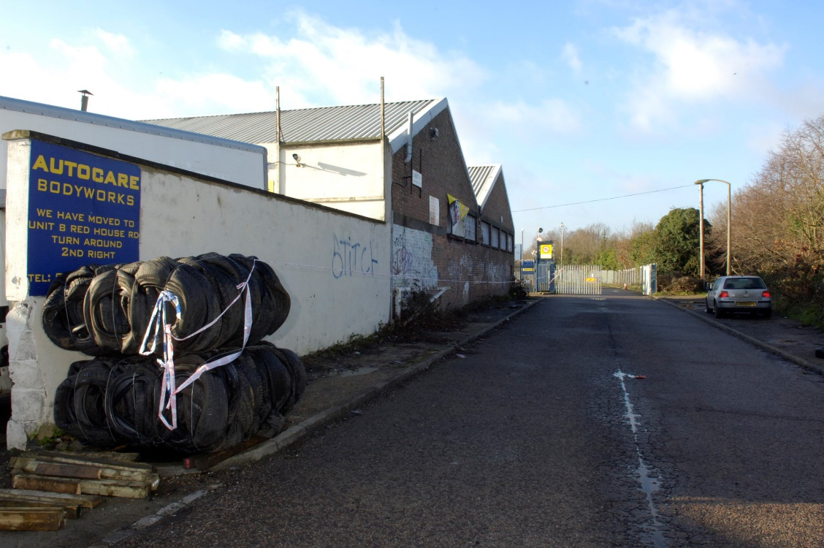
Figure 2 – Crime scene photograph, Oxford

In another paper, on crime scene photography (Banks, 2017), I developed an argument (following Elizabeth Edwards (2012) on the visual contours of the ‘no style style’) that crime scene photography – that is, official photographs taken for or by police officers at the scene of a crime – was characterised by its banality (Figure 2). The crime scene photographers I interviewed were adamant that there was nothing in their images that reflected anything that could be construed as an aesthetic sensibility. As far as they were concerned, the images they produced were entirely functional and neutrally descriptive of the ‘evidence’ they portrayed.

Figure 3 – Image taken from WhatsApp feed, original source unknown

At first glance, the ‘good morning’ memes are anything but banal – the photography is generally extremely artful, based on a stock image often employing highly saturated tones (or sometimes, moody sepia tones) and well-recognised principles of composition. It is meant to grab the attention in one’s news feed or WhatsApp conversations, after which the recipient or viewer can dwell on the often highly sentimental message. However, in this short paper, I want to argue that such memes are also banal, not least because of their ubiquity, yet at the same time they are perceived by both senders and recipients to be highly authentic.

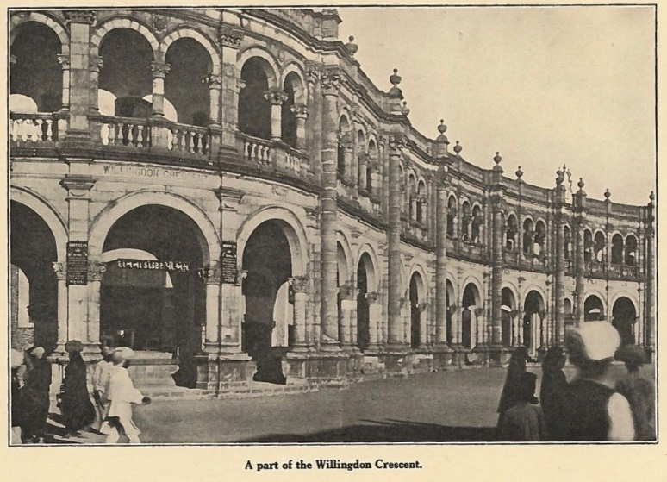
Figure 4 – Early twentieth century architecture in the city of Jamnagar, western India; photographer unknown

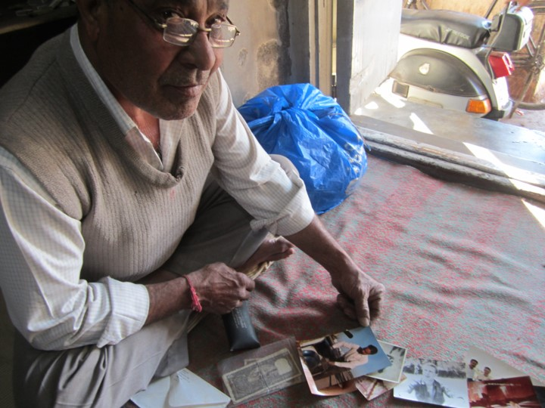
Figure 5 – Arvindbhai with his personal ‘archive’ of photographs accumulated over the years. © Marcus Banks

Photography in Jamnagar

First, some background. In spring 2017, I made a research trip to India, to my original PhD research site in Jamnagar, a medium-sized city in what is now Gujarat State, western India. The purpose of my visit was to conduct interviews around a set of photographs of the city taken in the 1920s when the city was undergoing a period of radical urban transformation. The changes were initiated by the then king of the city, Jam Saheb Ranjitsinhji, a famous cricketer, still talked of and loved today, though there can be no one alive today who remembers the transformations taking place. My research participants back in the mid-1980s (for a completely different project) were my age or older, and the majority of them were relatively prosperous cloth merchants, all men, although I also met many of their wives and children.
On my first visit to the city, and for many years subsequently, I was almost the only person I knew who owned a camera. With one exception, a cloth merchant called Chandrakant, no one I knew owned a camera (apart from professional wedding photographers who I encountered at the many weddings I attended). Furthermore, few people owned any hard-copy photographs apart from those in their own wedding album (where relevant) and perhaps a few studio photographs taken of themselves with family or friends to mark an occasion such as a birthday. There were a few cameras for sale in India in the 1980s, but they were expensive, as was film and processing. However, I think most of my research participants could have afforded a camera and associated costs if they had wished. As far as I can tell, cameras – and therefore photographic practice – were rare and unusual right through to the 2000s.
However, by around 2006, mobile phone sales had taken off (following economic liberalisation). In 2018, there were estimated to be around 775 million users – around half the total population. Many of these are smartphone users, but many more have so-called ‘feature phones’, a number that remained high as they were cheaper, have longer battery life, etc. Feature phones can send text messages, and many have a very basic camera. India is often presented as a country that has bypassed the personal computer and laptop: most consumers seem to have gone straight from being digital virgins (or having only encountered computers in school or college) to owning a smart phone and getting on the web.

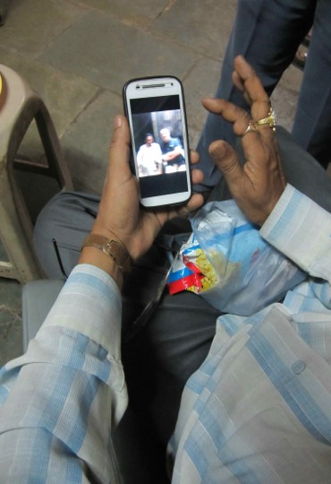
Figure 6 – Rakesh looking at a photograph messaged to him by Rajesh. © Marcus Banks

As well as the project on the historical photographs, on my visit to India in 2017, I also intended to conduct photo-elicitation exercises, using my own photographs from the 1980s and 1990s. For a variety of reasons which I explore in another paper (Banks, 2014), this project was not a great success. However, while in the field I decided to start interviewing people about the photographs on their own phones and to observe phone camera use. As elsewhere in the world, selfies are popular, though perhaps not so much with the generally older men I was interviewing. A couple of my research respondents commented that selfies were most popular with young women rather than men of their generation (which is generally understood to be the case in Europe and America). This may also be linked to the fact that few if any of my older male informants actually took photographs with their phones or sent them to their friends (it is entirely possible that young women do). What they did do however was to use their phones to view photographs, on Facebook for example.

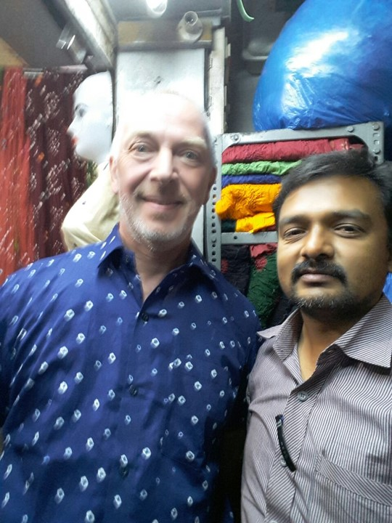
Figure 7 – Double selfie of author and Chirag. © Marcus Banks and Chirag Mehta

Younger men were more adventurous, however. For example, Chirag – a young cloth merchant (the son of Chandrakant, the only man I knew who actually owned a camera in the 1980s) – used my phone to take a selfie of the two of us together, and then requested that I send him a copy via WhatsApp (Figure 7). This was not because he wanted to hold a treasured memory (while he is Chandrakant’s son, we don’t know each other particularly well – he was a child last time I visited Jamnagar), or to share it with his friends, but because he wanted to use it for marketing purposes: he had sold me the cloth to make the shirt and wished to advertise it to his customers on his Facebook page. Unlike his cloth merchant father who has a shop nearby (and who also has a smartphone), he sells some ready-made garments, and also suggests novel designs to customers that can be made up – ‘stitched’ – at a local tailor’s shop.
For example, one morning when I was sitting at Chirag’s shop, some prospective customers arrived – a middle-aged couple from a nearby village and their daughter-in-law. The daughter-in-law was interested in a particular fabric and Chirag suggested she might like to have it made up into a ‘ladies’ shirt’ (he used the English phrase) rather than as a sari blouse (choli). By this he meant a fitted western-style shirt to be worn with a skirt or jeans, garments that have been fashionable in major Indian cities for several years now, but are not so common in socially-conservative Jamnagar, and even less common in the rural hinterland. The woman and her parents-in-law were confused by what he meant, however; in the end he took out his mobile phone and showed them pictures of ‘ladies’ shirts’ that he had had tailored locally, displayed on a mannequin.
The selfie Chirag requested from me shows me wearing a shirt I had ordered from him, stitched from a particular tie and dye fabric for which Jamnagar is historically very well known. This fabric – bandhani – is traditionally used for saris and women’s scarves: I was genuinely surprised when he told me that men now have the fabric made up into shirts, but I have always liked bandhani and was pleased that it was now acceptable for men to wear. As an aside, my sixty-plus friend Arvindbhai is a trader in traditional bandhani and was bemused by my shirt. This photo, taken by Chirag and WhatsApp-d to his phone, would stay on his phone to show the next person who enquired.
Like many others, Chirag made extensive use of WhatsApp, and in particular – like others I interviewed – he was a member of a WhatsApp group for members of his family. This way, family members, especially younger people who may have migrated for study or business to Ahmedabad, the state capital, or Bombay, or even overseas, could keep in touch. As I noted earlier, my older research informants, 60 and above, rarely if ever took photographs with their camera phones, but consumed photographs avidly, largely through Facebook and WhatsApp.
For example, in the course of an interview with Kishor, an informant in his 50s, his cousin Rajesh (a man in his 60s who was present) criticised his younger cousin for having only a feature phone, not a smartphone. Because Kishor didn’t have the WhatsApp app on his phone, he was not able to contribute to family WhatsApp exchanges. Although Rajesh himself rarely if ever took photographs with his phone and never posted self-made photographs to the group, he appreciated being able to see younger members of the extended family as they travelled, went to restaurants, and generally lived ‘modern’ lives. Although his cousin Kishor has, in some ways, a more ‘modern’ life than Rajesh – he travels extensively within the state of Gujarat selling auto parts, he travels on holiday beyond the state with his wife and children (rather than going on pilgrimage as older generations would have done) – his failure to engage with WhatsApp exchanges was seen as a failure of engagement with tradition by his older cousin. It might seem odd to criticise a ‘modern’ man for not being traditional enough, but what Rajesh was getting at was that ‘modern’ technologies such as smartphones, allowed ‘traditions’ (such as keeping in contact with kin) to be maintained.

Figure 8 – Screenshot taken from WhatsApp feed, original image source unknown

Figure 9 – Screenshot taken from WhatsApp feed, original image source unknown

Good morning!

Although he takes few if any photographs on his phone, Rajesh does make extensive use of his phone’s photographic capabilities. For various reasons, Rajesh has few face-to-face social contacts with family or friends today, although when I knew him in the 1980s and 1990s, he was at the centre of many overlapping networks of kin and friends. In 2017, he had a humble low-income ‘service’ job, and spent his evenings engaging with the wider world through his two phones, both smartphones: one for family and local friends (he is not married), the other for wider internet use. On the ‘family’ phone, he used WhatsApp and Facebook to keep in touch with family members and to take local telephone calls but, as noted, he did not take photographs to contribute to the familial WhatsApp chats. On his other phone, he used Google+ to search for inspirational memes which he customised by adding comments, in English, such as ‘How true!!!’ or ‘This is how [I] feel’, as well as – of course – ‘good morning’ (or more often, ‘good evening’), and then posting them to Facebook and to WhatsApp contacts (including myself). This searching for good morning meme images on Google is apparently causing concerns at Google HQ. Between sunrise and 8.00 a.m. in India, millions of images are downloaded and sent on, causing users’ phones to freeze and placing a heavy strain on Google’s servers. There are also rumours of Indian mobile phone networks crashing under the weight of all the ‘good mornings’ sent.
Rajesh has also somehow made contact with a number of (presumably) single women in Romania, and he and they conduct platonic relationships via WhatsApp and Facebook. They tend to send him head and shoulders photographs of themselves, along with ‘inspirational’ memes or photographs, and he in turn rebroadcasts these to his WhatsApp contacts and Facebook friends – including myself!
When I asked him about his ‘good morning’ habit, Rajesh said it was just something he liked to do. However, the Indian press is full of rather alarmist stories of the over-60s generation (Rajesh is 63) becoming ‘addicted’ to WhatsApp. Press stories contain accounts of adult children – who often live away from their parents in quasi-nuclear households – attempting to wean their parents off the ‘addiction’. WhatsApp was introduced to India in 2010 and has been a runaway success ever since, with more than 200 million active users. Rajesh said he sent ‘good morning’ and other memes to around ten other users each day, and received six to seven himself each day (as noted above, on his other phone, he followed family members through WhatsApp but did not participate). He had been using Facebook and WhatsApp for three to four years before 2017, about the time he became semi-estranged from his family. He didn’t often post in the morning, except sometimes on Sundays, because he was in a hurry to get to work, which was at some distance from his home, but typically, he came home from work around 9.00 pm, had something light to eat, and then hit his phones. He did not drink alcohol (Gujarat state is dry anyway), and he did not have a television, but he did smoke. His phones were his primary means of engagement with the world.

Figure 10 – Screenshot taken from WhatsApp feed, original image source unknown

When asked about his choice of images, Rajesh said they were either his choice, or re-postings of the memes of others. When I pressed him further, he said that all the pictures he sends are ‘true’ (saachun in Gujarati). As most if not all the images are clearly staged, they are most certainly not true in a conventional sense, but to Rajesh they were ‘true’ expressions of his feelings. He was prone to self-pity and many of the more inspirational texts seemed to be attempts to generate some optimism about his life. However, especially when sending memes to his Romanian friends, he tended to go for more upbeat images and themes, as he felt these friends (who he had never met and almost certainly never would) were ‘true’ friends, precisely because their friendship was disinterested and therefore ‘pure’ (swacch).

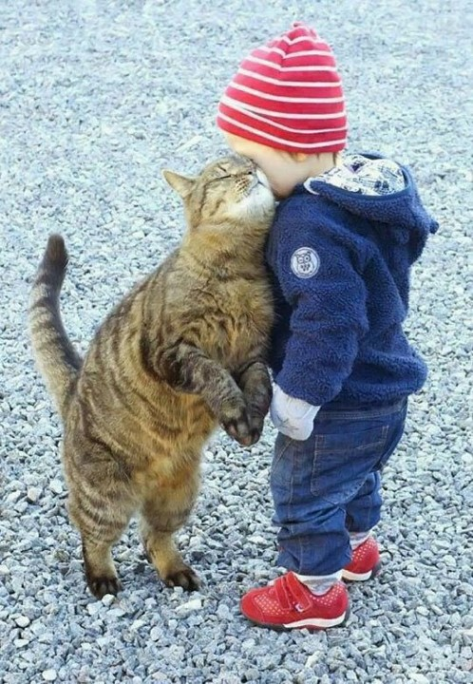
Figure 11 - Screenshot taken from WhatsApp feed, original image source unknown

Be happy

Rajesh was very conscious of his fallen circumstances, and slightly ashamed – at least in my presence – of the tiny, dilapidated two-room house he rented in the city centre. One could therefore hypothesise that he retreated into the colourful world of memes as a form of psychic escape, much as earlier theorists of Bombay cinema deemed it ‘escapist’, especially for the urban poor. However, more recent studies of cinema all around the world have shown that even in what seems to be such a passive medium, there is extensive engagement by audiences – whether during the screening, or in subsequent discussion, or both. Social media like WhatsApp and Facebook facilitate this engagement to a level previously unknown. We know from the work of Horst and Miller (2012), among others, that engagements with social media are complex and many-stranded: there is no single thing that social media ‘do’; rather, they are reconfigured according to the context.
Rajesh’s creative engagement with his phones allowed him to extend different aspects of his personhood into different social fields, including entirely new ones. The banality of the stock images and memes Rajesh used were precisely what attracted him. Although he did occasionally post photographs of himself, the one or two he used were studio shots taken in his early twenties, staring wistfully into the middle distance. Instead, on social media, he could be not anyone, but displayed aspects of what he considered to be his authentic self and what he considered to be authentic feelings: of platonic love, of friendship, and of a person who is meshed into wider networks of relationships.

Bibliography

Banks, Marcus 2020. Photography, memory, and affect: two fragments from the history of an Indian city, in Peter Aronsson, Andrej Slávik and Birgitta Svensson (eds.), Images in history: towards an (audio)visual historiography. Stockholm: Kungl. Vitterhets Historie och Antikvitets Akademien (Konferenser 99).

Banks, Marcus 2017. The significant banality of crime scene photography. Unpublished paper presented at the conference Visual South Asia: anthropological explorations of media and culture, University of Dhaka.

Banks, Marcus 2014. Slow research: exploring one’s own visual archive, Cadernos de Arte e Antropologia 3/2, 69 – 83. doi: https://doi.org/10.4000/cadernosaa.222.

Edwards, Elizabeth 2012. The camera as historian: amateur photographers and historical imagination, 1885-1918, Durham: Duke University Press.

Horst, Heather A. and Daniel Miller 2006. The cell phone: an anthropology of communication, New York and Oxford: Berg Publishers.

Horst, Heather A. and Daniel Miller (eds.) 2012. Digital anthropology, London: Bloomsbury.

This work is copyright of the author. Readers should note that the images are NOT included under the CC-license, but attributed to the rightful copyright owner.

It has been published by JASO under a Creative Commons Attribution-NonCommercial-ShareAlike License (CC BY NC 4.0) that allows others to share the work with an acknowledgement of the work's authorship and initial publication in this journal as long as it is non-commercial and that those using the work must agree to distribute it under the same license as the original. http://creativecommons.org/licenses/by/4.0/)

Institute of Social and Cultural Anthropology, University of Oxford
This previously unpublished posthumous paper was initially presented on June 8th, 2018, in a farewell symposium held in honour of Thomas Fillitz at the University of Vienna, entitled Art, Authenticity, Anthropology. A later version of the paper was presented in a conference at Worcester College, Oxford. Some core examples were initially presented in an unpublished paper entitled ‘Photography in and of the city: Three moments from the past and present of an Indian city’. Banks presented versions of this paper at the 2017 annual meeting of the Association of Social Anthropologists of the UK and Commonwealth (ASA) in Adelaide, the 2017 annual meeting of the German Anthropological Association (DGV) in Berlin, a 2017 departmental seminar at the University of Sussex, a 2018 Pitt-Rivers Museum Visual, Material, and Museum Anthropology seminar in Oxford, and a 2019 keynote at the Royal Anthropological Institute (RAI) Student Conference in Oxford. The current version has been edited by Chihab El Khachab, based on the Vienna and Worcester drafts and PowerPoint slides, with minor additions from different versions of the paper entitled ‘Photography in and of the city’. (Editorial note)
The general thrust of Rajesh’s memes and annotated photographs are (i) an appreciation of nature (highly manipulated shots of mountains, gorges, forests, and so forth) generally captioned by him with sentiments such as ‘So beautiful!!!’; (ii) ‘cute’ pictures of young children, generally not captioned; (iii) wistful images of women in shadowy profile, or couples walking through woods, often in sepia tones, with captions such as ‘Always trust those who make you smile’.
While the paper remains unfinished past this point, Marcus Banks is suggesting that memes elicit fragmentary representations of the self which, although shown as ‘authentic’, can never be integrally so. In other words, social media are neither an arena in which one integrally recreates oneself (i.e., by becoming ‘anyone’) nor an arena in which a pre-existing authentic self can manifest (i.e., by becoming ‘oneself’), but one in which different aspects of the self are displayed in ethnographically variable ways even when they are lived and felt as ‘authentic’. (Editorial note)

