MAKING ART, MAKING VALUE ONLINE: NFTS, BLOCKCHAINS AND ONLINE ART ECONOMIES

HEIDI COOKE

In recent years, cryptocurrencies have emerged as alternative forms of currency. These technologies were adapted to create Non-Fungible Tokens (NFTs), unique digital identifiers that can trace the provenance and ownership of online media. Despite often lacking property rights over the represented media, these tokens sell in large volumes online, and their supportive communities are vast and exist in both art and economic spheres. This paper explores the various communities that support NFTs from different perspectives. While NFTs have received significant media attention, this study aims to show that many aspects of the technologies and beliefs behind NFTs are grounded in earlier social movements, cryptographic techniques, and attitudes within art and economics. The digitisation of physical-world phenomena, such as the notion of an object biography (Kopytoff, 1986), is also recognised. NFTs’ provision of a restricted means for art to exist on a blockchain recalls Walter Benjamin’s (1936) concept of the aura. The paper also situates the history of blockchain technology within the context of cypherpunks, a 1990s punk-cryptography movement. The legacy of the cypherpunks and the new infrastructures and affordances that NFTs offer to the Internet are related to the values, communities, and future aspirations held by the online social networks that support NFTs. The paper argues that NFTs possess an affective force among these groups, allowing them to endure as enchanted digital sites of future promises despite constant threats of deception, volatile markets, and scams.

Keywords: Cryptocurrencies, economic, digital, NFTs, art

Introduction

A growing cadre of scholars is engaging in academic discourse surrounding Non-Fungible Tokens (NFTs) across art, economics, and anthropology. Concurrently, there has been a discernible uptick in conferences that specifically address NFT-related themes, signifying an emergent scholarly focus on this dynamic intersection of technology, economics, and cultural studies.
This paper aims to situate the communities which support NFT trading within anthropological understandings of economics and art. Through the subtleties of value creation using anthropological theories of circulation and exchange, this paper looks to understand the notions carried by people when it comes to the concepts of community, values, and future within online NFT marketplaces. The paper also explores the role of tokenisation in providing digital art with a certified uniqueness on the blockchain, and the implications of this tokenisation for the valuation of NFT art.
The first section of this paper aims to provide context to the study of digital anthropology, then moves to the history of anthropological studies of blockchain technologies, as well as a general recent history of large-scale NFT projects. While this paper mainly focuses on the values underpinning the communities that engage with mid-scale NFT projects online, I will briefly discuss the most famous, prestigious, and financially successful NFT projects to provide readers with context to the NFT market’s development. This moves to a consideration of the extent to which the value of an NFT anchors to the value of the underlying cryptocurrency that supports it. It concludes that while some correlation is expected, other dimensions exist to an NFT’s value. I use Arjun Appadurai’s (1986) collection ‘The Social Life of Things: Commodities in Cultural Perspective’, in particular Igor Kopytoff’s contribution to that volume, to consider how an NFT encodes an object’s history within itself. NFTs can also be understood within the context of anthropological work on art and enchantment, as NFTs recapitulate Walter Benjamin’s (1935) concept of an aura in an age of digital reproduction. The enchanting properties of NFTs are considered, drawing in Gell’s (1992) work on the enchantment of technology. NFTs are also linked to the growing phenomenon of AI-generated art.
As NFTs continue to reshape the landscape of ownership and creativity on the Internet, understanding the implications of their technology requires a multifaceted approach. This paper therefore explores NFTs using a hybrid methodology. This methodology entailed online fieldwork, interviewing with NFT creators, minting an NFT, and listing it for sale on a popular NFT marketplace. More on this is discussed in the ‘Making’ section of this paper.
The ethnographic discussion section provides a discussion on conversations had with approximately 30 people who make a living off creating and selling NFTs. This online research primarily took place through conversations with NFT creators on platforms such as Reddit, Instagram, and Discord, spanning a duration of 7 months in 2021 around the peak of NFTs in art excitement. Many of these conversations transitioned from platform-based chats to semi-structured interviews conducted via zoom. Within the NFT space, experimentation is encouraged, and novel applications, such as academic authentication via NFTs, were found to be embraced. The study also aims to underscore the evolving trust dynamics inherent in blockchain technology, where reliance shifts from traditional regulatory authorities to decentralised networks of users.
The discussion of this data is organised by three themes: the community, the values, and the future. Comprised of interconnected online networks, NFT communities track the trajectory of successful projects, gauging success through media exposure and substantial financial transactions. However, beneath the surface of the NFT landscape lies a sense of community spirit, a drive for experimentation, and an ethos towards shaping the digital landscape of the future. Many individuals within this community are drawn by the potential of NFTs to offer them stable incomes, a more meaningful livelihood, or even financial prosperity as they envision a future defined by the Internet.

From Penny Presses to NFTs

Most visitors to a museum or tourist attraction will probably have encountered a penny press. These work by operating two rollers to deform and flatten a standard coin to impress a new image onto it. The value of the subsequent coin is no longer equivalent to that of the penny initially inserted into the press, the ‘pressing’ rendering it unusable as currency. Instead, the penny acquires a new value, serving as a form of memorabilia, an aesthetically pleasing object, or, in some instances, a collectable or saleable item.

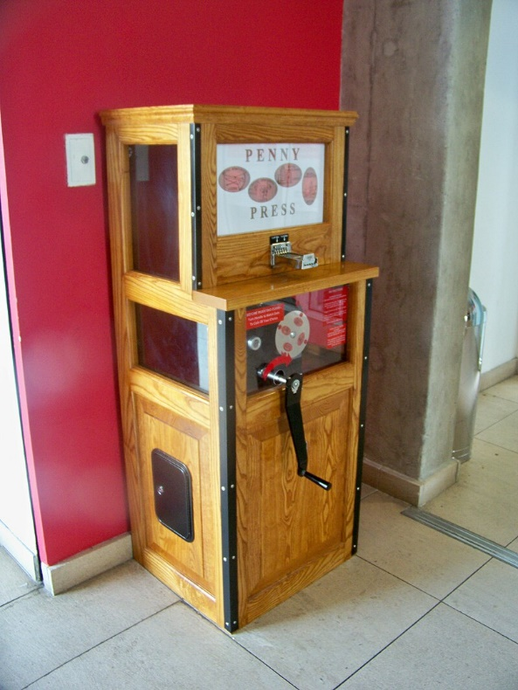
Figure 1: A Penny Press at the Royal Armories Museum (Leeds, UK). Wikimedia Commons. Mtaylor848. 24 June 2010. (Retrieved 15/02/2022.)

Creating a Non-Fungible Token, or ‘NFT,’ is similar to using a penny press. A cryptocurrency is used instead of inserting a coin, most commonly the cryptocurrency Ether or ETH. Unlike the production of elongated coins with a limited selection of designs, an NFT produces a unique token tied to a digital asset, such as a photo, video, or audio file. The applications of NFTs vary widely, with some projects acting as certificates that point to externally stored objects, while other projects are held entirely ‘on-chain’, with the NFT representing an image stored within the smart contract itself. Most of the projects mentioned within this paper represent the latter of these two cases.
A more detailed discussion of the origin of NFTs and their underlying technologies will be presented later in this paper. As is typical for most artwork sales, often purchasing an NFT does not confer any rights to the intellectual property associated with the asset represented by the NFT. For example, purchasing the NFT of the world’s first tweet for $2.9 million, as Malaysian businessman Sina Estavi did in March 2021 (Harper, 2021), does not prevent others from viewing, copying, or using the tweet. Anyone can access the tweet by making a Twitter account or searching for it on a web engine. Nevertheless, only one person, Sina Estavi, can claim ownership of that particular NFT of the world’s first tweet.

Digital anthropology

The field of digital anthropology emerged in the late 1980s and early 1990s when anthropologists became interested in the potential of interactive multimedia, made possible by technologies such as personal computers and CD-ROMs (Pink, 2011: 209). This interest led to the establishment of institutions such as the Centre for Social Anthropology and Computing at the University of Kent. After the dot-com bubble burst in the early 2000s, the enthusiasm surrounding digital technologies subsided but was later met with a renewed interest after the rise in popularity of Web 2.0 post-2004. This new age of the Internet led to the development of digital ethnography as a theory and method for studying the digital world, and several handbooks were published on the topic. Today, digital anthropology is a growing field that offers a comprehensive view of how digital technologies intersect with society.
One approach to digital anthropology emerged from material culture studies (Miller, 2018). Researchers in this field examined how the proliferation of material goods associated with consumer culture accelerated further with the emergence of digital technologies. A material culture studies approach to digital anthropology emphasises that even phenomena that take place predominantly online, such as NFTs, cannot be regarded as immaterial since digital activities are subject to cultural differentiation and are facilitated through physical interfaces (Horst and Miller, 2012). There is a significant overlap between this approach and previous studies of the social aspects of money. The introduction of digital technologies in capitalist markets around the 1980s led to an explosion of finance capitalism. In more modern years, digital technologies gave rise to new forms of abstracting money, such as mobile phone-based money systems such as M-Pesa, and later blockchain-based cryptocurrencies (Maurer, 2015).
Horst and Miller (2012) proposed a definition of the digital as anything that can be represented with binary code based on the historical precedent of decimal systems of modern money. They argue that debates on the consequences of money can help us understand the effects of digital technologies on human sociality. They draw on Simmel’s (2011 [1900]) The Philosophy of Money to support this. Within Simmel’s theories, money creates sources of alienation as it abstracts practically anything to the same common element, which enhances freedom but leads to a cognitive separation of people from objects. This line of thinking can be applied to the digital, where reproduction and abstraction occur at the speed of our Internet connections. The digital age has brought us ‘too much culture’, which we need help managing or engaging with properly. On the other hand, the digital also offers solutions to problems of alienation and abstraction, as new money-like schemes such as cryptocurrencies propose exchange systems outside of mainstream capitalist markets which are claimed to be more democratic and humanistic than ‘the market’.
Another key aspect of digital culture studies relevant to an understanding the rise of NFTs is the concept of ‘digital prosumption’. Beer and Burrows (2010) describe the concept of the digital prosumer as a critical part of Web 2.0. They argue that new participatory web cultures, characterised by user-generated content, rating, reviewing, and collaboration, break traditional boundaries between producers and consumers. The concept of the prosumer informs the everyday lives of millions of people. Beer and Burrows draw on Bauman’s (2007) idea of a confessional society, where contemporary consumer cultures are part of a society with a sense of obligation to lead their private lives in the public domain. This, combined with digital prosumption, has led to the proliferation of data becoming available for capitalist industries to use. However, with scandals surrounding data breaches becoming increasingly regular, there is a demand for more private and trustworthy digital infrastructure.
It is expected that there will be a Web 3.0, which some believe is currently in development. This term was coined by Gavin Wood in 2014 to describe a World Wide Web distinguished from its predecessors by the decentralisation of data through the widespread use of blockchain technology. For many of its adherents, this new age will mark the end of ‘Big Tech’s’ monopoly on data and content, and NFTs are viewed as an appendage of this new turn.

The rise of cryptocurrencies

Privacy is the power to reveal oneself to the world selectively.
(A Cypherpunk’s Manifesto, Hughes 1993)

Bitcoin, the first cryptocurrency, was created by a group of politically motivated hackers. These individuals, under the name of the ‘cypherpunks’ advocated for using cryptography as a means to protect individual liberties from governmental interference (Dodd, 2014). The philosophy of this group included a mistrust of centralised social institutions, particularly the state (Shaw, 2023). The original mission statement written by cypherpunk Timothy May, takes privacy protection to be a fundamental right that should be secured using technology, as opposed to legislation (May, 1994). The concept of a cryptocurrency, aimed to be the world’s first entirely technologically secured payment system, was first proposed by cypherpunk Wei Dai (1998), while the smart contract, an early precursor to NFTs, was developed by cryptographer Nick Szabo.
In 2009, an individual under the pseudonym Satoshi Nakamoto announced the first official cryptocurrency paper on a cryptography mailing list. This new open-source online currency system, Bitcoin, would be decentralised, enabling direct connections between currency holders without the need for a third-party intermediary, such as a bank or government (Nakamoto, 2009). As Bitcoin gained attention throughout 2010 and 2011, many people became excited about its potential to offer payments that would elude bank interference and state surveillance (Maurer et al., 2013: 2-3). This excitement was fuelled by the belief that money could and should be abstracted from social life, particularly social institutions, to avoid potential manipulation, exploitation, and inflation dynamics (Dodd, 2018: 39). Monetary reform was seen to contribute to social reform, and Bitcoin offered an elegant technical solution towards this end. As Nakamoto’s paper says:

Commerce on the Internet has come to rely almost exclusively on financial institutions serving as trusted third parties to process electronic payments. While the system works well enough for most transactions, it still suffers from the inherent weaknesses of the trust-based model.
[…]
What is needed is an electronic payment system based on cryptographic proof instead of trust, allowing any two willing parties to transact directly with each other without the need for a trusted third party. (Nakamoto, 2009: 1)

Cryptocurrencies promise to provide a means of value transfer and exchange with minimal social interference through machine code. This code operates through an ingenious solution to the double-spending problem, which refers to the challenge of preventing opportunists from spending the same digital money twice. Before Nakamoto’s solution, all online payments required validation by a third party to regulate digital money supply. Bitcoin avoids the need for a centralised third party through a decentralised verification system. The system harnesses the combined processing power of computers worldwide to record every transaction to date in a database shared by all nodes on the network. Every ten minutes, all the transactions from the preceding period are grouped into a block, which is then linked to the previous blocks to form a chain. Each block contains a cryptographic puzzle that validates the entire chain every time it is solved. The puzzle can only be solved by trial and error (also known as brute force computing). The node that successfully solves the puzzle starts a new block by submitting its proof of work to the network and receives the ability to create a fixed amount of bitcoin for itself as a reward. Mining is the term for the computationally demanding process of solving the brute force puzzle, which becomes more challenging over time, requiring increasing computational power to decipher.
Bitcoin’s value can be understood using what Maurer et al. (2013) call ‘digital metallism’, a concept taken from Ingham’s ‘practical metallism’ theory, which describes how commodity money theories naturalise the social relations of credit that make money (Ingham, 2004). Encoded within Bitcoin is a virtual scarcity that limits the number of Bitcoins that can ever exist to 21 million. Maurer et al. argue that understanding Bitcoin’s value relies on the semiotics of metallic money, referencing mining, rigs, and the natural limits of Bitcoin. This makes the currency more akin to a commodity than a currency. While the value of Bitcoin could be changed easily by doubling the supply of coins, it is a necessary social construct that this could never happen (Dodd, 2014).
As a result, there are inconsistencies between Bitcoin as a currency for an individualistic, privacy-based world and the social project required to establish and support the money (Dodd, 2018). Bitcoin may initially seem more trust-free than it is. It does not operate above social relations, as a team of people actively supports the currency by mining it, developing its software, investing in it, and exchanging it. The currency relies on the ability and incentives of miners to process transactions, individuals who support the source code, and the community’s trust in the technology and process (DeVries, 2016). Therefore, in the case of cryptocurrencies, machine code has not replaced social relations of exchange but has instead merged with them (Hayes, 2019: 50-51).
Working in parallel to the development of Bitcoin, another cypherpunk named Nick Szabo imagined a new kind of exchange during the late 1990s. His concept was to be able to transfer property rights over encrypted computer networks, which would avoid the threat of a state’s ability to destroy or confiscate property and its corresponding records, especially during times of political instability (Szabo, 1997). Szabo’s solution combined cryptography developed in the 1980s with new advances in replicated database technology, allowing the secure maintenance and transferal of ownership for a wide range of property types. This concept laid the groundwork for the blockchain – a decentralised and digital public ledger that maintains every transaction conducted in the network chronologically (Jervis, 2019).
In 2013, a Russian-Canadian programmer named Vitalik Buterin wrote a white paper outlining a new cryptocurrency known as Ether, held on the Ethereum blockchain (Buterin, 2013). Ether complemented Szabo’s idea of using smart contracts to encode property legislation online. It is a complementary currency to Bitcoin, allowing for the blockchain registration of a wide range of contractual clauses. Ether is mined in the same way as Bitcoin, and miners receive rewards for mining new blocks and transaction fees known as ‘gas’. Tokens are always built onto a standard. The standard provides essential functions required for a token asset to be held and transferred – it has a name, a total supply, and a function that returns a given account’s balance and permits transfers to another Ethereum ‘wallet’. These tokens are always linked to an address (a string beginning with 0x and 40 hexadecimal), which can own multiple tokens and Ether (needed for gas payments to perform operations using the tokens). The owner of the address must retain a private key to control their assets, and while the balance of an address is public, this does not mean that the owner is necessarily known.
The standard onto which the first Ethereum tokens were built is called ERC-20. Unlike the later non-fungible tokens (NFTs), tokens built onto ERC-20 are fungible, meaning that they can be split just as a pound sterling can be split into 100 pennies (Chohan, 2021). The concept of non-fungible tokens (NFTs) was later introduced onto the ERC-721 standard (Chohan, 2021). This standard allowed for tokens to be unique and have values that differ from other tokens in the same contract, such as age, rarity, or visual appearance. ERC-721 was proposed in January 2018 by William Entriken, Dieter Shirley, Jacob Evans, and Nastassia Sachs.

First History of NFTs

The following section provides a brief overview of the history of NFTs through a condensed discussion of some NFT projects which have attracted particular attention from the media before 2023. The following projects were chosen as they represent large-scale, famous and (primarily) generative art projects, which can be helpful to characterise the head of the ‘long-tail’ of the NFT market. However, these examples were not an exclusive list of NFT projects to choose from.

CryptoPunks

In 2017, Matt Hall and John Watkinson, the founders of a New York-based software company called Larva Labs, created a computer program that could generate 10,000 24x24 8-bit style pixel characters, each with a unique combination of distinctive traits which varied from beanies and mohawks to blue faces and buck teeth (Davis, 2021). These were the CryptoPunks, arguably the first art-collectible project to hit the NFT space. Each punk is an NFT, held on the blockchain, and since their release in June 2017, they have been traded, and their value skyrocketed. In May 2021, a collection of 9 punks sold at Christie’s for around $9 million (Kastrenakes, 2021).

CryptoKitties

A little while after the CryptoPunks came the CryptoKitties, a blockchain game that allowed players to buy, collect and breed virtual collectable cats. Each CryptoKitty is an NFT with a unique ‘genome’ defining its appearance and traits. Players must purchase Ether to join the game and spend it to breed and trade CryptoKitties (Dapper Labs, 2022). Canadian studio Dapper Labs developed the game in November 2017. By December of that year, the game had reached such popularity that the volume of transactions made for CryptoKitties congested the entire Ethereum network (BBC News, 2017).
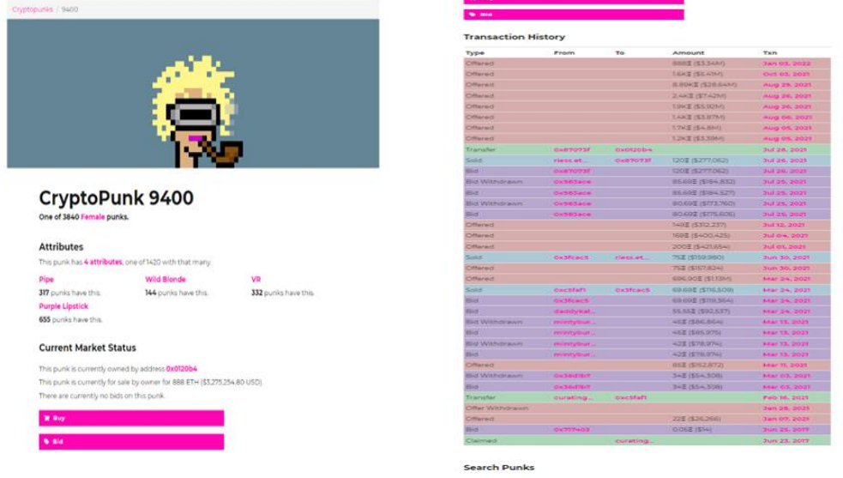
Figure 2: Two Screenshots taken from https://www.larvalabs.com/cryptopunks/details/9400. 03/01/2021 - 20:45 GMT. Detailing the attributes and transaction history of Cryptopunk 9400. Images reproduced with permission from Larva Labs.

Decentraland and Open Sea

The successes of the CryptoPunks and CryptoKitties projects led to a rise in cryptographic collectables in the NFT space following 2017. Another widespread use of NFTs came about with the sale of NFT-based digital real estate hosted on platforms such as Decentraland. Decentraland is an online world and community where users, much like traditional virtual worlds such as Second Life, can interact with each other via an avatar and participate in online events (Marquez, 2021).
The ability to trade within virtual worlds is not a particularly novel feature. In traditional virtual worlds from the early 2000s, such as Second Life, avatars can trade items within the game’s economy. However, unlike traditional virtual worlds, nearly everything in Decentraland is an NFT that can be bought and sold as real estate. In other words, within virtual worlds such as Second Life, records of user ownership are held on a centralised server specific to the world itself. In contrast, a platform such as Decentraland holds its ownership records on the Ethereum blockchain. Keeping these records on the Ethereum blockchain has advantages as users can verify ownership of goods independently and can also trade goods bought on Decentraland on third-party marketplaces.
2017 brought yet another milestone for the NFT scene with the launch of OpenSea – currently the largest NFT marketplace - where NFTs of art, collectables, domain names, music, photos, trading cards, virtual real estate, and game items are traded online (OpenSea, 2017).

The growth of the market in 2020

The NFT space reached unforeseen heights in July 2020, when the market experienced dramatic growth, with a total volume of NFTs exchanged daily on major platforms surpassing $10 million in March 2021 (Nadini, et al., 2021: 2). In the same month, a digital artist known as Beeple sold an NFT of his work ‘Everydays: The First 5000 Days’, a collage of 5000 digital images created for his Everydays series (a project producing a work of art daily for 5000 days), at Christie’s for $69.3 million (Reyburn, 2021). This was the third-highest auction price achieved for a living artist after Jeff Koons and David Hockney. The work was purchased by Singaporean programmer and cryptocurrency investor Vignesh Sundaresan, known under the pseudonym MetaKovan.
The profitability of NFTs also attracted many celebrities, who began to create their own NFTs and bought into a project known as Bored Ape Yacht Club (sometimes abbreviated to BAYC). BAYC is a collection of 10000 NFTs, costing a minimum of $ 200,000 to buy, which was launched in April 2021 by four pseudonymous developers (Yuga et al., 2021). Bored Ape Yacht Club represents a kind of NFT known as PFPs – or profile pictures – as they are popularly set as the social media profile pictures of celebrities who have purchased them. The project signalled the lucrative nature of the NFT market for digital art and digital collectables. It inspired even more to enter the long tail of creating their own NFT projects.

The legacy of the 2021 cryptocurrency crash

In 2021, the cryptocurrency market experienced a very significant downturn, which was triggered by a combination of factors, including concerns over inflation and rising interest rates, as well as national crackdowns on local cryptocurrency mining and trading (Smith, 2022).
One of the most notable events during this market crash involved FTX Trading Ltd., a popular cryptocurrency exchange that saw its token (FTT) drop by over 40% in just a few hours (Sigalos, 2022). Following the FTX crash, the NFT market saw a sharp price decline, with some NFTs losing over 50% of their value (Huang, 2022). This was due in part to the fact that many NFTs had been bought using cryptocurrencies that lost significant weight during the market crash.
Overall, the FTX market crash served as a reminder of the volatility of the cryptocurrency market and highlighted the risks associated with leveraged trading and other high-risk investment strategies. On the other hand, this crash and the gradual rebuilding of the NFT market following November 2021 can also be seen as a reflection of the changing nature of art and value recognition. The fact that NFTs are decentralised and can be traded on a global market has led to new opportunities for small-scale speculative NFT traders to participate in the art market and potentially profit from their investments.

NFTs within economic anthropology

Figure 3: Minting and purchasing an NFT.

Creating an NFT involves an ‘input’ of a certain amount of cryptocurrency known as ‘gas’. The amount of gas required to create an NFT depends on the number of users on the Ethereum network at a given time, and this gas fee constitutes a transactional fee that goes to the miners in addition to the rewards they receive for cracking the code to produce a new block on the blockchain. NFT creators often refer to the gas as ‘fuel’ rather than payment, as they talk about how gas is ‘burned’ during the creation of an NFT. The value of an NFT is partly understood as the value of the digital money that is burnt up during its creation.
There is a discussion on the extent to which the economic value of NFTs is parallel to the value of the cryptocurrencies that support them (Dowling, 2022; Ante, 2020). While there are some similarities, such as the likelihood that the value of an NFT will increase if the value of Ether rises, this is only part of the picture. An NFT has a double value.
Arjun Appadurai’s (1986) work, The Social Life of Things: Commodities in Cultural Perspective, can help us understand the double value of NFTs. Appadurai’s collection of essays proposed a new perspective on commodities and their circulation in social life by focusing on how goods and objects may adopt (and lose) a particular role as a commodity. Commodities, defined by Simmel (2011 [1900]) as objects of economic value, generate value during exchange. In other words, the value given to an object is culturally determined by the spheres of exchange in which they circulate. Things create value off the back of the politics and social barter of trade, and in this sense, they can be thought to have social lives.
The production of commodities is also a cultural and cognitive process. Kopytoff (1986), in the same volume of essays, notes that objects are fashioned out of materials, but they must also be categorised as a particular kind of object. Kopytoff also notes that only some objects are considered commodities. A thing may be a commodity at one point and not at another, as objects can move in and out of a state of commodity - a point where its exchangeability for another object is a relevant feature, and a point where it is not.
Within cryptocurrencies, there is constant slippage between the currency and commodity state. NFTs, on the other hand, fix digital assets as commodities, held suspended on a blockchain ledger. Beyond the value of the cryptocurrencies burned in minting an NFT lies the value of how human interactions with NFTs make digital assets meaningful within their social worlds. These NFTs have object biographies, called ‘provenance’ in the conventional art world, following Appadurai’s theories.
We can bring further detail into our economic study of NFTs by considering Kopytoff’s argument that it is possible to follow an individual object’s ‘life history’ as it moves back and forth between different regimes of value - value as commodities and value as unique objects. As Kopytoff writes, following Durkheim (1912), societies commonly set apart a particular portion of their environment, singularising it and marking it as sacred (Kopytoff, 1986: 72-80). In so-called ‘complex societies’, there is a yearning for this kind of singularisation, as people seek new ways to collect objects, such as matchbooks, comic books, or old beer cans. This yearning leads us to designate particular objects as unique. Unique objects like heirloom jewellery have a history and often a name. Further elements, such as the history of ownership and the social identities of the giver and the recipient, often become entangled within the object. These histories and identities are essentially the source of the object’s value. NFTs have a commodity aspect, but their uniqueness is also a fundamental value component. Built within their architecture is a life history that anyone can access, a certifiable stamp of one-ness, and the ability to create smart contracts so that the spirit of the original seller may be recapitulated throughout time as resale profits inevitably work their way back to the NFT creator.

NFTs in the age of digital reproduction

The recent surge in the popularity of NFTs can be attributed to their introduction to the digital art world. Beeple’s groundbreaking sale at Christie’s in 2020 sparked a wave of digital artists and photographers tokenising their works for sale.
In popular perception, art is often equated with beauty. However, studies within and beyond anthropology have demonstrated this is an poor definition of art, as notions of beauty are highly culturally and temporally contextual (Clifford, 1988: 200; Ingold, 1996: 210). The question of what defines art, if not the pursuit of beauty, has been long debated, but for this paper, I will adopt the institutional and not entirely unproblematic definition of art popularised by Gell (1996) - that artworks are things which the ‘art world’ deems to be such. These ‘art worlds’ - a term coined by Becker (1982) - are the cooperative networks through which art happens, and they are responsible for the patterns of collective activity leading to the production and consumption of art (Becker, 1982: 23).
There are three general uses for NFTs, one of which is as art objects, what Franceschet et al. term ‘crypto art’ or ‘rare digital art’ (Franceschet, et al., 2021 (2019): 3). These are limited-edition pieces of collectable art, made to be tokenised and registered on a blockchain to be sold. I distinguish these NFTs from those made for other purposes, such as for utility in online gaming platforms or as part of a cryptographic speculative project. These digital artworks are typically sold at digital auctions and may even be hosted on online NFT galleries such as SuperRare and KnownOrigin.
Even so, ‘crypto art’ pieces do not neatly fit into traditional definitions of art objects, as they are often generated using artificial intelligence (AI) algorithms. AI art represents an intersection between art, technology, and science, and raises questions about the nature of creativity, authorship, and aesthetic experience in the digital age. The origins of AI art can be traced back to the 1960s and 1970s, when computer scientists and artists began experimenting with early forms of computer-generated art (McCorduck, 1991). However, it was only in the development of deep learning algorithms and other advanced AI technology in the past decade that AI art began to attract wider attention and recognition. AI art can take many forms, from generative algorithms that create new images or music based on predefined rules or patterns to machine learning systems that analyse and classify images to interactive installations that respond to the movements and actions of viewers. Some AI artists work collaboratively with AI algorithms, while others use AI as a tool to augment their artistic practice. NFTs offer a new way for AI artists to monetise their creations and establish their value in the art market. By creating NFTs that represent unique digital artworks generated or manipulated by AI algorithms, AI artists can prove ownership, authenticity, and provenance for their works in a way that was not previously possible. At the same time, the use of AI in art raises important questions about the role of technology in the creative process and the relationship between humans and machines in artistic production. Some critics argue that AI art threatens human creativity and artistic autonomy. In contrast, others see it as a tool for expanding the boundaries of creative expression and pushing the limits of what is possible in the digital age (Edwards, 2022).
The intersection between creative and technological interfaces found in the NFT-AI art debate recalls Alfred Gell’s concept of the enchantment of technology. In his work, Gell introduces the study of art as a technical system used by cultures to ‘dazzle’ and ‘enchant’ the viewer (Gell, 1992: 43). Gell draws on ethnography from the Trobriand Islands, where canoe boards are intricately carved for use in Kula exchange. These boards are beautifully decorated and skilfully carved to act as a psychological weapon to persuade Kula partners to, as it were, take leave of their senses and give generously during the exchange (Gell, 1992: 50). The skill required to produce such a board is viewed and expressed as magical power. Gell argues that we can apply this theory of art cross-culturally and that technical processes can make us see the world in an enchanted way, leaving us somehow dazzled and making the products of technology seem like vessels of magical power. We could conceive of the technology behind NFTs as dazzling and enchanting. Given that purchasing an NFT does not buy any intellectual rights over the asset the token represents, what would induce anyone to spend money on one?
Walter Benjamin tackled the issue of reproduction a long time ago, specifically concerning photography, when he introduced the term ‘aura’ to define the unique unity of place and time that even the most perfect reproduction lacks (Benjamin, 2008). Although artworks have always been reproducible in principle, the advent of lithography and photography in the 19th century accelerated the processes of pictorial reproduction enormously. This newfound scale of reproduction enabled copies of original works of art to be placed in situations that previously were out of reach for them. Benjamin argued that this led to the detachment of the reproduced object from the domain of tradition, substituting the unique existence of a work of art in a gallery, home, or studio for a plurality of copies (Benjamin, 2008: 223).
Benjamin contended that a perfect reproduction of a work of art lacked its aura, its presence in time and space, and its unique existence at the place where it happens to be. This presence is crucial to the concept of authenticity. Prior to mechanical reproduction, art objects were associated with a kind of ritual appreciated on two different poles: its cult value (the art object as a symbol for veneration) and its exhibition value (the object as something to be displaced and appreciated) (Benjamin, 2008: 235). The cult value of an art object demanded that it remain hidden from view. For reproduced art, the exhibition value eclipsed its cult value, as the maker had very little control over the audience who engaged with the work.
Benjamin’s critique was of the cult of authenticity rather than a defence of the aura of the authentic. He argued that reproducing everything so people could see great works of art was taking away the values of authenticity and was typical of the modern era. However, despite Benjamin’s prediction that mechanical reproduction would help end the cult value of art, the concept still matters in contemporary art worlds, for example, in the case of NFTs sold at Christie’s. Maintaining a scarcity of supply has always been a problem for the marketing of digital art. While the issues of mechanical reproduction and authenticity were undoubtedly of great importance to the art worlds of Benjamin’s time, these issues pale in comparison to the problems raised for the marketability of digital art in an age where perfect digital reproductions can happen in a matter of seconds using a computer. Before the development of NFTs, galleries solved this problem by producing a certain number of limited-edition copies (a system already used in photography). However, the advent of crypto art introduced a way to establish verifiable ownership, scarcity, and provenance for digital artworks through blockchain technology.
To return to Gell’s work on art and enchantment, the technology of NFTs dazzles and enchants the viewer by situating a work of art in time and place on a blockchain ledger. For the first time in history, digital art can have an aura.

Making

This section describes my attempts to mint an NFT. This was inspired by Tim Ingold’s approach in his 2013 book Making: Anthropology, Archaeology, Art, Architecture, in which an understanding of the materiality of things can be gained through a philosophy of phenomenology, corresponding with the world by ‘thinking through making and learning by doing’. In doing so, we are drawn to take our focus away from already-formed objects and their consumption to look instead at the processes behind their production.
Before making my NFT, I first needed to consider the digital asset I wanted to tokenise. I decided to use an asset that I already had ready to hand – a form I had produced and had approved by the University of Oxford’s Central University Research Ethics Committee (CUREC). This was used for the NFT creators I would interview to provide informed consent to speak to me and for their data to be used in my research. Specifically, I decided to mint my ‘Study Information Sheet’, outlining my research’s purposes and potential risks, as an NFT. The production of an NFT version of my study information sheet cemented the research in time and place on the blockchain and made it freely accessible to anyone.
The next step was to choose a marketplace to mint and list my NFT. While each marketplace offers its own merits, I decided to pick the largest and the one I was most acquainted with: OpenSea. In addition to a marketplace account, a wallet is needed to access the blockchain. The wallet must also be connected to the marketplace account. I set a wallet up with a popular Ethereum wallet called MetaMask.
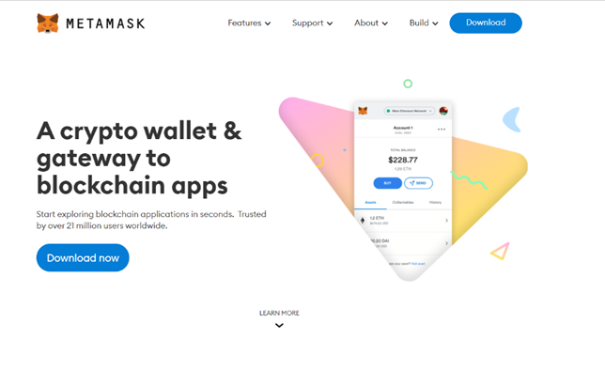
Figure 4: A screenshot taken of the MetaMask homepage. 03/01/2021. https://metamask.io

It is important to note that, like most cryptocurrency wallets, MetaMask will not have any knowledge or database of you or any of their other customers. In addition to a password, you are provided with a 12-word backup phrase known as a seed phrase. This phrase is of the highest importance to the security of the wallet. It must be kept both entirely private and entirely secure, as if it is lost, your funds inside the account will become inaccessible.
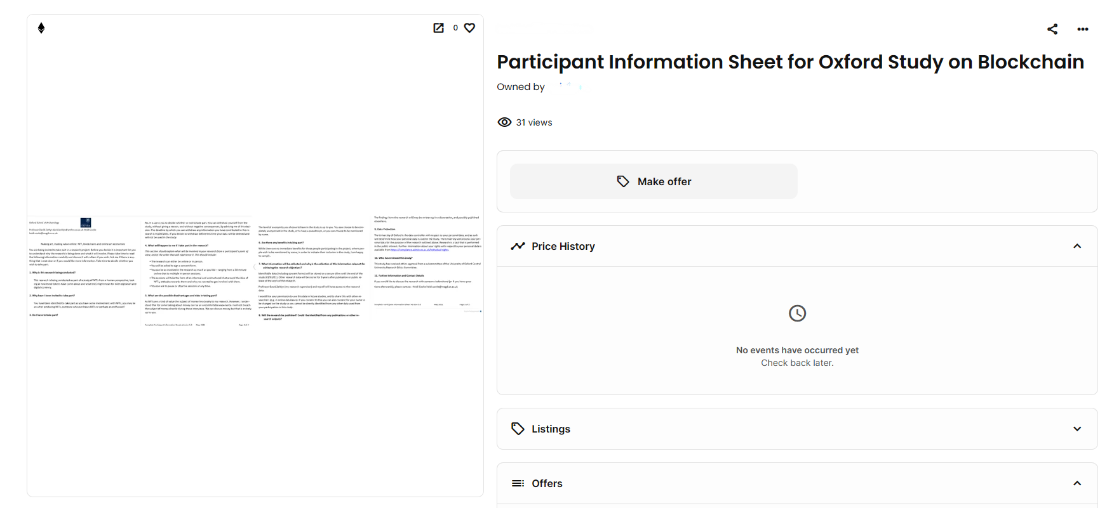
Figure 5: Participant Information Sheet for Oxford Study on Blockchain.

To mint NFTs, cryptocurrencies such as Ether are used. The process involves sending Ether from a cryptocurrency exchange account to a wallet, such as MetaMask. The wallet can be linked to a marketplace account, which enables the creation of NFTs using the marketplace website. Once an asset is uploaded, various details can be added about the NFT collection, including the name, logo, description, category (such as Art, Collectibles, Photography, Sports, Trading Cards, or Utility), links to websites or social media handles, and royalties from future sales. The NFT can be minted using a chosen blockchain and currency. After minting, the NFT can be listed for sale, which involves fees on OpenSea and gas fees for cryptocurrency transfer. The fees may vary widely, and a one-time fee is required to initialise the account.

Speaking to people online

After creating an information sheet and learning the basics of how to create Non-Fungible Tokens (NFTs), I then undertook some online ethnographic research by speaking to NFT creators. Most of the data was collected by initially contacting NFT creators on social media platforms such as Reddit, Instagram, and Discord. I spent 7 months conducting these interviews, with some chats remaining on the platforms, while others moved to semi-structured interviews via Zoom.
To begin a dialogue with people online, I found the CUREC form to be a valuable tool. Due to the prevalence of scams and spam messages in the NFT creation community, it was difficult to gain the trust of people. However, providing a link to an OpenSea page with clear guidelines about my study helped convince people that I was not a scammer. From my time spent in the NFT space, I learned that it is constantly evolving and breaking new ground as the crypto world evolves. The experimental use of NFTs to verify academic authenticity and ethical credibility was welcomed by members of the community.
Blockchains require a new kind of trust. Bitcoin and other blockchain-based technologies represent a shift away from trusting the government to regulate behaviour. Instead, behaviour must be regulated (or not regulated) by those using these technologies.
To gain the trust of people in the NFT community, extensive networking on social media platforms is required. Cryptocurrencies and NFTs were born out of these social network communities, which is why I chose to conduct my research online using social media platforms.

Community, values and future

With nothing but a laptop and a minted NFT of my participant information sheet, I started to venture into the world of NFTs and quickly felt utterly out of my depth. I started by exploring the r/NFT subreddit, a popular forum on the content rating and discussion website Reddit. This subreddit is mainly filled with new NFT creators showcasing their latest NFT creations and advertising their projects. I used these posts as an opportunity to connect with creators. However, after a few months, I shifted most of my interactions to Instagram, an image-based social media platform with a more sophisticated built-in chat function than Reddit.
Instagram is a popular platform where NFT creators and project managers post their collections and highlight their sales success. Discord, another top-rated platform for NFT traders, offers instant messaging, voice calls, and file-sharing. Communities are divided into different servers, making it easier to interact with NFT creators.

The community

Replied to you:
> Networking is key, it’s impossible for your work/art to be ‘found’ by chance because there are a lot of people now on the NFT space, you need to do the work, and talk the talk
> Much like in academia you need to go to conferences and workshops and then you meet your peers that hopefully have the same interests or field of research as you, then you make articles together and cite each other in your work
> Same but with art. You go to virtual galleries, hackathons etc and you collab with them
(Online chat with anonymous NFT creator, September 2021)

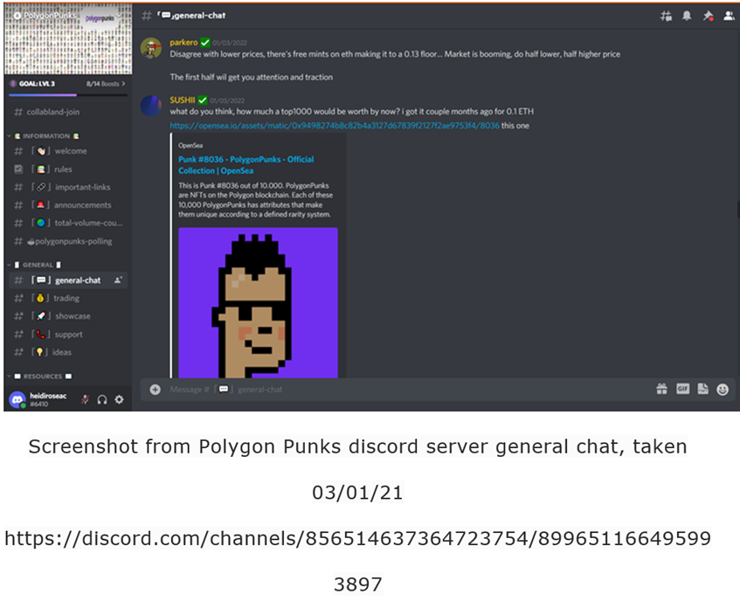
Figure 6: Screenshot taken from Polygon Punks Discord Server. 03/01/21.

Most NFT projects have their own Discord servers, which active participants, customers, and budding creators join to stay updated with the project managers. These servers are used to announce project updates and discuss various topics related to the NFT marketplace, including general chat and advertising new and upcoming projects.
In the NFT community, it’s especially important to advertise new projects, a practice known as ‘shilling’. This is because getting in on a new project before the NFTs are minted is a way to buy tokens at the lowest possible price, known as the ‘mint price’. To do this, you must find your way onto the ‘whitelist’ of a project, which is limited to people who have connections with the NFT project managers. Another way to get onto the whitelist is through giveaways of a limited number of NFTs in your own project. Often, such giveaways are crucial elements in the marketing of your project, its Discord server, and the NFTs you hope to sell.
Discord is a useful tool because it provides a gated platform that requires users to log in and request to join particular Discord communities. Discord was already popular in the gaming world prior to the NFT scene developed, and many NFT creators were already familiar with the platform’s operation.
For those unfamiliar with these types of online platforms (of which Discord is one of many), a place like Discord might seem slightly overwhelming. On Discord, you can see who is online and speak to anyone directly via the voice channel. You can even hover your cursor over people’s names and see which apps they are using alongside Discord. However, for those in the NFT community, these features are less important than the levels of connections between people which could be made using the platform in comparison to other community-building networks.
Another merit of Discord, especially regarding NFTs, is the vast number of applications that can be added to a Discord server. Someone with programming knowledge can write additional scripts for their servers to modify and customise their own networking space. For example, it is possible to program features that permit the transfer of cryptocurrencies and NFTs through the Discord application, allowing the recipient of a giveaway to receive their NFT without the complex and data-sensitive issue of contacting one another and asking directly for a wallet address.
NFT creators are therefore able to leverage platforms such as Discord in the context of the digital age’s ‘cultural abundance’ (to return to Horst and Miller’s (2012) work on digital abstraction). Through providing a space for discussion, announcements and opportunity, Discord servers enable the abundance of the crowd to be navigated and managed. Horst and Miller’s concept of abstraction aligns with the NFT market’s emphasis on the mint price, where NFTs aligns digital assets into unique tokens with value. Discord servers facilitate activities like ‘shilling’, leveraging connections and understanding of NFTs’ abstract value. The ability of some NFT creators to customise their Discord servers, including cryptocurrency and NFT transfer capabilities, connects to concerns about data privacy. Custom applications within Discord may address privacy concerns by enabling secure peer-to-peer transfers, reducing data sharing risks.
Beer and Burrow’s (2010) theories on digital prosumption are also relevant to NFT communities, where participants engage in user-generated content, collaborations and peer-to-peer exchanges. NFT communities are characterised by active participation: users cannot be separated into producers and consumers, but rather as contributors to cultural and economic dynamics. Discord servers, as the central hubs for NFT enthusiasts, serve as platforms where users generate content through discussions, project updates, and sharing insights. This user-generated content contributes to the richness of the community’s interactions and is a hallmark of prosumption in the digital context. Users collaborate on projects, participate in giveaways, and trade NFT tokens directly. The Discord environment facilitates such collaborations, enabling users to connect, exchange ideas, and engage in mutually beneficial exchanges. In this way, participants actively shape the NFT market, becoming both producers and consumers of value.
The idea of prosumption further aligns with the ethos of democratisation in the NFT world. NFTs empower creators to tokenise their digital art and content, allowing them to become both the creators and sellers of their work. Discord servers provide a space where creators can showcase their art, engage with their audience, and directly sell their NFTs to interested buyers. This direct creator-consumer interaction epitomises prosumption as artists become entrepreneurs in the NFT marketplace.

The values

I think it’s absolutely crazy to pay for any sort of digital asset, but that’s just old-school mentality, right? Just like the generations before us put value into physical assets, and now those things seem to pale in comparison to the new generation assets which are now looking digital.
(Online interview with NFT creator sneaker_alchemist, October 2021)

Speaking to NFT creators on Zoom, it was hard not to be taken aback by the highly curated and all-important post-2020 ‘Zoom backgrounds’ I came across. Over the heads of these creators were blindingly lit colourful strips of LEDs surrounding the angles of their offices and living rooms. Many took hits from similarly flashing vape pens and sat on gaming chairs complete with sound decks and headsets. Their faces contrasted with the beaming glow from their monitors, all of these coming together to give the impression that these creators, surrounded in their homes by electronics, lived a life which, even during their offline time, was still primarily influenced by the digital.
Many of the people I spoke to valued their NFT-facilitated livelihoods as the digital allowed them to live lives disengaged from the stresses and responsibilities of what they saw as the mundane life of the past. Many expressed their desires to use NFTs to escape the entrapments of mundane work in coffee shops and retail stores – which they described as underpaid, inhumane, or ‘soulless’ - or from the difficulties of making a creative living in their self-described ‘third world countries’. The prospect of selling their NFTs offered a hope of self-employed, humane, and fulfilling labour, providing relatively easy money for those who could educate themselves on the dynamics of the technology and the market.
These hopes recalled some of the early promises many saw when the Internet came in, that the technologies and infrastructures offered by the onset of the digital era would democratise many aspects of life. Many creators expressed a desire to make a living using their skillsets: making digital art, online content, and a knowledge of computer programming. One creator I spoke to, a young adult from Mexico, put it this way:

> ... I guess I liked the idea to make a living with my skillset (3D artist, CS related stuff) in a country with little to no job opportunities in this area (Mexico)
> Away from my hometown, I guess there are some opportunities, but I’d have to move to Mexico’s capital for that, also, here is frowned upon to pursue an art related career
(Online chat with NFT creator Diego_PerMar, December 2021)
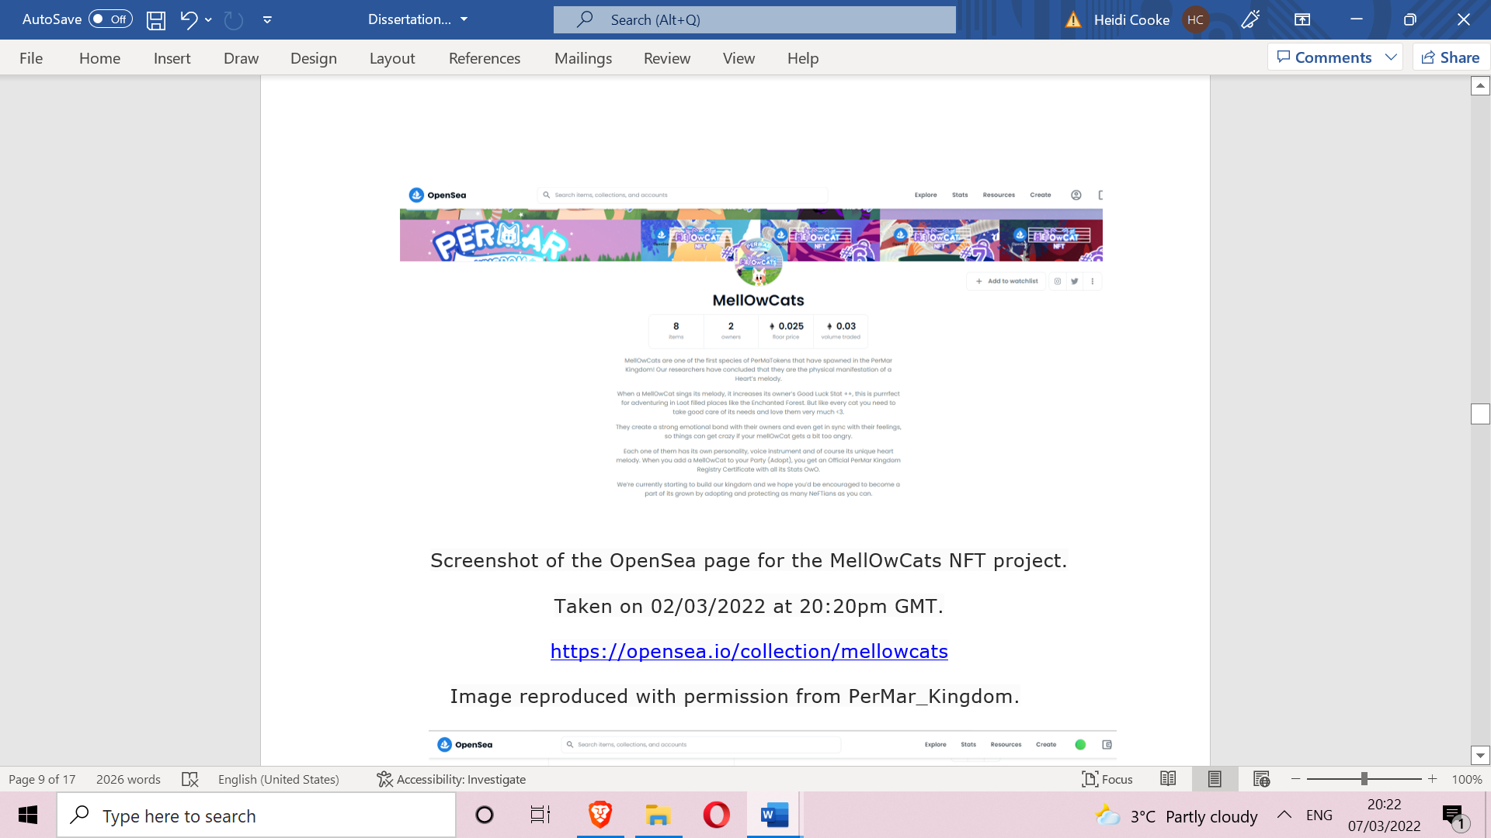
Figure 7: Screenshot of the OpenSea page for the MellOwCats NFT project. 02/03/22
20:20pm GMT. Image reproduced with permission from PerMar_Kingdom.

Many people I spoke to came from Latin America and had taught themselves to code and make digital art using online web tutorials. For them, the Internet was a source of empowerment, allowing them to educate themselves to get out of their towns and avoid becoming an obrero, working ‘blue-collar jobs’. Many of them followed the hype which traced the long tail of the NFT success stories, such as the CryptoPunks or BAYC. Although they were aware these jobs would offer little financial security or labour protections and that the NFT space was rife with the risk of scams, the meaningful, potentially lucrative work NFTs provided far outweighed the security of unfulfilling careers.
The uniqueness of NFTs was also an essential aspect of the technology for these creators. However, it is important to bear in mind that a lot of the hype about NFTs is centred around aspects that are not unique, such as the internal similarity of PFP projects. Many new projects have attempted to replicate the successes of others, such as CryptoPunks and Bored Ape Yacht Club, producing similarly styled characters with slightly different traits. The goal of PFP creators is to produce stylised icons which, though each NFT is still individually unique, conform to a specific pre-established aesthetic demonstrated to be successful. True uniqueness is confined to the art collectors, who gather rare art, or ‘one of ones’, but this is seen as only really bringing success at the high end of a long tail.
The data I collected from NFT creators shows their perspectives and motivations for engaging in the NFT scene. These can be linked to Arjun Appadurai’s theories on the social life of commodities and the changing value dynamics of objects. These connections reveal how NFTs are not only viewed as digital assets with financial worth but also as cultural and social artefacts, echoing the complexity of contemporary digital culture. Many viewed the valuation of NFTs as being reflective of larger shifts to perceptions of value in the digital age, much like Appadurai’s exploration of how the value of objects is culturally determined by the social contexts in which they circulate.
Appadurai’s perspective of commodities adopting dual roles, one being their economic value and the other their cultural and social significance, aligns with NFT creation. While the financial value of NFTs is apparent, creators also emphasised the cultural and social importance NFTs held in their lives. NFTs provided a livelihood, enabling individuals to escape what they perceived as mundane or underpaid work, thus offering cultural and economic value. The creators’ aspirations to make a living through their skill sets, such as digital art and computer programming, recall the promises of democratisation early in the digital era. NFTs offer a platform where creators can leverage their digital skills independently from the state, mirroring the early promises of the Internet’s democratising potential.
Many participants discussed the uniqueness of NFTs in relation to their value, emphasising the value of rare, one-of-a-kind NFTs, as well as the challenges related to mass-produced or highly similar projects. This uniqueness reflects the duality of commodities and unique objects that Appadurai addressed. While some NFTs conform to specific aesthetics, rare art collectors focus on ‘one of ones’, and these unique NFTs hold particular cultural and economic significance.
The question of what would lead someone to buy NFTs provoked many responses. Some believed many people liked collecting rare art, digital collectables, or trading cards. Others quoted the often-used acronym FOMO (Fear of Missing Out). Following the auction of Beeple’s NFT, some felt compelled to get in on the NFT scene to avoid being left behind. The majority, however, cited a group of people, themselves included, who looked at NFTs from a technological point of view and believed they were only at their nascent stage. Seeing their applications as potentially travel far beyond their then current scope and potentially becoming pervasive in many aspects of life in the future was an inducement to become an early investor.
The motivations expressed by individuals for buying NFTs, ranging from collecting rare art to FOMO (Fear of Missing Out) and technological optimism, highlight the diverse values attributed to NFTs. This mirrors Appadurai’s concept of objects gaining value through their circulation in various social contexts. NFTs represent not only financial investments but also cultural and technological assets that may have broader applications in the future.

The future

> I think blockchain would help decentralise most things on the Internet
> Web 3.0 is already here, and it will only get larger and larger
> It would eventually reduce the influence of big social media and tech firms that are more centralised and take decisions willy nilly. based on their own set of rules and values
> People will have more control over their data
> There might be cons, too, as getting content off of a decentralised set-up is nearly impossible
(Online chat with NFT creator skeletoncrewnft, September 2021)

Many creators I spoke with believed that technologies such as NFTs were early signs of a digital revolution predicted to take place ‘soon’. Almost everyone I spoke to mentioned the forthcoming arrival of the ‘Metaverse’, an all-encompassing virtual world that includes almost all aspects of life. It is believed that all forms of value will eventually be digitised, and blockchain technologies will soon disrupt governments, banks, and legal systems. Governments will have to change how they manage money beyond their national currencies, switching to a decentralised and location-independent system of money based on cryptocurrencies. Many see banks investing in cryptocurrencies as an early sign of this societal revolution. According to these predictions, even taxes will need to be adapted to a digital world where wallets of cryptocurrencies may be stored in accounts that are shielded even from the company that holds the assets. Many people cited the fictional entertainment universe ‘OASIS’ (Ontologically Anthropocentric Sensory Immersive Simulation) from the 2008 movie ‘Ready Player One’, directed by Steven Spielberg and based on a science fiction novel of the same name by Ernest Cline, as an accurate prediction of how this future will look. The first major change will be in the job market with the transition of labour online. This is likely to accelerate in the future. An average person’s livelihood may involve playing video games with built-in NFTs, with rewards for high performance translating into wages in the form of cryptocurrencies.

[…] you’re going to see people who don’t have day jobs, like me. This is going to be a common thing where people can just sit at home and just grind out their game, whatever that can be. Like now I’m on the racing platforms, but [NFTs] will expand into every sort of gaming platform you can think of like farming simulators, MMO RPGs, battle royales… (Online interview with NFT creator sneaker_alchemist, October 2021)

For some, this transition represents a bleak but inevitable change brought on by the future threat of climate change making the outside environment uninhabitable, as well as anxieties about and an unwillingness to rely on jobs outside of the home as a consequence of the ongoing threat of enforced lockdowns post-pandemic.
For many, however, the Metaverse brings a welcome change, seen as the natural progression or evolution of our species to a life greatly facilitated by digital technology. NFT-related activity for these people represents buying stakes in this future, as many projects promise to deliver rewards for those who invested in them before transitioning onto the Metaverse. Some projects promise as part of their ‘roadmap’ to establish businesses such as casinos in the Metaverse and offer those holding their NFTs the promise of having shares in these ventures.

I believe that mainstream ‘artists’ are still dormant to the fact that NFTs are the future, and a lot of non-artists are surging and trying to make art, but it’s clear who has the right information and who is making the right preparations, and who hasn’t, and eventually we will see who is really prepared for the changes that are about to happen (Online interview with NFT creator cryptoverts, September 2021)

NFTs represent a wellspring from which the evolving relationship between digital technology, art and authenticity can be perceived. The anticipated changes found within this discussion, particularly regarding the rise of Web 3.0, the Metaverse and the transformation of the job market, can be linked to theories about the anthropology of art by Alfred Gell.
Many NFT creators view blockchain technology, NFTs, and the upcoming Metaverse as signs of a digital revolution. These technologies are seen as enablers of transformative societal change. This is similar to Gell’s concept of technology enchanting and dazzling the viewer. In this context, NFTs and blockchain technology are perceived as magical or powerful tools that have the potential to reshape the digital landscape. Following Gell’s theories still further, technologies like NFTs can make people see the world in an enchanted way. NFTs, as part of this technological revolution, are viewed with a sense of awe and potential for profound change.

Conclusion

This paper presents one of the first anthropological studies of Non-Fungible Tokens (NFTs) and the ideals of NFT creators. NFTs gained a lot of media and public attention in the years after 2020. However, this paper aims to show that the feverish publicity around new technologies can often mislead us into thinking that they are entirely unprecedented, mystifying, and groundbreaking. In this paper, I have shown how NFTs and the beliefs behind them are grounded in many earlier social movements, cryptographic technologies, and attitudes in art, economics, and politics.
One of the communities that formed the foundation of NFTs is the NFT creators’ community. It comprises large online networks that share a language (a jargon), a set of understandings, and, in many ways, a shared history. This community often follows the trail of highly successful projects, where success is determined by media coverage and large sums of money being transferred. However, at the core of the NFT scene, there is a spirit of community, experimentation, and pioneering aspirations to take responsibility for building the architecture of what they believe to be a new online future. Many of these people have been drawn to the promises of NFTs to provide them with stable incomes, a more fulfilling livelihood, or even wealth and abundance when the future of the Internet arrives.
The capacity of NFTs to provide certifiable provenance and an ownership history for digital assets is equally important to this spirit. Within the technological architecture of an NFT, we can see the recapitulation of many themes and ideas set out in the study of physical-world phenomena. Firstly, the notion of an object biography or the life history of an object is central to the NFT. Alongside each token stands a certified account of all previous owners of the token, the details of its creation, and all transactions made. NFTs also exemplify Walter Benjamin’s concept of the aura, as they provide a restricted presence for a work of art on the blockchain, providing it with an aura, a unique location in time and space.
This paper employed a hybrid approach to collect data by using a range of methodologies. This approach was useful as it encapsulated different ways of seeing, including as an external researcher, a neophyte setting out to mint their first NFT, and someone trying to understand the knowledge of others much more experienced in NFT creation. There is still much to be discussed about NFTs, which has been beyond the scope of this paper. They represent the start of an exciting new future for the Internet, and I hope that more will be published on them in years to come.

Bibliography

Ante, Lennart 2020. Smart contracts on the blockchain – A bibliometric analysis and review, Telematics and Informatics, 57. doi: 10.1016/j.tele.2020.101519.

Appadurai, Arjun 1986. The social life of things: commodities in cultural perspective, Cambridge: Cambridge University Press.

Bauman, Zygmunt 2007. Consuming life, Cambridge: Polity Press.

BBC News 2017. CryptoKitties craze slows down transactions on Ethereum, BBC News https://www.bbc.co.uk/news/technology-42237162.amp (accessed 14 Jan 2022).

Becker, Howard Saul 1982. Art worlds, Oakland: University of California Press.

Beer, David and Burrows, Roger 2010. Consumption, prosumption and participatory web cultures, Journal of Consumer Culture 10 (1), 3-10. doi: 10.1177/1469540509354009.

Benjamin, Walter 2008 (1936). The work of art in the age of mechanical reproduction, translated by J.A. Underwood, London: Penguin Random House.

Buterin, Vitalik 2013. Ethereum whitepaper, Ethereum https://ethereum.org/en/whitepaper/ (accessed 05 Jan 2022).

Chohan, Usman 2024. Non-fungible tokens: blockchains, scarcity, and value, in Chohan, Usman (eds.), Non-Fungible Tokens, 1-11. London: Routledge.

Clifford, James 1988. The predicament of culture: twentieth-century ethnography, literature, and art, Harvard: Harvard University Press.

Dapper Labs 2022. CryptoKitties | Collect and breed digital cats! https://www.cryptokitties.co/ (accessed 05 Jan 2022).

Davis, Noah 2021. 10 things to know about CryptoPunks, the original NFTs, Christies https://www.christies.com/stories/10-things-to-know-about-cryptopunks-94347afeea234209a7739c240149f769 (accessed 14 Jan 2022).

DeVries, Peter D. 2016. An analysis of cryptocurrency, Bitcoin, and the future, International Journal of Business Management and Commerce 1 (2), 1-9.

Dodd, Nigel 2018. The social life of Bitcoin, Theory, Culture and Society 35 (3), 35-56. doi: 10.1177/0263276417746464.
—2014. The social life of money, Princeton, New Jersey: Princeton University Press.

Dowling, Michael 2022. Is non-fungible token pricing driven by cryptocurrencies?, ScienceDirect44. doi: 10.1016/j.frl.2021.102097.

Durkheim, Émile 2008 [1912]. The elementary forms of religious life, Oxford: Oxford University Press.

Edwards, Benj 2022. Artists stage mass protest against AI-generated art on ArtStation | Arts Technica https://arstechnica.com/information-technology/2022/12/artstation-artists-stage-mass-protest-against-ai-generated-artwork/ (accessed 05 March 2023).

Franceschet, Massimo, Giovanni Colavizza, Tai Smith, Blake Finucane, Martin Lukas Ostachowski, Sergio Scalet, Jonathan Perkins, James Morgan, and Sebastian Hernandez 2021 (2019). Crypto art: A decentralized view, Leonardo 54 (4), 402–405. doi: 10.1162/leon_a_02003.

Gell, Alfred 1992. The enchantment of technology and the technology of enchantment, in Jeremy Coote and Anthony Shelton (eds.), Anthropology, art and aesthetics, 40-66. Oxford: Clarendon Press.

Gell, Alfred 1996. Vogel’s net: traps as artworks and artworks as traps, The Journal of Material Culture 1 (1), 15-38. doi: 10.1177/135918359600100102.

Harper, Justin 2021. Jack Dorsey’s first ever tweet sells for $2.9m, BBC News https://www.bbc.co.uk/news/business56492358#:~:text=Twitter%20founder%20Jack%20Dorsey%27s%20first,by%20Mr%20Dorsey%20for%20charity (accessed 03 May 2021).

Hayes, Adam, 2019. The socio-technological lives of Bitcoin. Theory, Culture and Society 36 (4), 49-72. doi: 10.1177/0263276419826218.

Horst, Heather and Daniel Miller 2012. Digital anthropology, London: Routledge.

Huang, Kalley, 2022. Why did FTX collapse? Here’s what to know, The New York Times https://www.nytimes.com/2022/11/10/technology/ftx-binance-crypto-explained.html (accessed 10 Jan 2023).

Ingham, Geoffrey 2004. The emergence of capitalist credit money, in L. Randall Wray (eds.), Credit and state theory of money. Cheltenham: Edward Elgar Publishing.

Ingold, Tim 1996. Key debates in anthropology, London: Routledge.
—2013. Making: anthropology, archaeology, art and architecture, London: Routledge.

Jervis, Francis 2019. From economization to tokenization: New forms of economic life on chain, Information Systems and Economics eJournal, 1-16. doi: 10.2139/ssrn.3344748.

Kastrenakes, Jacob 2021. CryptoPunks NFTs sell at Christie’s for $16.9 million - The Verge https://www.theverge.com/2021/5/11/22430254/cryptopunkschristies-sale-larva-labs (accessed 14 Jan 2022).

Kopytoff, Igor 1986. The cultural biography of things, in Arjun Appadurai (eds.), The social life of things: commodities in cultural perspective, 64-91. Cambridge: Cambridge University Press.

Marquez, Alexandra 2021. Welcome to Decentraland, where NFTs meet a virtual world, NBC News https://www.nbcnews.com/tech/tech news/welcomedecentraland-nfts-meet-virtual-world-rcna553 (accessed 15 Oct 2021).

Maurer, Bill 2015. How would you like to pay? How technology is changing the future of money, Durham: Duke University Press.

Maurer, Bill, Taylor C. Nelms, and Lana Swartz 2013. ‘When perhaps the real problem is money itself!’: The practical materiality of Bitcoin, Social Semiotics 23 (2), 261–277. doi: 10.1080/10350330.2013.777594.

May, Timothy 1994. The Cyphernomicon. Nakamoto Institute https://nakamotoinstitute.org/static/docs/cyphernomicon.txt (accessed 16 Jan 2022).

McCorduck, Pamela 1991. AARONS’s code: meta-art. artificial intelligence, and the work of Harold Cohen, New York: W. H. Freeman and Company.

Miller, Daniel 2018. Digital anthropology, Cambridge Encyclopedia of Anthropology https://www.anthroencyclopedia.com/entry/digital-anthropology (accessed 03 Mar 2022).

Nadini, Matthieu, Laura Alessandretti, Flavio Di Giacinto, Mauro Martino, Luca Maria Aiello, and Andrea Baronchelli 2021. Mapping the NFT revolution: market trends, trade networks, and visual features, Nature 11 (2). doi: 10.1038/s41598-021-00053-8.

Nakamoto, Satoshi 2009. Bitcoin white paper https://bitcoinwhitepaper.co/ (accessed 14 Jan 2022).

OpenSea 2017. Announcing OpenSea: We’re excited to announce the alpha... OpenSea Medium https://medium.com/opensea/announcing/open-sea-4e90daa8c84 (accessed 12 Jan 2022).

Pink, Sarah 2011. Digital visual anthropology: potentials and challenges, in Marcus Banks and Jay Ruby (eds.), Made to be seen. Perspectives on the history of Visual Anthropology. Chicago University Press.

Reyburn, Scott 2021. JPG file sells NFT for $69 million, as ‘NFT mania’ gathers pace, The New York Times https://www.nytimes.com/2021/03/11/arts/design/nft-auction-christies-beeple.html (accessed 20 Jun 2021).

Shaw, Lynette 2023. The inevitable sociality of money: the primacy of practical affirmation over conceptual consensus in the construction of Bitcoin’s economic value, Socio-Economic Review 21.1, 51-78. doi: 10.1093/ser/mwab009.

Sigalos, MacKenzie 2022. FTX’s FTT token plunges 80%, wiping out over $2 billion in value, CNBC News https://www.cnbc.com/2022/11/08/ftxs-ftt-token-plunges-80percent-wiping-out-over-2-billion-in-value.html (accessed 08 Jan 2023).

Simmel, Georg 2011 [1900]. The philosophy of money, London: Routledge.

Smith, Hannah 2023. Bitcoin price crash: What caused the latest collapse? - Times Money Mentor, The Times https://www.thetimes.co.uk/money-mentor/article/is-bitcoin-crash-coming/ (accessed 20 May 2023).

Szabo, Nick 1997. Formalizing and securing relationships on public networks, First Monday 2 (9). doi: 10.5210/fm.v2i9.548.

Yuga Labs LLC 2021. Team, Bored Ape Yacht Club, https://boredapeyachtclub.com/?utm_source=nonfungible#/home#team. (accessed 14 Jan 2022).

This work is copyright of the author.

It has been published by JASO under a Creative Commons Attribution-NonCommercial-NonDerivatives ShareAlike License (CC BY NC ND 4.0) that allows others to share the work with an acknowledgement of the work's authorship and initial publication in this journal as long as it is non-commercial and that those using the work must agree to distribute it under the same license as the original. https://creativecommons.org/licenses/by-nc-nd/4.0/)



MSt student in Anthropology, Purdue University. This research is based on a BA dissertation in Archaeology and Anthropology at the University Oxford (2022).
See https://rome.temple.edu/nft and https://decrypt.co/111219/time-is-now-a-medium-academics-ponder-nfts-at-oxford-university-conference.
The overrepresentation of Latin American informants in this study is primarily attributed to the snowball sampling method employed during data collection. Initial contacts who were proficient in coding and digital art creation happened to be from Latin America, leading to subsequent referrals from within the same demographic. It is important to note that while these informants offer valuable insights into their experiences with coding and digital art, their perspectives may not fully represent the diversity of the NFT trading community as a whole.

