MSc and MPhil
in Visual, Material, & Museum Anthropology (VMMA)

Student Handbook 2020-2021

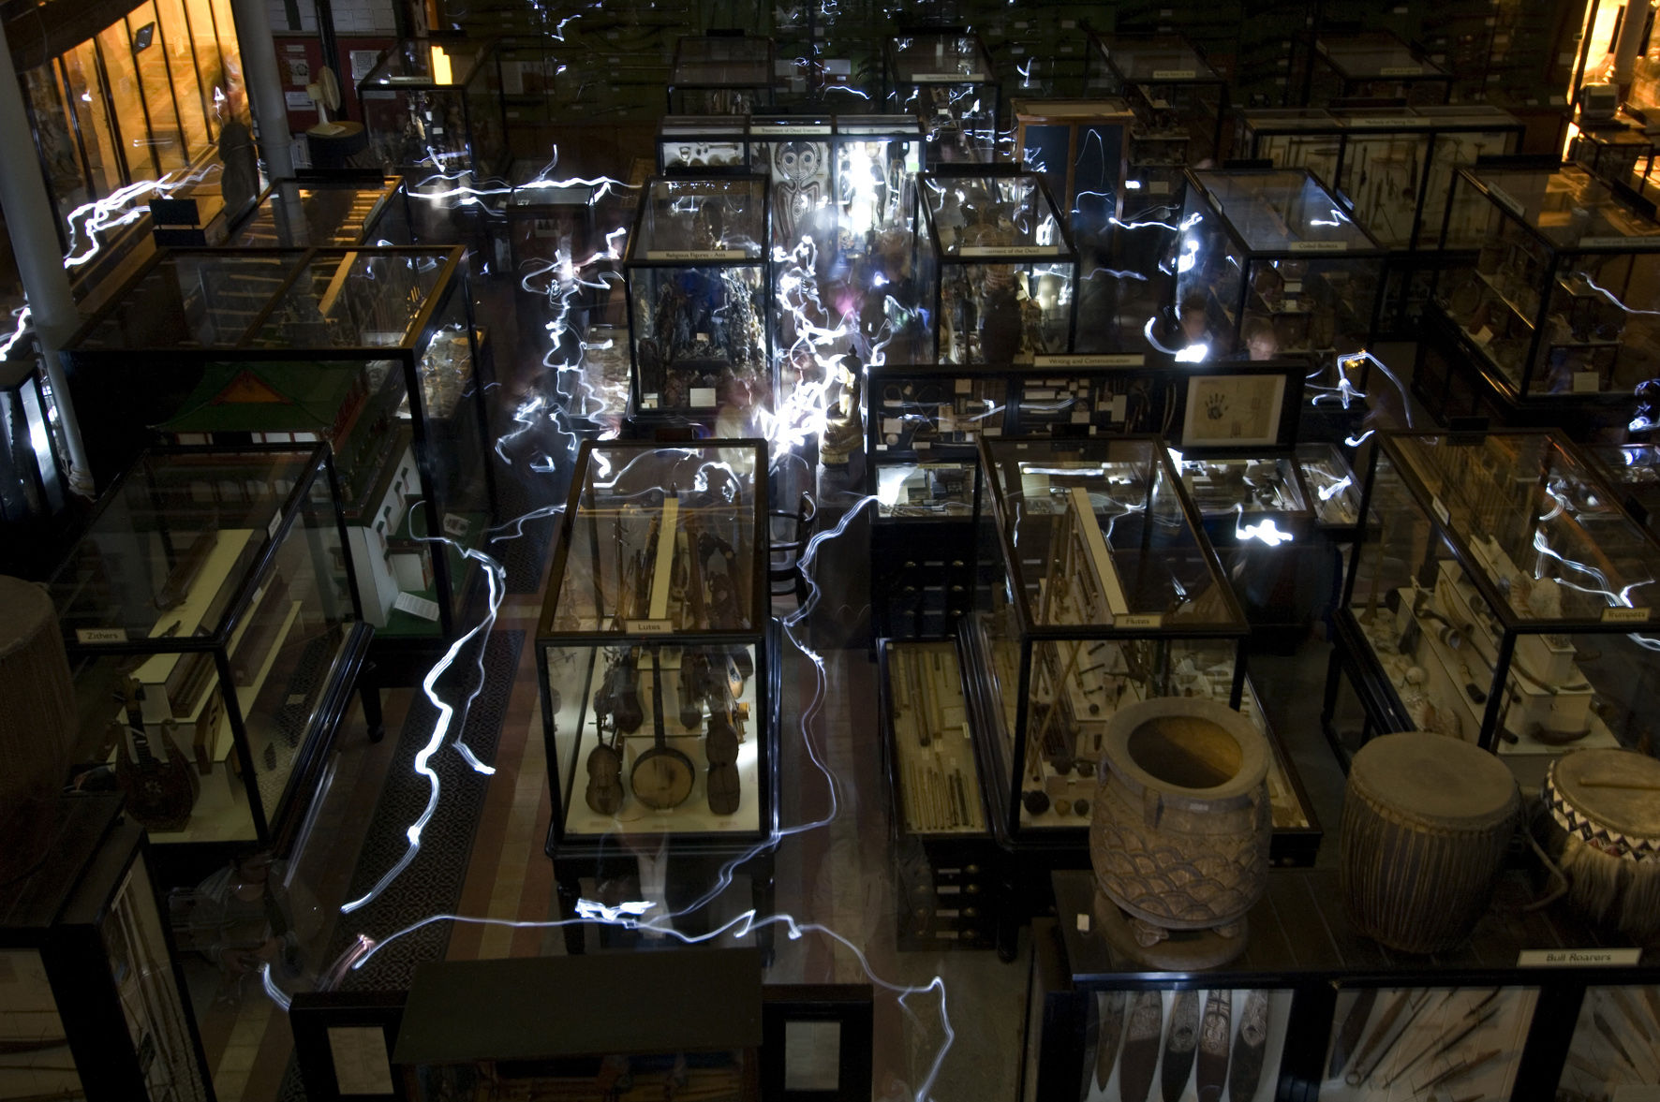
The Pitt Rivers Museum during a late-night event © Rob Judges

School of Anthropology and Museum Ethnography
University of Oxford

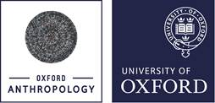 | 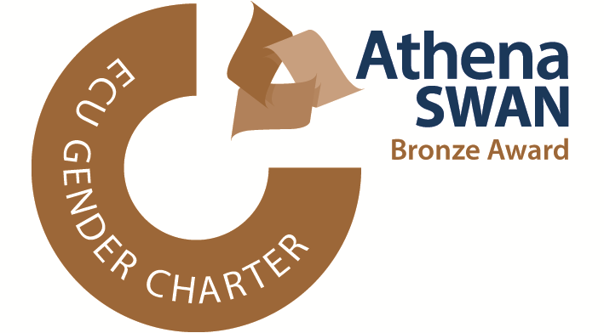

This handbook applies to students starting the MSc/MPhil in Visual, Material & Museum Anthropology in Michaelmas term 2020. The information in this handbook may be different for students starting in other years. If you need to refer to information found in this handbook, please specify the version you read. This is version 5.5 (5th October 2020).

Disclaimer

The Examination Regulations relating to this course are available at http://www.admin.ox.ac.uk/examregs/2019-20/mosbciv-mandmuseanth/studentview/ (MSc), http://www.admin.ox.ac.uk/examregs/2019-20/mopiv-mandmuseanth/studentview/ (MPhil first years) and http://www.admin.ox.ac.uk/examregs/2019-20/mopiv-mandmuseanth/studentview/ (MPhil second years). If there is a conflict between information in this handbook and the Examination Regulations then you should follow the Examination Regulations. If you have any concerns please contact the Course Director.

The information in this handbook is accurate as at 5th October 2020, however it may be necessary for changes to be made in certain circumstances, as explained at https://www.ox.ac.uk/admissions/graduate/courses/msc-visual-material-and-museum-anthropology and https://www.ox.ac.uk/admissions/graduate/courses/mphil-visual-material-and-museum-anthropology. If such changes are made the department will publish a new version of this handbook together with a list of the changes and students will be informed.

Map of the School’s Premises

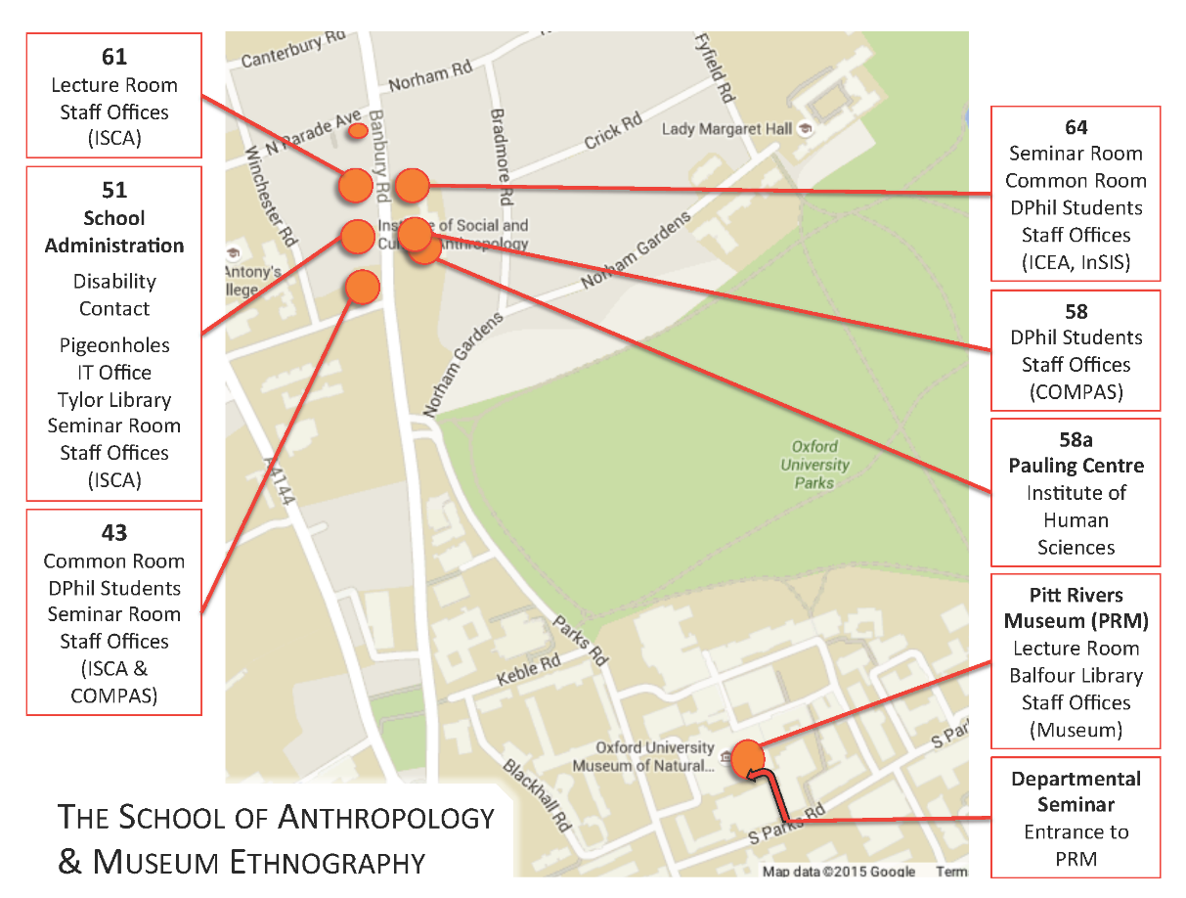
TABLE OF CONTENTS
1. Introduction 5
2. Useful Contact Details 5
Course Director for 2020-2021 5
Core Teaching Staff 5
Key Staff at School of Anthropology and the Pitt Rivers Museum 5
3. Organization of Teaching and Learning 6
Tutorials 6
Lectures 6
Classes 7
Seminars 7
Study Expectations 7
Guidance on writing tutorial essays 8
4. Lectures and Classes for MSc and MPhil Year 1 10
Lectures and Classes: Michaelmas Term 2019 10
Cultural Representations Lecture Series 10
VMMA Research Methods Classes 10
Tutorials 11
Film screenings: ‘Classic Ethnographic Films and beyond’ 11
Options Fair in MT 12
Lectures and Classes: Hilary Term 2020 13
Cultural Representations Lecture Series 13
VMMA Research Methods Classes* 13
Film screening: Developments in ethnographic cinema (MB) 14
Options (time and place varies) 15
Anthropology and Film 15
Key Debates in the Anthropology of Art and Visual Culture 15
Objects in Motion: Debates in Visual, Material and Economic Anthropology 15
Lectures and Classes: Trinity Term 2020 17
VMMA Classes 17
Fieldwork: Theories and Methods – Lectures and Seminars 17
Other Lectures and Seminars 18
Tutorials 18
5. Key Dates and Deadlines 18
MSc VMMA important dates 18
MPhil VMMA 1st year important dates 18
MPhil VMMA 2nd Year important dates 19
6. Examined Work 19
Assessed Coursework (MSc and MPhil first year) 19
Paper 1: Contemporary themes in Visual, Material and Museum Anthropology 20
Paper 2: Option paper 20
Paper 3: Research Methods 20
Some Guidance for Preparing the Methods Portfolio 21
Paper 4: Fundamental Concepts in Visual, Material, and Museum Anthropology 21
Dissertation (MSc students only) 21
A Note on Other Coursework 22
7. VMMA MPhil (second year) 23
MPhil Thesis 23
Methods Modules 23
8. Assessment (All Degrees) 24
Examination Conventions 24
Marking criteria 25
Sitting examinations 25
Past papers 25
9. Feedback (All Degrees) 25
10. Resources at the SAME and the PRM 25
ISCA Video Library 26
Object and Photograph Collections, Pitt Rivers Museum 26
What’s On 26
11. Student Projects/Volunteering Opportunities at the Pitt Rivers Museum 26

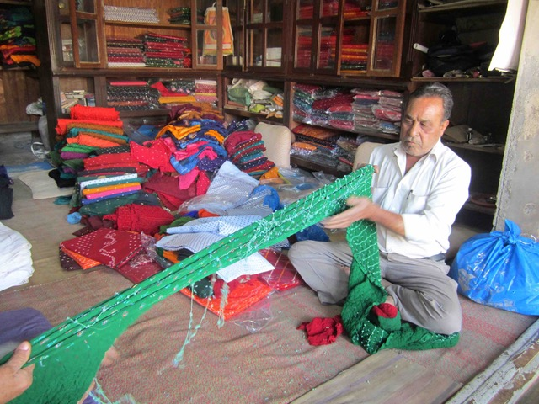
Cloth merchant preparing a length of sari fabric; Jamnagar, India 2018. Photo copyright; Marcus Banks.

1. Introduction

Welcome to Oxford, the School of Anthropology & Museum Ethnography (SAME), the Pitt Rivers Museum (PRM) and to studying Visual, Material and Museum Anthropology (VMMA)! We look forward to getting to know you in the coming months. This handbook contains important information that you need to read carefully. There is a lot to digest, but don’t be alarmed, as we will discuss its contents as a group at the start of term. If you have questions that are not answered in the following pages or at that meeting, do please ask your supervisor or the Course Director as we progress through the degree(s).
This handbook is specifically intended for students following the MSc or MPhil in Visual, Material and Museum Anthropology. It should be read in conjunction with the Graduate Handbook which has more generic information about studying in SAME, including formal statements concerning your degree, such as the regulations pertaining to it.

2. Useful Contact Details

Core Teaching Staff

Prof. Clare Harris (Course Director)  Professor of Visual Anthropology and Curator for Asian Collections at the Pitt Rivers Museum | [6]13009  clare.harris@prm.ox.ac.uk
Prof. Marcus Banks  Professor of Visual Anthropology  Dr. Dolores (Lola) Martinez  Emeritus Reader SOAS and SAME Research Affiliate dm6@soas.ac.uk | [2]74675 marcus.banks@anthro.ox.ac.uk
Dr. Elizabeth (Liz) Hallam Associate Professor in Visual, Material, and Museum Anthropology | [2]84980  elizabeth.hallam@anthro.ox.ac.uk
Contributions are also made by other staff of the School of Anthropology and Museum Ethnography and of the Pitt Rivers Museum, particularly by:

Dr Chris Morton christopher.morton@prm.ox.ac.uk

Key Staff at School of Anthropology and the Pitt Rivers Museum
Academic Administrator  Vicky Dean  SAME IT Team  Tylor Librarian  Helen Worrell  Tylor Assistant Librarian  Martin Pevsner  Balfour Librarian  Mark Dickerson | [2]74670  vicky.dean@anthro.ox.ac.uk  [2]74629  it.support@anthro.ox.ac.uk  helen.worrell@bodleian.ox.ac.uk  [2]74696  martin.pevsner@bodleian.ox.ac.uk  [2]70939  mark.dickerson@prm.ox.ac.uk

JCC representative – to be elected by the cohort of VMMA students in the first term.

3. Organization of Teaching and ‘Blended Learning’

The VMMA MSc and MPhil are organized through the Institute of Social and Cultural Anthropology (ISCA), which is part of the School of Anthropology and Museum Ethnography (SAME), within the Social Sciences Division (SSD) of the University of Oxford. The timetable for lectures and seminars can be found here https://www.anthro.ox.ac.uk/lecture-list. If you have any problems with teaching or supervision please raise these as soon as possible so that they can be addressed promptly. You should discuss such issues with your supervisor in the first instance and then consult the course director or your college tutor if necessary.

‘Blended Learning’
As you’ll be aware, things will be a little different from usual this year due to ongoing restrictions relating to the Covid-19 pandemic. At the time of updating this handbook, it is anticipated that course delivery will entail a flexible blend of online and face-to-face activities. We will keep you updated on course-specific guidance as we go along. For more general information, advice and updates please check the Oxford Students webpage of the University website: ox.ac.uk/students and ox.ac.uk/coronavirus/students.

TEAMS
This year many of your VMMA classes, tutorials, lectures, seminars, and meetings with supervisors will be conducted online via Microsoft Teams and Canvas. For information on Teams see:
https://help.it.ox.ac.uk/nexus365/teams-how-do-i

It is hoped that some classes will be able to be delivered face to face (F2F) with appropriate safety measures taken into account. These will mainly take place in the Pitt Rivers Museum and are highlighted in the document below. Some classes are listed in this document as either F2F (with location where they will happen) or Online. We will inform you nearer the time which mode we will deliver the session in, subject to the prevailing conditions of the pandemic.

CANVAS
Canvas is the University’s Virtual Learning Environment. Here you will find lecture slides, lecture recordings and other course related materials, such as reading lists. All SAME students will receive an automated email to say they have been added to the relevant Canvas site for their degree programme and this will enable you to link into it.

Here is a link for a course that explains how to use Canvas: https://canvas.ox.ac.uk/courses/21629

*PLEASE NOTE THAT ALL TIMES GIVEN IN THIS HANDBOOK ARE UK TIME.*

VMMA WEEKLY STAFF ‘OFFICE HOUR’
Tuesdays 10 - 11 AM on Teams

On each Tuesday of Michaelmas Term, members of the VMMA Teaching Team will be available on Teams to answer any questions you may have on topics other than those to do with course content. (That kind of question should be directed to your supervisor in the first instance). These sessions are primarily designed to support students as they negotiate the exceptional circumstances of this term (e.g. new modes of teaching online).
We will not operate a booking system, so you should just call the staff member on Teams and if they are speaking with someone else, please call again after 5 minutes or so.

NB In week 1, we’d like all of you to attend the office hour from 10 – 11 on Tuesday for a general discussion about how to use Teams and the etiquette for the different formats for online teaching.

In the following weeks, staff taking calls will be: Weeks 3, 5, and 8: CH. WEEKS 2 AND 6: EH. WEEKS 4 AND 7: MB.

Further details of your core lectures, classes and tutorials appear in the following pages.

Tutorials, Lectures, Classes, Seminars and Meetings with Supervisors

Meetings with Your Supervisor

You should expect to be invited to a meeting with your supervisor (in their capacity as overseer of all aspects of your experience of the VMMA course(s)) to discuss your plans, progress and ideas for the degree (e.g. dissertation topics) at the start and end of each term.

Tutorials

A VMMA tutorial is a meeting with between two and four students and a tutor that usually takes place in the tutor’s office for an hour or so. For each tutorial, the tutor will have assigned an essay question or prompt and a selection of readings. The student will write an essay of sufficient length (between 1,500 and 2,000 words) to cover the readings on the assigned topic. These essays form the basis for discussions with the tutor and other students (see further guidance below).

It is important to realize that tutorial essays are an essential teaching and learning tool but they do not contribute to degree results in any way (summative assessment), and no marks are given, only qualitative (formative) feedback. The essays and tutorial discussion help you to assess your progress, and the contents and standard of the essay will normally enter into the tutorial discussion at some point. Expect constructive criticism from your tutor and don’t be alarmed by it, while nonetheless taking it seriously. Tutorials provide the opportunity to discuss your understanding of a topic in a small group setting and they are complemented by other kinds of classes and seminars with the rest of the degree cohort.

Lectures

While lectures (of just under an hour’s duration) may not always be linked directly to tutorials on a week-by-week basis, they usually provide an introduction to a topic you will work on at some point during the course of the degree, as well as being a source of learning in their own right. You are therefore advised to attend as many lectures as possible and especially those listed in this handbook. Other lecture series provided by the School of Anthropology and Museum Ethnography are also likely to be relevant. Lectures are fairly formal in Oxford and do not ordinarily allow for discussion, but for the core VMMA lecture series, ‘Cultural Representations’, we hold a meeting for half an hour immediately after the lecture at which VMMA students may ask questions and explore the lecture topic further with the lecturer.

VMMA students who do not already have a background in anthropology should attend some of the lectures designed for the MSc in Social Anthropology. Please discuss this with your supervisor.

NB All lectures given in the School of Anthropology this year will be delivered either pre-recorded or online ‘live’ and simultaneously recorded. Recordings of the lectures will be deposited on Canvas.

Classes

Classes are the primary format used in the teaching of option courses, but they are also held for some important aspects of VMMA core teaching (in addition to tutorials, lectures and seminars). They normally last for two hours. In option teaching, a class may sometimes be combined with a lecture (e.g. in the first or last hour of a two-hour session). For classes of all sorts students are often asked to give a short presentation of around ten to fifteen minutes on a selection of readings assigned previously, followed by a class discussion guided by the member(s) of staff organizing the class. All the students attending the class are expected to have done the assigned readings so that they can contribute to the discussion. Classes are the format used for VMMA Research Methods training and students may be asked to perform a task in advance of the class, or to do an exercise during the class.

(Classes often correspond to what are called ‘seminars’ at other universities, whereas in Oxford the seminar is usually a session where ‘in house’ and visiting academics present their research. See below.)

Seminars

The Pitt Rivers Museum Seminar in VMMA

The ‘Pitt Rivers Museum Research Seminar in Visual, Material and Museum Anthropology’ is the core seminar dedicated to topics related to the VMMA degrees and the students taking them. The seminar will take place online on Fridays from 12.00 – 1.30 pm throughout the academic year and all VMMA students (MSc and first and second year MPhils) are expected to attend all sessions. Over the course of the terms we invite distinguished speakers, frequently from outside Oxford, to present their current research or other activity (e.g. curating an exhibition, producing a film). VMMA students are encouraged to propose speakers for this series in Trinity Term.

Departmental Seminar

The Departmental Seminar is also on Fridays at 15:15-17.00 pm and the series is intended to bring all members of the School of Anthropology and Museum Ethnography together for the seminar, the discussion of the speaker’s presentation. This seminar series presents the work of leading researchers in all aspects of the discipline of anthropology and we recommend that VMMA students attend as many of these seminars as possible. This series will be presented online in 2020-2021.

Details for both the VMMA and SAME seminars will be circulated by email at the start of each term and are also available on the SAME website.

Lectures and Seminars beyond VMMA and SAME

A very wide range of undergraduate and postgraduate lectures and specialist seminars is offered both in the School of Anthropology and elsewhere in the University of Oxford. Students should consult their supervisor as to which of them are best geared towards their interests and the VMMA degrees before deciding which to attend.

Study Expectations

All students in SAME are responsible for their own academic progress. During term time, the programme requires a substantial amount of reading and writing, which may sometimes be difficult to combine with other activities or duties. Try to concentrate on the essentials and follow the guidance of your supervisor. Remember that the University vacations are a good time to catch up on any reading you may have missed, to read more widely, and to start thinking about your dissertation.

The School, like the University as a whole, takes the view that full-time courses require full-time study and that studying at Oxford does not allow sufficient time to earn one’s living from paid employment simultaneously. The School’s Teaching Committee has therefore drawn up guidelines for students wishing to take paid employment during term time (see the SAME Graduate Handbook for SAME’s own policy and https://academic.admin.ox.ac.uk/policies/paid-word-guidelines-graduate-students) for the university policy. Note that it is not possible to study for any Master’s degree within the School on a part-time basis in order to facilitate working while studying.

Oxford workload is demanding, but you have been accepted because we are certain you can manage. If you encounter difficulties keeping up with the pace, please discuss them with your supervisor or College adviser, or both.

Guidance on writing tutorial essays

Tutorial assignments usually consist of answering a question on the basis of the suggested readings. If possible, consult every text that is suggested, but be selective in choosing the most appropriate material with which to answer the question. Do not be afraid to bring in additional material to answer it either, whether something you have learned from a lecture or seminar, something you have read in a different context (perhaps for a previous essay, or by independent study), or information from an ethnographic film. While a rough rule of thumb regarding the length of essays is around 1500 to 2000 words, quality counts for far more than quantity. Answer the question set in light of the readings, thinking carefully, and paying attention to the clarity of what you write. All essays should conclude with a list of references to the works you have consulted. You may find the following points helpful:

Always carefully read and discuss the question: obvious as this may sound, not answering the question is the single most important reason why student essays, whether for exams or tutorials, may be deemed to be weak. Sometimes students notice only the key words and miss the point of the question as a whole.

Overall structure: try to structure your essay carefully: beginning, middle and end, with careful attention being paid to the appropriate balance and juxtaposition of argument and examples. Make effective use of ‘signposting’ the essay as you go along, e.g. indicate what you have just said and what will come next. An effective introduction is clear and succinct, showing you have understood the question, and giving an indication of how you are going to answer it. Ideally a conclusion should avoid simply repeating what has already been said in the body of the answer, but should set the whole essay in a wider context. The body of the essay should provide the central argument, illustrated as appropriate with examples, whether interweaved with the argument or in the form of one or more extended cases studies coming after it (see below).

Be intelligently creative: there is no ‘right’ answer to any essay question, and you may well find that some of the readings flatly contradict each other over the interpretation of some piece of ethnographic data. Make up your own mind about which theoretical position seems most convincing (which may be a synthesis of different readings) and state this in your conclusion, but be sure to demonstrate that you have considered the alternatives carefully.

Use ethnographic (i.e. case study) examples: no argument in social or cultural anthropology can be sustained entirely in the abstract, so make careful reference to the ethnography you have read. Avoid the two extremes, however: you do not need to reproduce pages and pages of ethnographic detail, especially when referring to the ‘classic’ older ethnographies; on the other hand, do not drop ethnographic snippets into an argument with no context, especially when the ethnographies are of people far apart in time or space. Consider whether you should set out all the arguments and then have a separate section for examples, or instead interweave points in the argument with examples as appropriate. The former may be easier, but the latter is often (but not always) more effective, though requiring and demonstrating greater knowledge and understanding of the material and greater facility in using it.

Do not make sweeping generalizations: (‘the so-and-so people believe such and such...’), although you may find such statements in older works. For every piece of ethnographic information you use, you should remember and cite the exact name of the author and the name of the group; you should also pay careful attention to the date of a publication: this is often important in helping you identify an author’s likely theoretical position (but make sure you know the original date, not the date of a reprint or translation).

Keep careful notes: you cannot take notes of every word of the readings. Try to read a page or so at a time and then write a note that summarizes the points. Be sure your notes indicate the correct work and the page references; do not copy things verbatim except for particularly striking sentences that you may want to quote in your essay. When you use your notes to write the essay, do not simply regurgitate the author’s own words or a close approximation: remember, supervisors read several essays a term on the same subject, and nothing is more boring for a supervisor than to read the same passages over and over again. Reproducing an author’s words also makes it very difficult for the supervisor and yourself to be sure that you have actually understood what you have read. Intelligent summaries of other people’s work, with clear reference to those works, mean that your own ideas and insights stand out more clearly.

Quoting properly and good academic practice: if you wish to quote another author’s exact words, make sure those words are placed within quotation marks and give the correct reference. If you paraphrase an author’s words, make sure you identify the author and give the correct reference. In other words, leave the reader, including supervisor or examiner, in no doubt about what is your own contribution to the essay or other text and what you have taken from other authors. Separate quotations should not be taken from widely different contexts or widely separate pages and assembled together if to do so would seriously distort the original author’s meaning. It is also completely unacceptable to set out another author’s words, whether verbatim or only slightly and superficially altered, and pass them off as your own, rather than attributing them properly to the original author as described above. Either practice constitutes plagiarism, which is a serious offence, whether it occurs in examinations or coursework or in tutorial essays, and may incur academic or other penalties. This rule applies whether the quotation is taken from a book or journal or from a website. In particular, do not be tempted simply to cut and paste material from a website into your essay.

In general, therefore, unless quoting directly, put things in your own words. As noted above, this also offers some guarantee that you have actually understood what you have read. That said, you are unlikely to understand everything you read, whether during your degree or at any other time in your academic career. It is also important to realize that, while there is quite a lot that it is possible to be right or wrong about in anthropology, in general it is a highly interpretative subject, with plenty of room for debate over even quite fundamental issues. It is never too early to learn to engage in such debates: tutorials give you precisely an opportunity to do so.

Use of introductory material: the mention of websites above prompts discussion of the use of introductory materials generally, including introductory books directed especially at first-year students. There are now many of these on the market, and some School members of staff have themselves written them. While they are often useful in helping a student see the wood for the trees, at graduate level especially students should not rely on them entirely, but rather seek to go beyond them as soon as possible by reading the original or primary texts. Supervisors and examiners are likely to consider any written assignment that consists wholly or mainly of such introductory material, including any that relies wholly or mainly on web sources, as highly unsatisfactory. Examination answers in either form are likely to be marked down accordingly.
Guidance on academic good practice, including definitions of plagiarism as well as skills such as time management, note-taking, referencing, research and library skills, and information literacy can be found at http://www.ox.ac.uk/students/academic/.

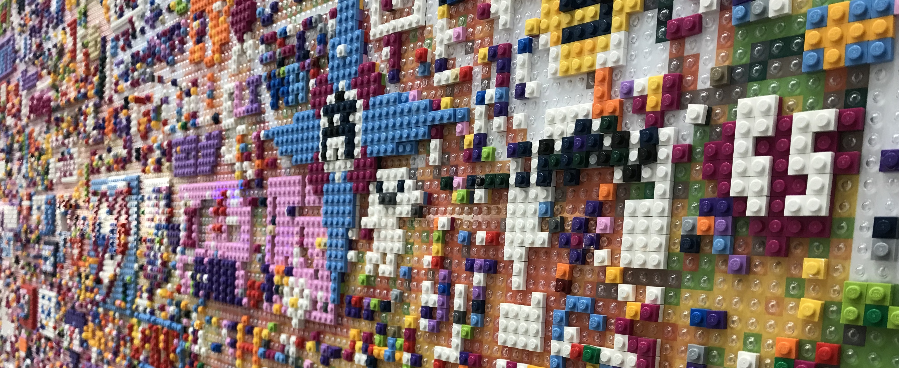
Pop-up Lego mural made by passers-by, Changi Airport, Singapore, 2018. Photo copyright: E. Hallam.

4. Lectures and Classes for MSc and MPhil Year 1

Lectures and Classes: Michaelmas Term 2020

Cultural Representations Lecture Series
Thursdays 12.00 - 13.00 Live or pre-recorded and available on Canvas.

NB This lecture series is supplemented by a half hour class for VMMA students only that will take place online at 9.30 AM on FRIDAYS. Please ensure that you have watched the lecture beforehand, as this class gives you the opportunity to ask questions and discuss the topic with the lecturer.
Lecturers: Clare Harris (CH), Elizabeth Hallam (EH), Chris Morton (CM), Charlotte Linton (CL), Shireen Walton (SW)
Wk 1 | Anthropology, museums, and material culture (CH)
Wk 2 | Colonialism, Collecting and Contemporary Debates (CH)
Wk 3 | Social Lives of Things (EH)
Wk 4 | Consumption (CL)
Wk 5 | Art, Aesthetics and Agency (CH)
Wk 6 | Photography and Representation (CM)
Wk 7 | Rethinking Museums and Collections in the Digital Era (CH)
Wk 8 | Digital Theories and Methods (SW)

VMMA Research Methods Classes

Wednesdays 14.00 – 17.00
Sessions in this series that we hope to deliver F2F will be held in the Pitt Rivers Museum Lecture Theatre with students divided into two groups for separate sessions of up to one hour duration. One of the sessions will be filmed and deposited on Canvas afterwards, so that students who are not in residence can see what happened.

Special Session in the Pitt Rivers Museum
Monday 12th October from 10 - 12.
Our first research methods class will be held in the Pitt Rivers Museum. It will be closed to the public for this special session for VMMA students only.

Wk 1 | Introductory Session: Thinking through VMMA (group discussion) Pitt Rivers Museum Court – enter via Robinson Close back entrance to the museum
Wk 2 | Working with museum objects, (CH) PRM Lecture Theatre or online
Wk 3 | Working with objects in the world (EH) Online
Wk 4 | Working with photographic collections (CM) PRM Lecture Theatre or online
Wk 5 | Working with film and video (MB) PRM Lecture Theatre or online
Wk 6 | Working with art and artists (CH) PRM Lecture Theatre or online
Wk 7 | Student presentations 1 (All staff) Online
Wk 8 | Student presentations 2 (All staff) Online
These classes are designed to introduce students to a variety of anthropological methods for thinking about material/visual culture and museums and which may then be applied in research for your dissertation etc.. They also help students select an item to discuss in a presentation to be given to all staff and members of the VMMA cohort in the last two weeks of Michaelmas term. For those sessions, students should select an object/display/photograph/film clip etc. either from the displays and collections of the Pitt Rivers Museum, or from outside the museum, and prepare a short presentation (of about 10 minutes) discussing how it might be analysed using one or more of the approaches discussed in the Research Methods classes. If you are not sure what to choose, please consult your supervisor. In previous years, students have presented on objects on display in the Pitt Rivers or from among the museum’s collections, and on a wide range of examples from beyond its walls, including art works, consumer goods, film, photographs, digital/online ‘objects’ and so on.

Tutorials

At the start of the year, students will each be assigned an academic supervisor, who will advise them on many things throughout the year. Your supervisor will also give tutorials on all the tutorial topics. A list of those topics and readings will be given out at the start of term. Tutorial times will be announced by your supervisor and sessions for each topic will occur at some point over a two-week period. For each tutorial students will be required to submit an essay of maximum 2000 words by a specified time by email (usually on Mondays of the first week of the two-week period by 5 pm.) General guidelines for writing tutorial essays can be found in the SAME Graduate Handbook. Please inform the tutor in advance if you cannot attend a tutorial for good reason.

Tutorial Topics in MT

Wk 1 | Thinking through VMMA. Essay to be emailed to supervisor for first tutorial by Monday of week 2.
Wk 2 | Tutorials on first week essays about VMMA
Wk 3 | Museums, Anthropology and Colonialism
Wk 4 | Museums, Anthropology and Colonialism
Wk 5 | Objects and Persons
Wk 6 | Objects and Persons
Wk 7 | Viewing the Environment
Wk 8 | Viewing the Environment Tutorials  AND  Group meeting: re. dissertations and Paper 3 – all students and staff  Tuesday1st December 2 – 3 pm, Online

Following discussion of the themes of Week 1 in the Pitt Rivers, you will need to write an essay based on the readings for Week 1 and email it to your academic supervisor by Monday of 2nd week. They will then arrange a meeting to discuss it in week 2.

The Pitt Rivers Museum Seminar in Visual, Material and Museum Anthropology
Fridays 12.00 – 1.30 pm Online

This series of talks by distinguished speakers from Oxford and beyond is a core element of the VMMA degrees and all students should attend. The list of speakers will be sent to you and available on the SAME website.

Film screenings: ‘Classic Ethnographic Films and beyond’
Mondays 2 – 4 pm. NB All details of this series will be confirmed by 1st week.
Films to be viewed before the class.

These film screenings and the discussions around them are a core part of the VMMA degrees that students should attend each week.

After Week 1, VMMA students will take it in turns to present the films; Prof Banks will prepare suggested readings to accompany each film. Copies of most films can be found in the ISCA Video Library held in Martin Pevsner’s office at 51 Banbury Road and some are on Alexander Street Anthropology (anth.alexanderstreet.com/). Many are available on YouTube.

Wk 1 | The Block (Maria Şalaru, 2016, 60 Minutes)
Wk 2 | Nanook of the North (Robert Flaherty, 1922, 55 mins)
Wk 3 | Chronique d’un Été (Jean Rouch, 1961, 87 mins)
Wk 4 | To Live with Herds (David and Judith MacDougall, 1972, 70 mins)
Wk 5 | Trobriand Cricket (Gary Kildea and Jerry Leach, 1973, 50 mins)
Wk 6 | Photo Wallahs (David & Judith MacDougall, 1991, 60 mins)
Wk 7 | Forest of Bliss (Robert Gardner, 1985, 80 mins)
Wk 8 | Journey to the Maggot Feeder (Liivo Niglas and Priit Tender, 2015, 68 mins)

Options Fair in MT

Teaching for all the option courses mainly takes place in Hilary Term, but students will be asked to select one option course by the end of Week 3 in Michaelmas Term, following the ‘Options Fair’ in Week 2, when tutors explain the content of their option courses (details to follow). A list of the options available for 2020-2021 will be distributed separately. Although VMMA students are free to choose from any of the options available, they may be well-advised to select an option taught by members of the core teaching team for the VMMA degrees. (See below for recommendations.) Please discuss your option choice with your supervisor. Typically, option teaching consists of a mixture of lectures and classes, supported in some cases by tutorials and film screenings. Note that there is a cap on numbers for some options and your first-choice option may therefore not always be available.

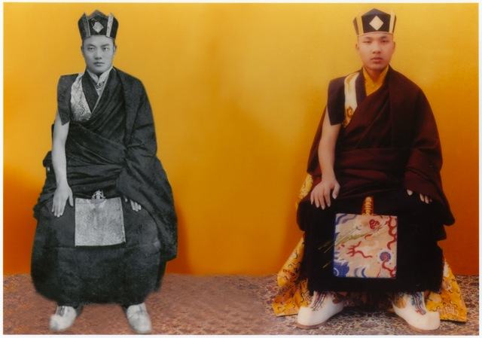‘Photo-icon’ of two incarnations of a senior Buddhist monk by Tibetan photographer Bhutook. Created in Dharamshala, India, 2010. Photo copyright: Clare Harris.

Lectures and Classes: Hilary Term 2021

Cultural Representations Lecture Series
Thursdays 12.00 - 13.00 Live or pre-recorded and available on Canvas.

NB This lecture series is supplemented by a half hour class for VMMA students only on Fridays at 9.30 am. Please ensure that you have watched the lecture beforehand, as this class gives students the opportunity to ask questions and discuss the topic with the lecturer.

Lecturers: MB: Marcus Banks, EH: Elizabeth Hallam, CH: Clare Harris,

Wk 1 | tbc
Wk 2 | Transnational Artworlds (CH)
Wk 3 | Text and Materiality (EH)
Wk 4 | Bodies in Anthropology (EH)
Wk 5 | Materials: Anthropological Debates (EH)
Wk 6 | Anthropology, Film and Cinema (MB)
Wk 7 | Authenticity (MB)
Wk 8 | The Anthropology of Tourism (tbc)

VMMA Research Methods Classes
Wednesdays 14.00 – 16.00

These classes are compulsory for VMMA students and are part of the preparation for Paper 3. In HT they are also taken as the stand-alone ‘VMMA Methods Module’ by other students of SAME.

Wk 1 | Introduction to the VMMA Methods Module; transects and walking (MB)
Wk 2 | Object/Material biography as method (EH)
Wk 3 | Sketching as method and analysis (EH)
Wk 4 | Photo elicitation (CM)
Wk 5 | Museum Labelling Matters (Marenka Thompson-Odlun)
Wk 6 | Digital methods (Shireen Walton)
Wk 7 | Student presentations 1
Wk 8 | Student presentations 2

For weeks 7 and 8, you should prepare a 10 minute presentation about one or more methodological exercises that you plan to use in your methods portfolio (Paper 3b). The method(s) that you present can be related to a different topic from the ones you may eventually use in your dissertation but the aim is to get feedback on the method(s) that you are planning to use. Your focus should be on visual, material or museum anthropological methods that you think will enable you to answer a certain question, while also considering the strengths and weaknesses of the proposed method. You should draw on things you have learned in the VMMA classes and the ‘Fieldwork: theory and practice’ lectures that are provided for all students in the School.

Students are reminded that while full ethics clearance (the CUREC process) is not required for these exercises, all human subjects involved in the exercises (e.g. as interview subjects) must be made aware of the nature of the exercise.

Tutorials (time and place varies)

Wk 1 | Art, Aesthetics and Agency
Wk 2 | Art, Aesthetics and Agency
Wk 3 | Text and Materiality
Wk 4 | Text and Materiality
Wk 5 | Materials: anthropological approaches
Wk 6 | Materials: anthropological approaches
Wk 7 | Reading week to prepare for week 8 debate
Wk 8 | Repatriation Debate (online): Group session. Date and time to be confirmed.

A Note on Week 8: The Repatriation Debate
Our group session in week 8 will take the form of a debate on one of the most pressing issues facing museums and communities around the world: repatriation. Further details about the format of this session and readings relating to the topic will be sent to you at the start of HT.

The Pitt Rivers Museum Seminar in Visual, Material and Museum Anthropology
Fridays 12.00 – 1.30 pm Online

This series of talks by outside speakers reflecting on their research continues in HT.

Film screening: Developments in ethnographic cinema (MB)
Time and Location to be announced.

Details of the films will be announced in Week 0 of Hilary Term. This set of films is loosely tied to the Anthropology and Film option described below, but all VMMA students should try to attend. As in Michaelmas Term, students take it in turn to make short introductions to the films.

Options (time and place varies)

All VMMA students take an option course in their first year. (MPhil students also take a second one in the second year.) Students select their option from any of those presented at the ‘Options Fair’ in Week 2 of Michaelmas Term.

You will find details of available options through the following link:
https://www.anthro.ox.ac.uk/options

The following options running in 2021 are likely to be of particular interest to VMMA students:

Anthropology and Film
Marcus Banks

This option explores the various ways in which the discipline of social anthropology and the theory and practice of filmmaking have come together over the past century and more. The first encounter was at the end of the nineteenth century, when marine biologist turned anthropologist Alfred Cort Haddon took a film camera to the Torres Strait Islands in 1898 and shot a few minutes of local people dancing. Since then, film has been co-opted methodologically by social anthropology as a medium of record. However, documentary film theory shows us that there is no such thing as neutral objective record of a social event: all film records are social constructions, including Haddon’s 1898 footage. The option will critically explore the growth and development of the genre of ‘ethnographic film’ and its associated media presence through television broadcasting and festivals, as well as anthropological investigations into film production and film semiotics. The class does not include a practical component, but participants will be expected to use the internet to research film genres and to present film clips as well as critical readings in their class presentations. The option is examined by assessed essay and it is expected that film clips (as digital files submitted on CD-ROM or as hyperlinked files) will be included as part of the submission.

Key Debates in the Anthropology of Art and Visual Culture
Clare Harris and Elizabeth Hallam

This course explores key debates in the anthropology of art and visual culture, drawing on studies of art, artists, museums, and communities from around the world. It will begin with an overview of previous and current anthropological approaches to art. We will then focus on more specific issues such as: the critique of distinctions between art, artefacts and organisms; religion and art; processes of production, circulation and attributions of value; art markets and authenticity; exhibition practices and interpretation; modes for analyzing the burgeoning contemporary transnational artworld; and recent theoretical turns, most notably in relation to ‘Art and Agency’. The course is organized according to conceptual themes and theoretical questions and supported by ethnographic case studies from many different parts of the world so that students may pursue their own regional interests within it. Dr Hallam will lead sessions on sketching as method/analytical tool in anthropological research and the relationship between artists and anthropologists.

Subject to prevailing conditions of the pandemic, we hope to make active use of the museums and galleries of Oxford and students are very welcome to bring their own examples and experiences to bear on the themes of the course. We will also make a fieldtrip to visit exhibitions and museums in London depending upon what is on display in spring 2021 and whether Covid 19 conditions allow for this.

This course takes place over the 8 weeks of HT with a weekly class that lasts up to 3 hours. It is capped at 12 students with priority given to those taking the VMMA degrees. Since this option is very much driven by discussion, laptops are not allowed in class (except in special circumstances).

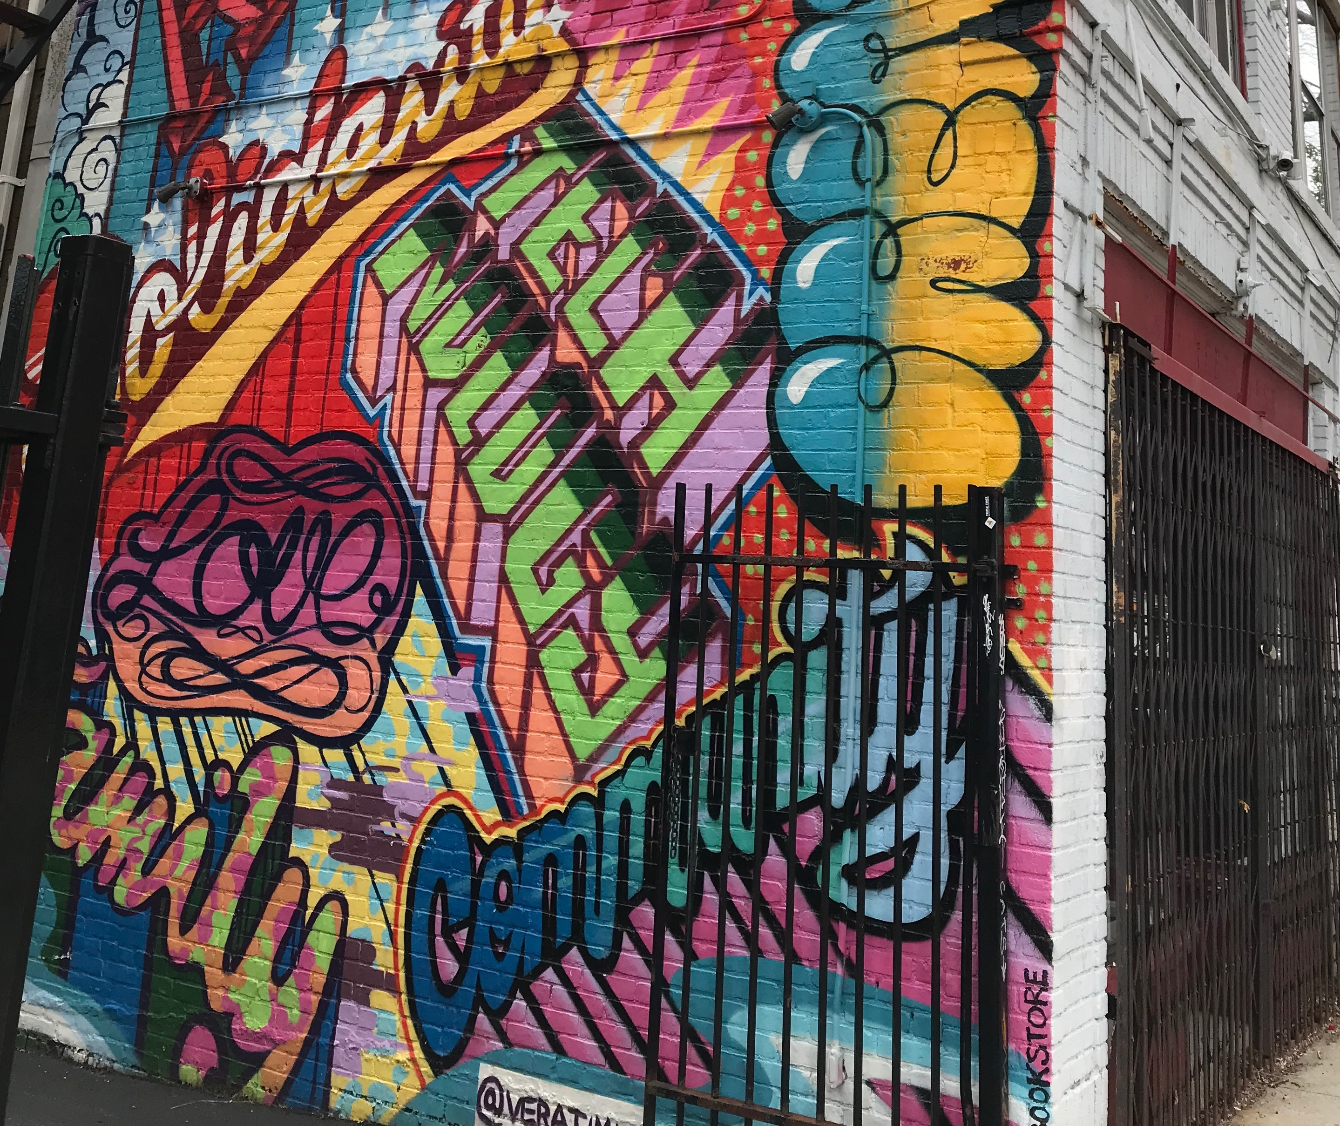
Graffiti, Massachusetts Avenue, Cambridge Mass., USA, 2019. Photo copyright: E. Hallam.

Lectures and Classes: Trinity Term 2020

VMMA Classes
Wednesdays 14.00 - 16.00, Weeks 1-5

These classes are aimed at revision for Paper 4, and will include a dissertation preparation workshop, but other topics to discuss may be suggested by students.

Pitt Rivers Museum Seminar in VMMA
Fridays 12 – 1.30 pm
Pitt Rivers Museum Lecture Theatre or Online.

This seminar series continues for the first 4 weeks of Trinity Term.

Fieldwork: Theories and Methods – Lectures
In addition to the VMMA Research Methods classes, there is a weekly lecture for all graduate students in Anthropology that VMMA students should participate in.
The aim of this course is to examine the relationship between anthropological theory and anthropological practice, with specific reference to field ethnography. It is aimed at all new graduate students in ISCA. The series consists of 6 pre-recorded lectures that will be available on Canvas from the start of Trinity Term 2021, and will be accompanied by a Q&A discussion session – details will be confirmed in HT. Each session will include a lecture on a key aspect of ethnographic fieldwork, and may include a practical activity. Readings and instructions will be finalised before the end of HT. Students will prepare their first exercise over the break (e.g. fieldnotes/observation).
Wks 1-6 | Lecture List  Week 1: Introduction: Participant observation and a history of ethnographic methods (ZO)  + Dissertation research skills for SCA & VMMA (Tylor Library)  Week 2: Ethics in the field (EE)  + Safety in the field (Social Science Division)  Week 3: Multi-sited fieldwork (IZ)  Week 4: Digital anthropology (DZ)  Week 5: Interviewing (DP)  Week 6: Fieldnotes and writing (TDC)

VMMA Reading Group
This is a student-led reading group that meets to discuss a book of their choice, usually focusing on an ethnographic study relating to the VMMA programme. It is optional and there will be around three meetings in Trinity Term at times to be arranged by Dr Hallam. All students in the VMMA programme (MSc, First and Second Year MPhil) are encouraged to participate.

Options (time and place to be announced)
Teaching for some options may continue into the first four weeks of Trinity Term; if so option co-ordinators will announce the details.

Other Lectures and Seminars
Other lectures, classes and seminars will be announced on the SAME website.

The SAME Departmental Research Seminar (Fridays 15.15-17.00) continues through the first six weeks of Trinity.

Tutorials
Tutorials may be held in Trinity Term, depending on student interest and need.

5. Key Dates and Deadlines

Graduate Supervision Reporting

Every term, you will be expected to submit a self-evaluation report to the Graduate Supervision Reporting system (GSR). Your supervisor will also submit a report at the end of each term. These reports will be available to you, to your supervisor, to your college advisor and to the Director of Graduate Studies. The reports are designed to give you feedback on your progress and to indicate any causes for concern.

MSc VMMA important dates

MICHAELMAS TERM
Week 2: Options Fair
Monday week 4: Return online form with option choices.
Friday week 7: Essay titles released for Paper 1 essay.

HILARY TERM
Thursday week 1: Submit Paper 1 essay electronically via WebLearn

TRINITY TERM
Thursday week 2: Depending on your option choices you may have an assessed essay to submit electronically via WebLearn.
Thursday week 5: Submit Paper 3 electronically via Weblearn
Thursday week 5: Return dissertation title form and synopsis to via Microsoft Forms.

Exams for paper 4 and option papers normally take place in week 7 of Trinity Term. The exact timetable for exams will be issued by Examination Schools in early Trinity term. Information can also be found at (http://www.ox.ac.uk/students/academic/exams/timetables).

Last Wednesday in August by Noon; submit Dissertation electronically via WebLearn.

MPhil VMMA 1st year important dates

MICHAELMAS TERM
Week 2: Options Fair
Monday week 4: Return form online form with option choices.
Friday week 7: Essay titles released for Paper 1 essay.

HILARY TERM
Thursday week 1: Submit Paper 1 essay electronically via WebLearn

TRINITY TERM
Thursday week 2: Depending on your option choices you may have an assessed essay to submit electronically via WebLearn
Thursday week 5: Submit Paper 3 electronically via Weblearn
Friday week 5: Submit preliminary thesis title and synopsis form via Microsoft Forms

Exams for Paper 4 and option papers normally take place in week 7 of Trinity Term. The exact timetable for exams will be issued by Examination Schools in early Trinity term. Information can also be found at www.ox.ac.uk/students/academic/exams.

Last Wednesday in August by Noon; submit Dissertation electronically via WebLearn

MPhil VMMA 2nd Year important dates

MICHAELMAS TERM
Monday week 2 Submit final thesis title and synopsis via Microsoft Forms
Monday week 4 Return online form with option choices.

TRINITY TERM
Thursday week 2: Depending on your option choices you may have an assessed essay to submit.
Thursday week 2: Submit Thesis electronically via WebLearn.
Thursday week 5: Submit Assessed Essay electronically via WebLearn
Week 9: In exceptional cases, you may be called for a viva voce examination. For example, if your final mark is a borderline mark between two degree classifications.

NB All important dates and deadlines are also listed on the SAME website https://www.anthro.ox.ac.uk/deadlines

6. Examined Work

The MSc and MPhil in Visual, Material, and Museum Anthropology are examined through written examinations, as well as by assessed coursework and a dissertation. The methods, procedures, criteria and other relevant details relating to examination are detailed in depth in the Examination Conventions for the degrees, which are available at https://www.anthro.ox.ac.uk/examination-conventions-and-marking-criteria.The Examination Conventions are the formal record of the specific assessment standards for the course or courses to which they apply. They set out how your examined work will be marked and how the resulting marks will be used to arrive at a final result and classification of your award. They include information on: marking scales, marking and classification criteria, scaling of marks, progression, resits, use of viva voce examinations, penalties for late submission, and penalties for over-length work. You are strongly encouraged to ensure that you are completely familiar with their content. More informal guidance is provided below.
[[

Assessed Coursework (MSc and MPhil first year)
Details of the length of essays and submission dates are given in the Examination Conventions for the VMMA degrees (https://www.anthro.ox.ac.uk/examination-conventions-and-marking-criteria) but in brief, one essay for Paper 1 must be submitted by the start of Hilary Term, while the portfolio of work and an outline proposal for Paper 3 must be submitted later in Trinity Term, and the dissertation must be submitted at the end of August.

In all cases, it goes without saying that the dissertation and all assessed coursework submitted for Papers 1 and 3 (and Paper 2, if applicable) should be original and the result of the candidate’s own work; checks for plagiarism will be made. Students concerned about plagiarism should consult the University’s site at http://www.ox.ac.uk/students/academic/guidance/skills/plagiarism. In addition, students should seek to present a broad and balanced range of themes, topics, and ideas across the corpus of their submitted work, situating the topic of enquiry within a broader intellectual and ethnographic context, rather than restricting all their writings to a small area of interest. The examiners will be looking for breadth as well as depth. Full details of the Marking Criteria used by the examiners are included in the appendices of the Examination Conventions. Cover sheets should be used for all assessed coursework

Paper 1: Contemporary themes in Visual, Material and Museum Anthropology

Paper 1 consists of one essay of no more than 5,000 words that must be submitted not later than noon of the Thursday of the first week of Hilary Term. A list of essay titles will be announced no later than Friday of the seventh week of Michaelmas Term.
We expect the work to consist primarily of written text, adhering to normal academic standards of presentation and referencing. Where relevant, still images, diagrams, sketches, etc., can be inserted directly into the text at the appropriate point, or gathered together as an appendix. In addition, students may wish to include short ‘video quotations’ from ethnographic or other films, or wish to animate a sequence of still images to make a particular point. For this, students can insert sound files or clips directly into the text document or can submit them as separate files at the same time. Any supporting multimedia materials that are not embedded within the essay file should be submitted as a single file separately to the ‘Accompanying Media’ part of the submission site, named in the same way as the essay text submission (full instructions appear on the submission site). This material may be embedded in a separate document (e.g. Word or Powerpoint) or may use any other readily-accessible file type (e.g. MP3, MP4, wav etc.). Submission of additional supporting materials of this sort is optional. Whatever form of presentation is chosen, the text document and any accompanying material should be clearly cross-referenced.

Paper 2: Option paper

Candidates must select one option paper from those taught each year for MSc candidates of the Institute of Social and Cultural Anthropology.

Paper 2 may be assessed either by one three-hour written exam or by coursework essay, depending on the option chosen. For those taking an option assessed by coursework, the submission deadline is noon of Thursday of the 2nd week of Trinity Term. For those taking an option assessed by written examination, the date of the examination will be in early June.

Paper 3: Research Methods

This paper must be submitted not later than noon on the Thursday of the fifth week of Trinity Term. It consists of two elements and should be presented as such:

Paper 3a is an outline research proposal of no more than 2,500 words. A template will be provided for the proposal by the Friday of 8th week of Hilary Term.
Paper 3b is a Methods Portfolio consisting of a report on a trial of ONE visual and material anthropological methods and/or ethnographic museological method. This should include some brief discussion of other visual, material and museum research methods which you have studied and/or the relevant published literature on research methods.
The word limit is 2,500 words. A contents page indexing the materials presented should also be included, as should a short overview document that introduces the portfolio and relates the various pieces to the published literature on research methods.

Some Guidance for Preparing the Methods Portfolio
Methods may include: anything relating to material, visual (photography, film, artworks etc.), museum, or archival/historical data used for the dissertation. Plus, topics such as the analysis of historical sources, photo or object elicitation, participant observation, museum visitor analysis, analysis of exhibition or museum design and anything you have learned/been exposed to on the VMMA course that is relevant to your dissertation data gathering.

Once you have determined which methods you will use, you should create short trials or tests of each method. For instance, if you will be using participant observation, you should find a situation in which you can be a participant observer, take notes, and write up the exercise. If you are using forms of visual analysis of historical photographs, do a test run of that process and write up how you did it and how it worked (or how it failed). As this is a course exercise, you do not need CUREC (research ethics clearance) approval for the trials.

In your write-up, focus on briefly describing the method, how you tested the method, and the strengths and weaknesses of the method for your purposes. Use citations to relevant theoretical literature about the methodology.

Feel free to be creative in your testing of the method. However, we encourage you to submit the work in a standard A4 format, using standard Harvard-style bibliographic and textual formatting. Images, sound clips, video and other evidence may be attached but note that they should take no more than 30 minutes viewing or listening time.

Paper 4: Fundamental Concepts in Visual, Material, and Museum Anthropology

This paper is assessed by a one week take-home exam. Further guidance and instructions about it will be given in due course. Tutorial teaching and essays, the Cultural Representations lectures, and the VMMA seminar are all sources to assist students in preparing for this paper. The MSc and MPhil are intended in part as the first step of a research training programme, and students are also encouraged to show familiarity and competence with material learned through independent reading.
The paper focuses on anthropology’s distinctive contribution to understanding social and cultural form and process, and the role of human creativity within them, with particular reference to artefacts of material and visual culture, and to the collection, display, production, circulation and consumption of such artefacts. Attention will be paid to the subject’s history and its place within broader concerns of politics, colonialism, and culture; issues of power and identity in relation to visual, material and museum anthropology; the formation of museum collections and visual archives; and also to the place of the socio-cultural in constituting such ‘natural’ phenomena as ecology, landscape, and population. The scope of this paper includes the following topics: the history and development of anthropological photography and object analysis, of documentary and ethnographic film, and of visual display in and beyond museums; an introduction to film and photographic theory, to material culture theory and to anthropological theories of representation, exchange and consumption; the Colonial archive and Colonial documentary practices; the ethnography of film, photography and other visual representational practices.

Dissertation (MSc students only)

A dissertation of no more than 10,000 words, on a subject selected in consultation with the supervisor and approved by the Chairman of Examiners, and submitted on the last Wednesday in August. The proposed title of the dissertation together with a paragraph describing its scope and the supervisor's written endorsement, must be submitted to the Chairman of Examiners by Thursday of the second week of Trinity Term. Sessions designed to help you prepare for the dissertation will begin at the end of Michaelmas term – see timetable.

During the course of Hilary Term students should begin to think in earnest about their summer dissertation topic. Full details are given in the Graduate Handbook and the Examination Conventions, but here it should be noted that the topic should not be identical to one selected for an assessed coursework essay, and, although it can build upon the Paper 3 research proposal, this is not a requirement. Ethnographic fieldwork is not required (or indeed practical) though it may be possible to conduct a small number of interviews as the basis of a case study; note that any research involving living human subjects requires ethical clearance (via submission of a CUREC form available from the departmental website) and, if overseas travel is involved (including to a student’s home country), a risk assessment; see https://www.anthro.ox.ac.uk/safety-fieldwork-and-ethics. Generally, it is expected that the dissertation will constitute an original piece of research, drawing upon primary or secondary visual and textual materials, that addresses a clearly formulated anthropological question. As with the assessed coursework essays, the dissertation will normally be accompanied by some visual materials, prepared in the ways described above.

NB MPhil candidates do not write a summer dissertation in the first year, but instead conduct research over the summer for their second-year thesis. Brief advice on this is featured below; supervisors will give further advice on this nearer the time.

A Note on Other Coursework
Tutorial essays, film introductions, and class presentations etc.

Essays written for tutorials, presentations before the weekly film screenings or prepared for seminars and classes are not formally assessed and do not count towards examination marks. They are, however, qualitatively assessed at the time or afterwards and they provide feedback to help students gain a sense of their progress during the course of the year. Tutorial essays and presentations will help in preparing for assessed coursework essays and written examinations.

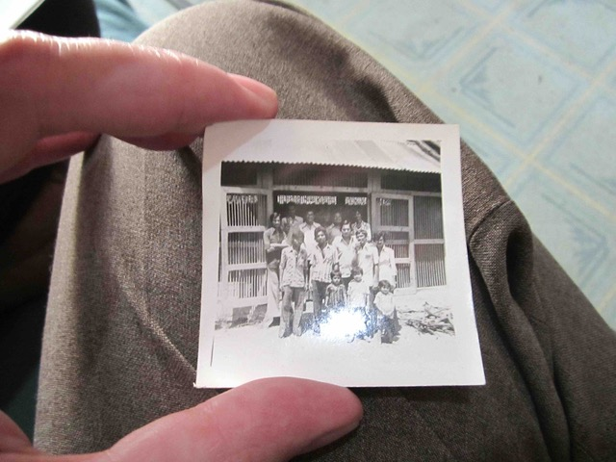
One of the very few men in Jamnagar, India, with a camera in the 1960s showing one of his photographs. Photo copyright: Marcus Banks.

7. VMMA MPhil (second year)

In the 2nd year of the MPhil degree you will be expected to devote the bulk of your time to research and writing a 30,000 word MPhil thesis. Your supervisor will support you in this and hold meetings with you. They will also arrange some tutorials over MT and HT. There will be fewer lectures and classes to attend, though we expect all 2nd year MPhil students to continue to come to the VMMA Friday lunchtime seminars. The reading group organised by Dr Hallam in Trinity Term is also recommended for second years. You may also wish to attend VMMA lectures on topics you may have missed or were not given in the first year. Other lectures and seminars across the University may be relevant for your dissertation research. All second years will select one option paper to be taken in Hilary term, and one Methods Module. After submitting your thesis, you will be expected to write one assessed essay on a topic in the field of VMMA, chosen from a list issued by the examiners. You will have two weeks in which to write this essay.

MPhil Thesis
In the 2nd year of the MPhil degree students are expected to devote the bulk of their time to research and writing a 30,000 word MPhil thesis. MPhil students should begin planning this during their first year of studies. Supervision for dissertations will not be available over the summer months, so students should ensure that they have taken all the advice they need from their Supervisor before the end of Trinity Term. In the first week of Michaelmas Term of the second year, MPhil students are expected to contact their Supervisor, and with his or her signature, submit the final title of their dissertation for approval to the Chairman of Examiners on Monday of the second week of Michaelmas Term of the second year. Fieldwork is not a requirement for the MPhil. Nevertheless, depending on the project, some MPhil students may wish to conduct brief field enquiries during the summer months between the two years of the degree. They then should discuss feasibility with their Supervisor and/or Dissertation Supervisor, ideally at the end of Hilary Term of the first year. Any fieldwork project, however small, that is carried out in connection with the University requires the completion of Fieldwork Safety and Ethics (CUREC) forms, which are available online (see https://www.anthro.ox.ac.uk/safety-fieldwork-and-ethics). Approval of these forms by the CUREC committee takes up to six weeks, and must be obtained before fieldwork starts. The maximum length of a MPhil thesis is 30,000 words, footnotes included, but bibliography and appendices excluded. The dissertation is written during the course of the second year, for submission on Thursday of the fifth week of Trinity Term. See the Examination Conventions for full details of the requirements.

Methods Modules

2nd year MPhil students are required to attend the introductory PRS (Probationer Research Student – first year DPhil) dissertation classes in MT, in weeks 1-5 (detailed below; PRS continue to attend these classes for the remainder of the year).

In addition, VMMA MPhil students are required to attend a minimum of two methods modules over the course of their two years of study. In year 1 of the MPhil they take the (compulsory) module in VMMA methods (alongside the MSc students), and in Year 2 they take one further module (free choice). These modules are held in MT and HT (except for ethnobiology and urban anthropology, in TT). Most methods modules classes are 90 mins long and held throughout six weeks. Please discuss your Methods Module choices with your supervisor, who will be happy to advise. [Note that these arrangements are different from those for MPhil students in other degrees, who take no methods module in their first year, and two in their second year].

I. The PRS class
The PRS (Probationer Research Student) class is convened weekly across the academic year. During Michaelmas Term the first five weeks feature essential introductions to a range of procedural and skill acquisition matters that will form a foundation for engagement with fieldwork and/or other forms of data collection. Sessions include topics such as: doctoral training approaches and resources; fieldwork and data collection; library and research resources; ethical research practice in the field; and fieldwork health and safety.

II. Methods Modules
As noted, 2nd year VMMA MPhil students choose one of the methods modules on offer in the School this year. All methods modules will be presented in the dissertation class in Michaelmas Term, Week 1, by Dr Zuzanna Olszewska, the School’s Research Methods Training Convenor for 2020. She can be contacted if any questions arise on zuzanna.olszewska@anthro.ox.ac.uk. Some methods modules convenors may have to cap the numbers of the participants they can accept, hence students are requested to sign up for and rank three modules they wish to attend in the order of their preference.

Assessment: at the end of each module, each participant is asked to write up a practical task (minimum length: one A4 page) and/or submit a 2,500 word essay, following the instructions of the module convenor. This writing will be assessed but not marked (except for Medical Anthropology 2nd year MPhils). In the case of PRS students these assignments must be submitted as part of their Transfer of Status portfolio (Transfer of Status Assessors will note whether they have been submitted). Feedback will be provided verbally directly to students in class by the module convenors.

Ethics and CUREC: any methods module which has a practical element involving encounters with people outside the Department requires the methods module convenor to list the projects and name the participants conducting the fieldwork for the methods module. This list must be sent to Kate Atherton (kate.atherton@anthro.ox.ac.uk) for approval by the CUREC team before any fieldwork for the respective methods module is carried out outside the Department. If a participant wishes to publish or use the data gathered during these classes for publication, a full CUREC procedure has to be initiated by the module convenor. PRS students are also encouraged to attend methods training provided by the Doctoral Training Partnership of the Social Sciences Division. Those who wish to take, as one of their two courses, another course from within the university that is appropriate to their needs in place of one of the courses offered in SAME, should first seek endorsement from their supervisor and then approach Dr Zuzanna Olszewska for approval.

Critical Readings MPhil Class – in MT, 8 sessions
In this class students critically engage with ethnographic theory and writing, with presentations and debates around selected texts. The sessions will be chaired by David Gellner and Akanksha Awal. Day and time to be announced.

MPhil Thesis writing Class – in HT, 8 sessions
In this class students take it in turns to present excerpts from their MPhil thesis to the rest of the class who offer comments and constructive feedback. The sessions will be facilitated by Morgan Clarke and Elizabeth Hallam. Day and time to be announced.

Option
In the middle of Michaelmas Term, you will be asked to select a second option paper which will be taught in Hilary term. The form of teaching for the option courses varies according to the preferences of the Course Convenor, but typically takes the form of a combination of lectures and discussion classes that span Hilary Term.

In order to help you decide what options to take, there will be an Options Fair in week 4 of Michaelmas Term, at which option coordinators introduce their options and are available to answer any questions you might have. You may also wish to discuss your option choices with your supervisor.

You will find details of available options through the following link:
https://www.anthro.ox.ac.uk/options

8. Assessment (All Degrees)

Information on Oxford University assessment and examination process can be found here http://www.ox.ac.uk/students/academic/exams. Full details of the structure of assessment of the MSc and MPhil in Social Anthropology, including marking criteria for each assessed component, are detailed in the Examination Conventions for the degrees.

Examination Conventions

The Examination Conventions for MSc and MPhil in VMMA are an essential complement for this handbook, and should be read in detail. The full Examination Conventions for the MSc and MPhil in VMMA are available at https://www.anthro.ox.ac.uk/examination-conventions-and-marking-criteria.

Examination Conventions are the formal record of the specific assessment standards for the course or courses to which they apply. They set out how your examined work will be marked and how the resulting marks will be used to arrive at a final result and classification of your award. They include information on: submission requirements, marking scales, marking and classification criteria, scaling of marks, progression, resits, use of viva voce examinations, penalties for late submission, and penalties for over-length work.

Marking criteria: Details of the marking criteria used by examiners in assessing coursework and examinations can be found as the Appendices of the Examination Conventions. These guidelines are definitive, however in the event that any alterations become necessary, details of these changes will be circulated to all students well in advance of the examinations.

Taking examinations: In addition to the guidance in the Examination Conventions for the degrees, information on (a) the standards of conduct expected in examinations and (b) what to do if you would like examiners to be aware of any factors that may have affected your performance before or during an examination (such as illness, accident or bereavement) are available on the Oxford Students website http://www.ox.ac.uk/students/academic/exams/guidance.

Past papers: Information on past examination papers can be found here http://oxam.ox.ac.uk.

Any candidate who anticipates problems with meeting submission deadlines should contact their college at the earliest opportunity, not the examiners or anyone else in the School.

9. Feedback (All Degrees)

You will receive feedback continuously throughout your degree, in the form of verbal and written feedback from your tutors and supervisor.

Learning is not downloading information from a book or from a wise person’s brain to your own head or to typing hands. It is rather a dialogic experience. You read, you listen to someone (a lecturer, a tutor, a seminar speaker, a class mate etc.) and then you speak or write something. This is an essential part, but if you are then not told whether what you said or wrote was interesting or innovating, whether it made sense or a good point, etc., you will not be moving ahead in the improvement of your reasoning skills. Therefore, providing you with “feedback” is a fundamental part of our way of training and of our tutorial system. During a tutorial, a supervisor discusses what you have written and provides oral and written feedback to help you move on in your writing and thinking. However, please note that, precisely because we want to stress the effect of feedback on your ability to improve your reasoning strategies, the supervisor does not provide a mark for the essay, but rather engaging comments, either on why they think the essay is not well argued, or on why they think it is a brilliant piece of work (or somewhere in the middle).

All students will also receive written feedback on any dissertation or thesis of 5,000 words or over, submitted in the final term of the course, normally by email after completion of marking. See also Appendix 1 of the Graduate Handbook.

10. Resources at the SAME and the PRM

Libraries and ORLO

The Balfour Library at the Pitt Rivers Museum contains many books and journals that are highly relevant to the VMMA degrees. It is also an excellent library for wider research in all the sub-disciplines of VMMA. Some books that are especially important for you are kept on reserve for VMMA student use only. Please make the most of this valuable resource.

The Tylor Library at ISCA also contains a wealth of crucial material for all students of anthropology, including those in the VMMA programme.

Many items for this course are also available in digital formats or ebook editions and can be found using ORLO.

ORLO is the new reading list system for the University of Oxford. With ORLO, you can access up-to-date reading lists at any time from a range of devices, check live location and availability information for the items on your reading list and access many ebooks and article easily through the "View Online" button. Access ORLO through Canvas. More information on ORLO is available here: https://libguides.bodleian.ox.ac.uk/home/basics

If you have any difficulties with ORLO, please contact Helen Worrell, the Tylor Librarian.

ISCA Video Library
The library contains over 200 titles; DVDs are located in Assistant Librarian Martin Pevsner’s office at 51 Banbury Road; VHS tapes – if needed – are located in the basement seminar room at 53 Banbury Road. There are printed catalogues in the Tylor and Balfour Libraries. All ISCA students – graduate and undergraduate – may borrow tapes and DVDs to watch in the lecture theatre when it is free. The University also has a subscription to Alexander Street Ethnographic Video Online (anth.alexanderstreet.com/). Bodleian Libraries also contain a small number of ethnographic films on DVD – these can be found by searching SOLO.

Object and Photograph Collections, Pitt Rivers Museum
The Museum has one of the most important collections of its kind in the world, and its presence is a key feature of Visual, Material & Museum Anthropology at Oxford. The collections comprise some 300,000 objects and c. 250,000 photographic objects from all over the world and from 1850s onwards. The collections offer an invaluable starting point for research projects. Ideas for research with museum objects should be discussed in the first instance with Clare Harris (Curator for Asian Collections) [clare.harris@prm.ox.ac.uk] or Dan Hicks (Curator of Archaeology) [dan.hicks@prm.ox.ac.uk]. Students should keep in mind that object research normally requires a two-month lead-time for retrieval of objects from cases. Ideas for research with photographs, manuscripts, sound or film should be discussed in the first instance with Chris Morton (Curator of Photograph and Manuscript Collections) [christopher.morton@prm.ox.ac.uk]. Once projects have a rough delineation, appointments to consult original material can be organized.

What’s On

Throughout the year there are likely to be one-off film screenings, seminars, exhibitions, and other activities at the Pitt Rivers, in SAME, and elsewhere in the University which will be of interest to VMMA students. As far as possible we will try to inform you of these, but students should also regularly check the websites of the museum and the department. Each year VMMA students are encouraged to set up a Facebook group which can become a very vibrant forum to advertise and discuss screenings, shows and many other kinds of events.

11. Student Projects/Volunteering Opportunities at the Pitt Rivers Museum

Students on the VMMA course may be able to do short volunteer placements with staff at the Pitt Rivers Museum to enhance their learning. While no degree marks are given for this work, such projects enable them to explore how theory and method can be applied and they may feed into assessed coursework. However, these placements are not formalized at the Pitt Rivers and staff will inform you if there are any opportunities. NB Unfortunately, there are unlikely to be any volunteering opportunities at the Pitt Rivers in Michaelmas Term 2020 due to the Covid 19 pandemic but we hope things may be different in the museum from January 2021.

Previous projects have included:
- curating an exhibition on personal collections, ranging from cocktail stirrers to postcards
- assisting with Indigenous community research visits to the museum and transcribing interviews and notes from such visits
- shooting and editing a short documentary about the Seeing Lhasa exhibition, including audience responses
- co-curating Architecture for All: the Photography of Paul Oliver with students from Oxford Brookes University
- working with staff at the Pitt Rivers on public events and educational activities
- organising and hosting anthropologically-themed late night events at the museum
- helping to devise and perform a dance piece in the museum
- creating and conducting surveys to gather feedback from the public and from Tibetans on the Performing Tibetan Identities exhibition

Students are also welcome to join the volunteers programme for the Oxford University Museums as a whole. This provides valuable experience of giving talks for visitors of all ages and learning about museum education and public interpretation programmes.
www.glam.ox.ac.uk/volunteering

In addition to this, the Pitt Rivers participates each year in the Oxford University Internship Programme, offering between 2 and 4 paid 6-week internships in July/August. Full details about this are available from the University’s careers service.
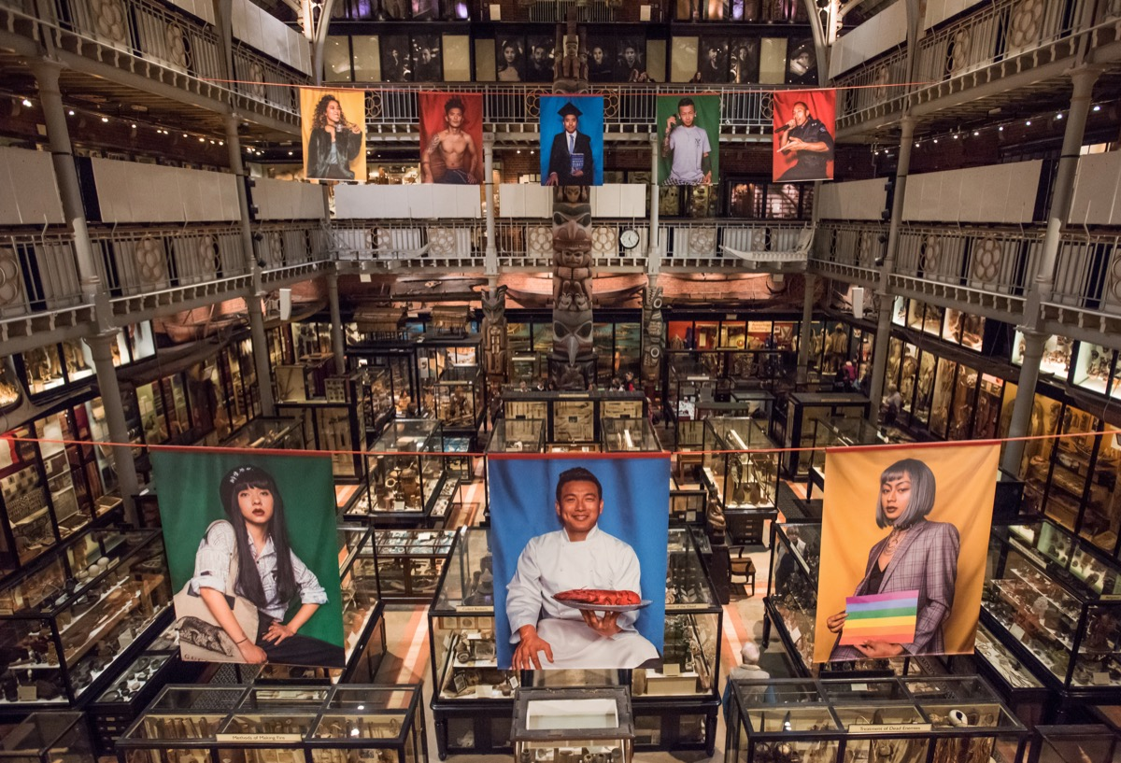
Installation of portraits by Tibetan photographer Nyema Droma in the court of the Pitt Rivers Museum, 2018. Photo copyright: John Cairns.

